RMI Pacific Resilience Project (PREP II)

GRIEVANCE REDRESS MECHANISM
Version 4



HOW TO GET INFORMATION OR RAISE A CONCERN ABOUT ACTIVTIES ASSOCIATED WITH
RMI PREP II

UPDATED: March 2023

Prepared by
RMI Ministry of Finance, Central Implementation Unit
Quality Information

Document | PREP II Grievance Redress Mechanism
Date | January 2023
Prepared by | CIU Safeguards Team
Reviewed | CIU/PREP II

Revision History
Revision | Revision Date | Details | Revision By
V1 | January 2019 | Original Version from ESMF V2 – developed pursuant to Additional Funding | CIU
V2 | September 2021 | Updated to include SEAH pathway | CIU
V3 | April 2022 | Updated to include new CIU Safeguards website and updated contact information | CIU
V4 | March 2023 | Updated to change DCP and include new Grievance Reporting Form and Grievance Register | CIU

Revision 4


Contents
List of Acronyms…………………………………………………………………………………….…….i
Contact Information iii
1. Introduction 1
2. Purpose of the PREP II GRM 1
3. How the PREP II GRM Operates 3
4. Gender-Based Violence, Sexual Exploitation, Abuse and Harassment and Violence against Children 6
5. How to Make a Compliant 7
6. GRM Information Handling and Storage 8
7. Communicating the GRM with Stakeholders 8
8. Reporting and Learning 8

List of Figures and Forms
PREP II Grievance Redress Procedure………………………………….…………..………………..5
PREP II Grievance Report Form (Written)……………………………….………….………………...10
PREP II Grievance Report Form (On-line)………………………………………….….…………….. 12
PREP II Project Grievance Register…………………………………………………………………..13

List of Acronyms
AP Aggrieved Party
CIU Central Implementation Unit
CSS Construction Site Supervisor
DCP Designated Contact Person
DIDA Division of International Development Assistance
GBV Gender Based Violence
GCF Green Climate Fund
GRM Grievance Redress Mechanism
HT Human Trafficking
IA Implementing Agency
IRM Independent Redress Mechanism (GCF)
MWIU Ministry of Works Infrastructure and Utilities
PREP II RMI Pacific Resilience Project, Phase II
SEAH Sexual exploitation, abuse and harassment
SEP Stakeholder Engagement Plan
VAC Violence Against Children
WB World Bank
WUTMI Women United Together Marshall Islands

Contact Information
PREP II Project
In person: PREP II Project Implementation Unit
Ministry of Finance, DIDA Office, M&L Building, Uliga Village, Majuro
By phone: (692) 625 5968
By email: Aliti Koroi aliti.koroi@prepii.org or
Bruce Jackson bruce.jackson@prepii.org or
inquiries.ciusafeguards@gmail.com

By mail: PREP II c/- DIDA P.O. Box D, Majuro. MH 96960
Internet: https://www.ciudidasafeguards.com/

If you are concerned, or you know someone who is concerned, about any aspect of the PREP II Project, please contact the PREP II Project Manager or anyone else working on the project as soon as possible.

Introduction
This document is relevant to anyone who has an interest in the Republic of the Marshall Islands (RMI) Pacific Resilience Project, Phase II (PREP II). This includes people who are directly or indirectly affected by Project activities and members of the public who wish to express concerns or make a complaint about PREP II.
The objective of PREP II is to strengthen early warning systems and climate resilient investments in shoreline protection, and to provide immediate and effective response to an eligible crisis or emergency. This objective will be achieved by implementing activities under the following four components:
Component 1 – Institutional Strengthening, early warning, and preparedness.
Component 2 – Strengthening Coastal Resilience (includes the Ebeye Seawall Project).
Component 3 – Contingency Emergency Response, and
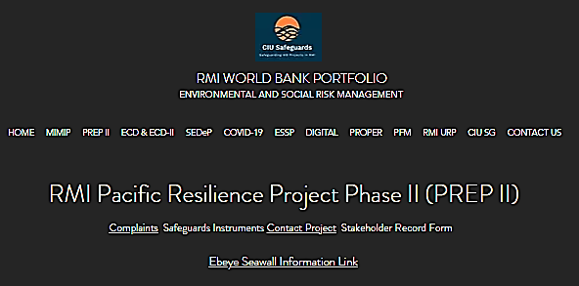
Component 4 – Project and Program Management
PREP II is funded by the World Bank and the Green Climate Fund (GCF) and is implemented in the RMI Ministry of Finance, with support from the Project Implementation Unit (PIU) and the Central Implementation Unit (CIU). Some activities are also implemented by the Pacific Community (SPC). PREP II is overseen by a Project Manager and a Project Steering Committee (PSC).
If you would like more information about PREP II, please do not hesitate to contact any member of the PIU or CIU. We also welcome suggestions about how to improve the Project. Staff contract information is on page 7, and you can also get in touch with us using the Contact Information Sheet on the CIU Website:
https://www.ciudidasafeguards.com/prep2 or email us at inquiries.ciusafeguards@gmail.com

What is the PREP II GRM?
The process of making a complaint and ensuring that complaints are addressed according to an agreed process is called a Grievance Redress Mechanism or GRM.
The purpose of the PREP II GRM is to ensure that the basic rights and interests of everyone affected by the Project are protected; that all concerns about the Project are addressed in a fair, timely and effective manner, and that the Project makes adjustments and improvements in response to people’s concerns and feedback.
Grievances can be raised about any aspect of PREP II, including project activities, services, environmental or social impacts, safety issues or about the behavior or attitudes of people carrying out project works. This includes concerns related to physical or sexual harassment, abuse or violence against any member of the community, as well as corruption, misuse of Project resources and human trafficking.
This document explains the process that will be used to investigate and resolve any concerns or complaints that are raised about the Project as quickly and respectfully as possible.
Important Points about the PREP II GRM
- The PREP II GRM only deals with project related matters.
- There is a different grievance procedure for PREP II staff and contract workers to use if they have issues about internal project matters.
- The GRM can be used by an individual or by a group of people who have concerns about how the project is impacting their lives.
- Grievances can be raised in an open and public manner, or anonymously and in confidence. The identify of people who make a complaint will be kept confidential and all documentation related to the concern will be kept in a secure location that can only be accessed by the Designated Contact Person and the Project Manager.
- Because different kinds of concerns could arise, this GRM provides different “pathways” to resolve problems - one for general issues and one for “serious and sensitive” matters that may require the involvement of external agencies such as the police or counselling services.
- People can choose to raise their concerns with someone they are not personally connected with and can also choose to talk with either a man or a woman. This is especially important in situations that involve gender-based violence, sexual exploitation, abuse or harassment.
- There is a person in charge of making sure that the PREP II GRM process operates properly, and that person is called the “Designated Contact Person” or the “DCP”,
- The PREP II Project Manager is the DCP for all grievances and will stay involved until the matter is resolved and will be the main point of contact for person(s) making the complaint. In addition, the Construction Site Supervisor (CSS) can serve as the DCP until the matter is resolved or transferred to the Communications Officer,
- If concerned persons are unsure who to contact, they can seek information or raise grievances with any staff involved project implementation who will immediately direct the matter to the appropriate party for resolution.
- The intent of the GRM is to solve problems, to everyone’s satisfaction, as quickly as possible. This will be done in accord with existing systems and processes where other agencies are involved.
- The PREP II GRM is not a substitute for legal or other public or civic resolution mechanisms and does not remove people’s right to take their grievance to a formal dispute-resolution mechanism.
- The PREP II GRM provides important information about how well the project is functioning and what improvements are required based on the kinds of concerns that arise. The Project Manager is responsible for regular reporting of all grievances to the RMI Government and to the World Bank (complaint names are kept confidential).

How does the PREP II GRM operate?
The PREP II grievance redress mechanism is a step-by-step process which follows the procedures outlined below. (This process is also shown in diagram form on page 5). There is a maximum period of time allowed for each step to ensure that concerns are addressed as quickly as possible.
Step 1: The PREP II GRM process begins when an “Aggrieved Party” (the “AP” or the person making the complaint) raises a concern to a Project staff, contractor, consultant or someone at the DIDA Office by any means.
The person who receives the complaint is called the “Recipient”. The Recipient is required to pass this information to the PREP II Designated Contact Person (DCP) within 12 hours using the PREP II Grievance Report Form (see page 10).
Step 2: After receiving the complaint, the DCP will document or “log” the concern in the PREP II Complaints Register (see page 13). This will serve as an official record that a complaint has been received and when the matter has been resolved.
Step 3: The DCP will determine whether the concern is related to the Project, and if it is, the investigation will begin immediately (see Step 4).
If the matter is not related to PREP II, the DCP will advise the Aggrieved Party and the matter will be referred to the appropriate authority to resolve the issue, and the matter will be closed on the Complaints Registry.
Step 4: The DCP will determine if the complaint relates to a serious or sensitive matter and if it does, an investigation will commence immediately. The DCP will also notify the Central Implementation Unit and the World Bank that an incident has occurred, although the names of the individuals involved will not be disclosed.
“Serious or sensitive matters” refer to issues involving potential criminal activity, political interference, conflicts of interest, corruption, land claims, gender-based violence (GBV), sexual exploitation, abuse, or harassment (SEAH) violence against children (VAC) or human trafficking (HT).

In the case of potential criminal activity, it is important that the Project GRM process does not impede investigation by the appropriate authorities. In situations involving land disputes or claims, the matter will be referred to the Secretary, Ministry of Finance.
If the concern is related to GBV or SEAH, the Project will first seek to ensure that the victim is safe and has access to required support services.
Referrals for GBV support for women and girls can be made to the WUTMI Weto in Mour.
Referrals for GBV support for men and boys can be made to Waan Aelon in Majel. (WAM)
WUTMI Weto in Mour | (692) 625-6687 | wetoinmour@wutmi.com
Waan Aelon in Majel. | (692) 625 6123 | associate@canoesmarshallislands.com
In the event WUTMI or WAM becomes aware of a situation involving MIMIP-related GBV, SEAH or VAC, a staff member will contact the Project Manager or DIDA Safeguards Officer within 12 hours. At that point, the concern will be documented and an internal MIMIP investigation with commence. Throughout the referral and investigation process, it is critical that confidentially is fully respected and that the safety and dignity of the victim is upheld.
- Step 4 (continued): After determining the grievance is project related but is not of a serious of sensitive nature, the DCP will advise the PREP II Project Manager and CIU Safeguards team. The DCP and PREP II Project Manager will attempt to resolve the concern to everyone’s satisfaction within 24 hours, or within 2 weeks if consultation with other parties is required.
- Steps 5-6: If resolution is not achieved within 2 weeks, the situation will be referred to the Secretary, Ministry of Finance who will also attempt to resolve the matter within 2 weeks.
- Steps 7: If resolution has still not occurred following attempts by the PREP II Project Manager and the Secretary of Finance, the Project Steering Committee (PSC) will have 1 month to resolve the matter.
- Step 8: If the issue remains unresolved or the complainant is dissatisfied with the outcome proposed by the Project Steering Committee, the Aggrieved Person may refer the matter to the appropriate legal or judicial authority. The decision of the Court will be final.
Note: If the complaint is related to the Ebeye Seawall Project, parties can also refer grievances to the CIU Representative in Ebeye or to the Green Climate Fund Independent Redress Mechanism (IRM) procedure.
To access this procedure, contact https://irm.greenclimate.fund/case-register/file-complaint

Figure 1: PREP II Grievance Redress Procedure
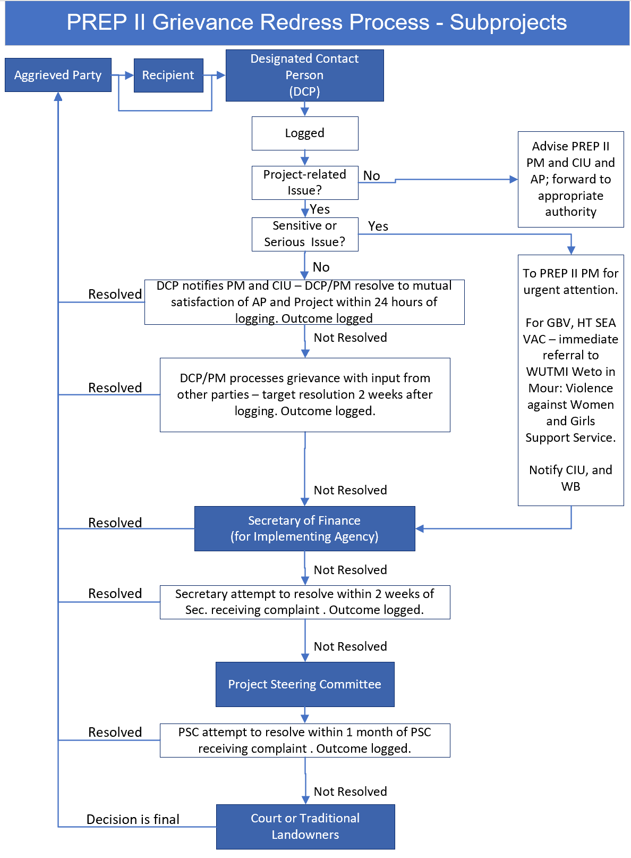

Gender-Based Violence, Sexual Exploitation, Abuse or Harassment, Violence against Children and Human Trafficking
As outlined in Section 3, complaints related to gender-based violence (GBV) – which includes sexual exploitation, abuse and harassment (SEAH), and violence against children (VAC), are referred to WUTMI Weto in Mour: Violence against Women and Girls Support Service (WUTMI - WIM) if the survivor (also known as the victim) is female, and to Waan Aelon in Majel (WAM) if the survivor is male. Situations involving Human Trafficking (HT) are also be referred to WAM.
The purpose of making these referrals is to ensure that the safety and support needs of survivors are addressed sensitively and quickly using a survivor-centered approach. This includes assisting the survivor locate safe housing and basic needs supplies, as well as initiating legal action as required.
In all situations involving GBV, SEAH, VAC an HT, the PREP II will use the survivor-centered approach, which means that:
- The rights, needs, and wishes of the survivor (or victim) is the foremost priority of everyone involved with the project
- The survivor has a right to:
  - be treated with dignity and respect instead of being exposed to victim-blaming attitudes.
  - choose the course of action in dealing with the violence instead of feeling powerless.
  - privacy and confidentiality instead of exposure.
  - non-discrimination instead of discrimination based on gender, age, race/ ethnicity, ability, sexual orientation, HIV status or any other characteristic.
  - receive comprehensive information to help her make her own decision instead of being told what to do.

The survivor-centered approach aims to create a supportive environment in which the survivor’s rights are respected and in which she is treated with dignity and respect. The approach helps to promote the survivor’s recovery and her ability to identify and express needs and wishes, as well as to reinforce her capacity to make decisions about possible interventions.
(UN Women)

How to Make a Compliant
To raise a concern about the Project, please get in touch with any of the following people by phone, mail, email, on our website, or in person using this contact information:
In Person:
Majuro: Ms. Aliti Koroi, PREP II, Implementation Support Officer
Ministry of Finance Office, Majuro or
DIDA Offices, M&L Building, Uliga Village, Majuro
or
Mr. Kimber Rilometo, Government of RMI (CIU) Safeguards Officer
DIDA Offices, M&L Building, Uliga Village, Majuro

Ebeye: Ms. Yumiko Crisostomo, Government of RMI (CIU) Ebeye Coordination Officer

By Phone or Email:
Aliti Koroi | Implementation Support Specialist | (692) 625 5968 | aliti.koroi@prepii.org
Bruce Jackson | Project Manager | (692) 625 5968 | bruce.jackson@prepii.org
Kimber Rilometo | CIU Safeguards Officer | (692) 456 5233 | inquiries.ciusafeguards@gmail.com
Yumi Crisostomo | CIU Ebeye Coordinator | (692) 329 8011 | inquiries.ciusafeguards@gmail.com
Colleen Peacock | CIU Safeguards Advisor | (692) 456 5233 | colleen@tautai.com
Garry Venus | CIU Safeguards Advisor | (692) 456 5233 | gazza700@gmail.com
WUTMI (if related to violence or abuse)  Services for women |  | (692) 625-6687 | wetoinmour@wutmi.com
WAM (if related to violence or abuse)  Services for men |  | (692) 625 6123 | associate@canoesmarshallislands.com
By Mail:
PREP II Project Manager, DIDA, P.O. Box D Majuro, Marshall Islands 96960
By internet:
https://www.ciudidasafeguards.com/prep2

GRM Information Handling and Storage
Every concern or complaint received by the DCP will be allocated a unique File identifier, such as PREP II GRM – 2021 #1, PREP II GRM – 2021 #2 etc.
Details of each concern or complaint will be entered in a password protected master file that can only be accessed by the Project Manager and the CIU Safeguards Team.
Any information related to situations involving GBV, SEA, HT or VAC will be treated as personal and confidential and can only be accessed by the Project Manager or the Chair of the Project Steering Committee. This information will only be made available to WUTMI or other approved authority (such as the police) with the written permission of the aggrieved party.

Communicating the GRM with Stakeholders
This GRM will be made widely available to all Project-affected persons and other interested groups using a variety of communication strategies including, but not limited to:
Radio | This could involve public notices about specific PREP II activities, including work schedules, disruption to services etc.
Marshall Islands Journal | This could include articles and notices about upcoming PREP II activities
Websites and Social Media | Project information will be published on the Project website or social media site: https://www.facebook.com
Notice Boards, Banners, Pamphlets | In all areas where physical works are carried out, a project notice board and/or other suitable communication materials must be displayed which includes GRM information

More information about Project communications is set out in the “PREP II Stakeholder Engagement Plan” which is available from the Project Implementation Unit and on the CIU website https://www.ciudidasafeguards.com/

Reporting and Learning
As outlined in Section 2, one of the purposes of the PREP II GRM is to ensure that the project learns from its grievance process, reports on the kinds of issues raised, and makes improvements, as needed, in response to people’s concerns and feedback. To this end, the following procedures will be followed:
- Incident Reports
- Within 12 hours, the Complaint Recipient must notify the Project Manager
- Within 12 hours, the Project Manager must complete the Grievance Form and initiate the investigation

- Monthly Reports
- The Project Manager completes monthly reports that summarize all new complaints, enquiries and grievances received, the type of concern and the number of days it took to resolve the matter. Monthly reports also summarize the status of any outstanding matters from previous months.
- Six-Monthly Reports
- The Project Manager completes a six-monthly report for the Project Steering Committee and the World Bank, that contains the following statistics:
- Total number of grievances and complaints received
- Total number of grievances and complaints resolved
- Total number of grievances and complaints active
- Total number of grievances and complaints unresolved
- Average number of days to resolve grievances and complaints.
- Six-monthly reports also need to specify any changes the project has made in response to existing or previous complaints.
Immediate Reporting to DIDA and the World Bank by the Project Manager under the following circumstances:
- Grievance or complaint is related to physical injury or death, including those incurred because of gender-based violence.
- Grievance or complaint received relating to sexual exploitation, abuse or harassment (SEAH), violence against children or human trafficking.
Immediate Reporting to WUTMI-WIM by the Project Manager of the following:
- Grievance or complaint is related to gender-based violence, sexual exploitation, abuse or harassment, or violence against children.

RMI GOVERNMENT & WORLD BANK PROJECT

GRIEVANCE REPORT FORM
* Grievance Recipient to complete all non-shaded areas and DCP to completed shaded areas
Name & Position of Grievance Recipient:

Contact Information of Grievance Recipient:
Grievance Reference #:

Name of concerned party (or anonymous), gender and age (or approx.)

Address:
Telephone: Email:
Date and time complaint received:
How complaint was received:
Date and Time Project Manager was notified:
How Project Manager was notified:

Date of 2-week deadline for initial resolution or escalation:
Date, time, and location of event leading to concern

Does the complaint involve injury, death, violence, sexual abuse, exploitation, harassment, violence against children or potential criminal activity?
Yes or No

Is anyone at immediate danger or risk?
Yes or No
If yes, describe risk and any actions that have been taken to protect people or property

Does the complaint involve Project or implementing agency staff, consultants or contractors?
Yes or No
Detailed account of concern (include names of persons involved if known)

Proposed solution or remedy sought by aggrieved party (if known)
Name and Position of DCP receiving this Grievance Form:
Date and time Grievance Form Received:

Dates and steps taken to resolve concern by DCP or other parties
Outcome of resolution process

PREP II GRIEVANCE REPORT FORM (on-line)
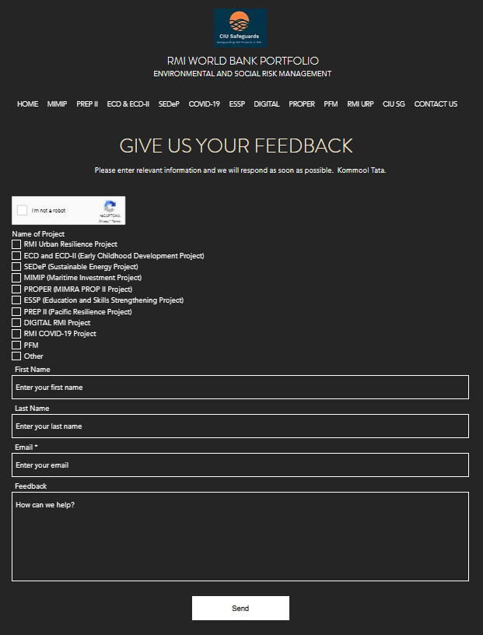

World Bank & RMI Government: Project Grievance Register

Name of Project: ________________________________ Name and position of person completing Register ______________________________________ Date of Last Update: _____________________________ Date Register Shared with: CIU ___________ PSC:___________ WB ____________
When/How Grievance received | File # | Name of Aggrieved Party or Complaint | Nature of Issue Raised | Sensitive or Serious Matter?  Yes/No | Description& Date of Response & Referral Info | Outcome of Response | If not resolved, steps taken & date | Status  (Date of closure or next step)
Date:  01/01/21  Method:  Phone | PREP II GRM – 2023 #1 | To be redacted when register is shared
Date:  Method: | 2 | To be redacted when register is shared
Date:  Method: |  | To be redacted when register is shared
Date:  Method: |  | To be redacted when register is shared

