
Republic of the Marshall Islands
World Bank RMI COVID-19 Emergency Response Project (P173887)

ENVIRONMENTAL AND SOCIAL MANAGEMENT FRAMEWORK

Ministry of Health and Human Services as Implementing Agency
Supported by the Centralized Support Unit of the Division of International Development Assistance.

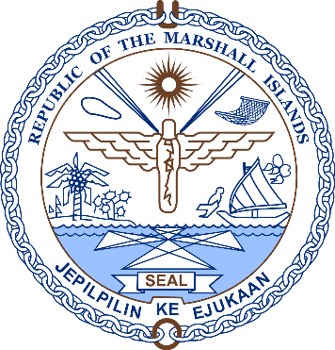
FINAL VERSION
24 May 2020

Republic of the Marshall Islands

Ministry of Health and Human Services

World Bank RMI COVID-19 Emergency Response Project (P173887)

ENVIRONMENTAL AND SOCIALMANAGEMENT FRAMEWORK

Quality Information

Document name | RMI COVID19 Final Environmental and Social Management Framework May 24 2020
Date | 24 May 2020
Prepared by | G Venus, DIDA Safeguards Advisor
Reviewed | CIU, MOHHS, WB Safeguards Team

Final Version
TABLE OF CONTENTS

PREAMBLE 1
1. BACKGROUND 2
2. PROJECT DESCRIPTION 3
2.1. Summary of Project Components and Costs 3
2.2. Project Beneficiaries 3
2.3. Project Activities 4
2.4. Environmental and Social Risk Classification 4
3. POLICY, LEGAL AND REGULATORY FRAMEWORK 4
3.1. Introduction 4
3.2. Country specific policy, legal and administrative frameworks relevant to the project 5
3.2.1. Introduction 5
3.2.2. General 5
3.2.3. Public Health Legislation 6
3.2.4. Hazardous Substances 7
3.2.5. Labor Legislation 8
3.2.6. Relevant International Conventions 9
3.3. RMI Government Policy – COVID-19 Response 10
3.3.1. National Pandemic Preparedness and Response Plan 10
3.3.2. RMI Public Health Emergency Operations Plan (PHEOP) 11
3.3.3. Outer Islands Response 11
3.4. Applicable World Bank Environmental and Social Standards 12
3.4.1. Environmental and Social Standards 12
3.4.2. World Bank Group Environmental, Health and Safety (EHS) Guidelines 14
3.5. WHO Guidelines 15
4. GAP ANALYSIS 16
4.1. Introduction 16
5. ENVIRONMENTAL AND SOCIAL BASELINES 19
5.1. Introduction 19
5.2. Location and scale of healthcare facilities 19
5.2.1. Overview 19
5.2.2. Majuro 19
5.2.3. Ebeye 20
5.2.4. Health Clinics 20
5.2.5. Laboratory Facilities 20
5.2.6. Immunization Programme 21
5.3. Health Care Waste Management Procedures 21
5.3.1. General 21
5.3.2. Definitions 21
5.3.3. Waste Management at Majuro Hospital 22
5.3.4. Waste Management at Ebeye Hospital 24
5.3.5. Waste Management at Arrak Quarantine Site 25
5.3.6. Waste Management at Outer Island Health clinics 25
5.4. Health, Gender and Poverty-related Vulnerabilities 25
5.5. Gender Based Violence and Sexual Exploitation and Abuse 26
6. PROJECT ACTIVITIES 29
7. POTENTIAL ENVIRONMENT AND SOCIAL RISKS AND MITIGATION 32
7.1. Summary 32
7.2. Evaluation of Eligible Activities 33
8. PROCEDURES FOR NEW ACTIVITIES 38
9. STAKEHOLDER ENGAGEMENT 38
9.1. Stakeholder Engagement Plan 38
9.2. Consultations during Project Preparation 39
9.3. COVID-19 Communications 40
9.4. Consultations During Project Implementation 40
10. GRIEVANCE MECHANISM 40
10.1. Introduction 40
10.2. Procedure 41
11. INSTITUTIONAL ARRANGEMENTS, RESPONSIBILITIES AND CAPACITY BUILDING 44
11.1. Institutional Arrangements 44
11.2. E&S Risk Management Responsibilities 44
11.3. Awareness Raising and Capacity Building 45
12. AUDITING 45
13. ANNEXES 46
Annex I: Abbreviations and Acronyms
Annex II: References
Annex III Protocol regarding Use of Military Forces to Assist in RMI COVID-19 Response Project
Annex IV: Screening of Potential Environment and Social Issues
Annex V: Stakeholder Engagement Plan
Annex VI: Environmental and Social Management Plan
Annex VII: Infection Prevention and Control Protocol on COVID-19, Update 2
Annex VIII: RMI COVID-19 Risk Communication and Community Outreach Plan
Annex IX: HCWM COVID19 Quarantine Site and COVID Isolation Ward - Waste Management Policy draft

PREAMBLE
This Environmental and Social Management Framework (ESMF) is prepared to assist the Government of the Republic of the Marshall Islands (RMI) in developing environmental and social (E&S) instruments for activities funded under the RMI COVID-19 Emergency Response Project (the Project), pursuant to national regulations and the World Bank’s Environmental and Social Framework (ESF).
This ESMF includes an Environmental and Social Management Plan (ESMP) (see Annex VII) and identifies the RMI Ministry of Health and Human Services (MOHHS) protocols for Infection Prevention and Control [Annex VII]. The former aims to provide an overarching action plan for the management of environmental, social, health and safety (ESHS) issues associated with minor renovations of healthcare facilities, the operation of healthcare facilities by personnel funded under the Project, and the use of equipment purchased by the Project.
Other E&S instruments as required by the ESF have been prepared: a standalone Stakeholder Engagement Plan (SEP) and Labor Management Procedure (LMP); all of which will be disclosed on the Ministry of Finance website www.rmi-mof.com/division-of-international-development-assistance/news-and-updates/ .

BACKGROUND
The RMI COVID-19 Emergency Response Project (P173887) aims to address urgent preparedness and response needs in the Republic of the Marshall Islands (RMI) related to a potential COVID-19 outbreak and simultaneously prepare the health system for future public health emergencies. The project will fund some of the immediate needs for responding to COVID-19 including: augmenting the number and readiness of human resources in health and other sectors; facilitating development and delivering risk communication; providing essential medical supplies, equipment and drugs; enhancing infection prevention and control in public health facilities; and engaging the community in public health prevention and mitigation measures.
The RMI is one of the world’s smallest, most isolated, and vulnerable nations. The country consists of 29 atolls and 5 isolated islands (24 of which are inhabited) and has a total land mass of just 181 km² set in an area of over 1.9 million km² in the Pacific Ocean. The population of the RMI is estimated at 53,066 , of which the two largest urban centers, Majuro (the nation’s capital) and Ebeye, have populations of 28,000 and 9,614, respectively. The RMI was consolidated into the Trust Territory of the Pacific Islands governed by the United States during the Second World War. It became self-governing in 1979 and achieved formal independence in 1986.
Geographically, the project will prioritize RMI’s two most densely populated atolls of Majuro and Ebeye. These urban centers are most at risk of a COVID-19 outbreak as they are home to 74 percent of the population, with areas of high population density and household crowding. They are also the sites of the country’s two hospitals and main international ports of entry. Project-related support for the Outer Islands (OI) will primarily be limited to communications and containment measures to limit the impact of COVID-19 on OI populations. The RMI currently has no cases of COVID-19 and has strict travel restrictions in place.
The COVID-19 emergency follows a previous State of Emergency in the RMI for a dengue outbreak in mid-late 2019. This has given the health and disaster management sectors recent experience with restricting travel and responding to health emergencies. The National Disaster Management Office (NDMO) in the Office of the Chief Secretary has activated the National Emergency Operations Center with the technical clusters (i.e. WASH, health, logistics, infrastructure and other relevant agencies) to provide coordination and implementation advice on COVID-19. The MOHHS recently conducted a preparedness self-assessment and scored at 57/100, largely due to the absence of human resources, personal protective equipment (PPE) and other infection prevention and control supplies, and laboratory capacity. Even before the threat of COVID-19 emerged, RMI’s health sector had been at breaking point due to the ongoing dengue outbreak.
The RMI regulatory regime for waste management and occupational health and safety is not comprehensive. There are no occupational health and safety laws or regulations. The National Environmental Management Strategy 2017-2022 identifies hospital waste management as a priority. Landfills on Majuro and Ebeye, the two main urban centers, are unsanitary, located on the foreshore and not engineered to manage leachates. Waste is piled above ground and uncovered in Majuro Landfill. Hazardous hospital waste from Majuro and reportedly from Ebeye is incinerated on Majuro (although the situation on Ebeye is somewhat unclear).
The rationale and purpose of using a framework instead of activity -specific plans is as follows:
- Rationale of the framework is that specific locations and detailed information about the activities will only be known during implementation.
- Purpose of the framework is to guide the MOHHS on the environment and social screening and subsequent assessment of activities during implementation, including the relevant activity-specific plans that have to be developed in compliance with the Bank policies.
- Scope of the framework includes environmental and social screening to determine activity environmental and social (E&S) risks, potential environment and social issues and activity-specific instruments (such as management plans).

PROJECT DESCRIPTION
The Project Development Objective is to prevent and respond to the threat posed by COVID-19 and strengthen national systems for public health preparedness in RMI. The objective will be achieved through two components: (i) Emergency COVID-19 Response; and (ii) Implementation Management and Monitoring and Evaluation.

Summary of Project Components and Costs
Component | Value (US$)
Component 1. Emergency COVID-19 Response | 2,100,000.00
Subcomponent 1.1. Prevention and Surveillance: Communication, Physical Distancing, Case Detection, Confirmation, and Contact Tracing | 465,000.00
Subcomponent 1.2. Strengthening health service delivery to respond to COVID-19 | 1,635,000.00
Component 2. Implementation Management and Monitoring and Evaluation | 400,000.00
Total | 2,500,000.00

Section 7.2 describes activities associated with each Component and Subcomponent.

Project Beneficiaries
The expected project beneficiaries will be:
- The general population of the RMI, including at-risk populations, particularly the elderly and people with pre-existing conditions; medical, emergency and testing facility personnel; and immigration, public safety, quarantine enforcement/management personnel and the staff of all other agencies engaged in the response.
- Potential infected populations should COVID-19 arrive.
- Health care workers working in facilities that benefit from project activities (such as training, equipment etc.).

Project Activities
The purpose of the Environmental and Social Management Framework (ESMF) is to address Project activities which may have environmental and social risks and impacts that require mitigation. Such activities will include:
- Only minor renovations and upgrades to existing laboratories, health care facilities such as plumbing, interior fit-outs, information technology (IT) hardware. No major civil works are required. There is no requirement for the use of additional land;
- Management of hospital waste that may also be infectious and/or hazardous including disposal via landfilling and/or incineration; waste management considerations may include improving waste handling and storage procedures at the source of waste, waste transportation procedures and ensuring the incinerators maintain current operationality through the duration of the project and beyond;
- The purchase of medical equipment, personal protective equipment, pharmaceuticals, chemical and / or biological reagents and other supplies, that when used, may require specific management, training, use and disposal; and
- The potential use of direct workers and contract workers.

Environmental and Social Risk Classification
The project will have long term positive environmental and social impacts, insofar as it should improve COVID-19 prevention, mitigation, monitoring and control and develop systems for future public health emergencies. Nevertheless, in the short-term the environmental and social risks associated with Medical Waste Management and Disposal, Worker Health and Safety, Community Health and Safety, Vulnerable Groups Access to Project Services and Facilities; and Gender-based Violence, Sexual Assault and Harassment must be taken into consideration. In view of these matters, the overall environmental and social risk classification is ‘Substantial’.

POLICY, LEGAL AND REGULATORY FRAMEWORK

Introduction
This section describes the following:
- Country specific policy, legal and administrative frameworks relevant to the project;
- World Bank environmental and social standards (ESS) relevant to the project;
- World Bank Group Environmental, Health and Safety Guidelines (EHS Guidelines) relevant to the project;
- Other relevant international and regional conventions that are adopted by the Borrower, such as Stockholm Convention for Persistent Organic Pollutants, Basel Convention for hazardous wastes and disposal; and
- Relevant international good practices technical references such as WHO guidelines.

Country specific policy, legal and administrative frameworks relevant to the project

Introduction
The Government of the Republic of Marshall Islands (GoRMI) operates under a mixed parliamentary-presidential system as set forth in its Constitution. Elections are held every four years, with each of the twenty-four constituencies electing one or more representatives (senators) to the lower house of RMI's uni-cameral legislature, the Nitijela. The President, who is head of state as well as head of government, is elected by the 33 senators of the Nitijela.
Legislative power lies with the Nitijela. The upper house of Parliament, called the Council of Iroij, is an advisory body comprising twelve tribal chiefs. The executive branch consists of the President and the Presidential Cabinet, which consists of ten ministers appointed by the President with the approval of the Nitijela. The twenty-four electoral districts into which the country is divided correspond to the inhabited islands and atolls
The following GoRMI legislation and regulations are relevant to the Project:

General
RMI Constitution - The Preamble to the Constitution of the Republic of the Marshall Islands states:
“All we have and are today as a people, we have received as a sacred heritage which we pledge ourselves to safeguard and maintain, valuing nothing more dearly than our rightful home on the islands within the traditional boundaries of this archipelago.”
This means that the government of the RMI has a responsibility to safeguard and maintain heritage and ensure that the islands can continue to provide a home to the people of the Marshall Islands for generations to come.
Disaster Assistance Act 1987 - An Act to reduce vulnerability of people and communities of the Republic to damage, injury, and loss of life and property resulting from natural or manmade catastrophes; to clarify the role of the Cabinet and local governments in the prevention of, preparation for, response to, and recovery from disaster; to authorize and provide for coordination of activities relating to disaster prevention, preparedness, response, and recovery between agencies. Every person shall conduct himself and keep and manage his affairs and property in ways that will reasonably assist and will not unreasonably detract from the ability of the Government of the Marshall Islands and the public to successfully meet disasters.
Local Government Act 1980 – an Act providing for the manner of operation of the system of local government. Each atoll has its own local Council.
National Environmental Protection Act 1984 (NEPA) - An Act to provide for the establishment of a National Environmental Protection Authority (EPA) for the protection and management of the environment. Marshall Islands environmental impact assessment legislation is found largely in Part IV of the National Environmental Protection Act 1984 (NEPA). The NEPA Act 1984 is supported and further elaborated in a set of 8 regulations for protection of surface and marine waters, and air quality, and managing of potential impacts from earth works, sanitation systems, waste and new infrastructure development. The Act, and these regulations along with the Coast Conservation Act 2008, provides the framework for the protection of resources and environmentally sustainable development in RMI. The 1994 Environmental Impact Assessment Regulations (Regulations) promulgated by the Republic of the Marshall Islands EPA provide project proponents specific details for the environmental impact assessment processes.
The National Environmental Management Strategy 2017-2022 states that poor waste management and pollution control are key national environmental risks, and identifies hospital waste management as a priority but there are currently no legislation, policies or management plans to cover such waste. The strategy proposed a Hospital Waste Management Plan. The MOHHS Hospital Waste Management Status Report [Annex II] addresses relevant matters but no explicit Hospital Waste Management Plan has yet been prepared.

Public Health Legislation
Public Health, Safety and Welfare Act 1966 – An Act which authorizes the Secretary of Health to (among other things) maintain and improve health and sanitary conditions, minimize and control communicable disease, establish standards of medical and dental care and practice, encourage scientific investigation in the field of health, supervise and administer all government-owned hospitals, sanitariums, clinics, dispensaries and such other medical and dental facilities as are or may be established throughout the Republic.
The Secretary, subject to the approval of the Cabinet, has powers to make such regulations as he deems necessary for the public health and safety across a range of matters including the following which relate to the Project:
(a) nuisances, foul and noxious odors, gases or vapors, water in which mosquitoes breed, sources of filth, and causes of sickness or disease, within the Republic, and on board any vessel within the Republic;
(f) interments and dead bodies;
(g) disinterments of dead human bodies:
(h) cemeteries and burying grounds;
(i) laundries, and the laundering and sterilization of all articles of linen and uniforms used by a range of businesses and professions;
(j) hospitals, maternity homes, convalescent homes, children’s boarding homes and old folk’s homes;
(k) hotels, rooming houses, lodging houses, apartment houses and tenements;
(l) laboratories;
(m) quarantine of communicable diseases and inspection;
(o) places of business, industry, employment, commerce, and processes, materials, tools, machinery, and methods of work done therein, and places of public gathering, recreation or entertainment;
(r) devices, including their components, parts and accessories, intended for use in the diagnosis, cure, mitigation, treatment or prevention of disease in man, or to affect the structure or any function of the body of man;
(s) sources of ionizing radiation, radiation protection;
(t) medical examination, vaccination, re-vaccination, and immunization of school children.
In particular, the Secretary has the authority to isolate and quarantine individuals or groups of individuals who are known to have, suspected of being ill with, or exposed to a wide range of diseases including COVID19.
The Act also provides for the Ministry of Health to be responsible for activities including the prompt collection of vital statistical information concerning all births and deaths occurring in the Republic.
School Immunization Act 1981 - establishes rules and regulations for the administration of immunization throughout RMI, the manner and frequency of their administration in conformance with recognized standard medical practices.

Hazardous Substances
The RMI Solid Waste Regulations 1989 define Hazardous waste as:
“any waste or combination of wastes which pose a substantial present or potential hazard to human health or living organisms because such wastes are nondegradable or persistent in nature, or because they can be lethal, or because they may otherwise cause or tend to cause detrimental cumulative effects”.
The Regulations deem hazardous wastes to be included with solid waste in respect of controls, and the Regulations stipulate the establishment of minimum standards governing the design, construction, installation, operation and maintenance of solid waste storage, collection and disposal systems to among other things “prevent the spread of disease and the creation of nuisances” and “protect the public health and safety”.
Requirements in the Regulations relevant to the Project include:
Solid Waste Storage
a) All solid waste shall be stored in such a manner that it does not constitute a fire, health, or safety hazard…
Solid Waste Collection
8. Safety
a) Collection systems shall operate in such a manner as to protect the health and safety of personnel associated with the operation.
b) All solid waste personnel shall receive instructions and training in safe container and waste handling techniques, and in the proper operation of collection equipment.
c) Personal protective equipment such as gloves, safety glasses, respirators, coveralls, and footwear shall be used by collection employees, as appropriate.
9. Collection
a) The equipment used in the collection and transportation of solid waste shall be constructed, operated, and maintained in such a manner as to minimize health and safety hazards to solid waste management personnel and the public. This equipment shall be maintained in good condition and kept clean to prevent the propagation or attraction of vectors and the creation of nuisances.
PART IV - SOLID WASTE MANAGEMENT RESPONSIBILITY
12. Storage Responsibility
The aesthetic, non-hazardous and sanitary storage of solid waste is the responsibility of the person owning, operating or managing the property, premise, business establishment or industry where the solid waste is accumulated.
PART VII - STANDARDS FOR HAZARDOUS WASTE DISPOSAL
33. Personal disposal
Any person desiring to dispose of hazardous waste materials shall notify the Authority in writing of the intention to do so. Such disposal shall be completed only upon the written approval of the Authority.
34. Solid waste facility disposal
Any solid waste facility that accepts hazardous waste materials for disposal shall dispose of such wastes in accordance with the standards delineated in this regulation, so as to prevent damage to human health or the environment.
In broad terms Regulation 34 (a) is the most relevant to the Project:
a) Infectious and pathological wastes generated at medical, veterinary and other facilities shall be incinerated, sterilized or otherwise rendered safe before removal from these facilities for final disposal.

Labor Legislation
The Labor (Non-Resident Workers) Act 2006 - sets out various requirements of workers including the need to hold work visas by foreign (other than USA) contractors and workers including fly-in fly-out consultants who are restricted by the 30-day entry visa limit. No other Labor Legislation constraints apply to workers potentially engaged on Project activities.
The “Public Service Commission Act 1979" established the Public Service Commission (PSC) which is the employing authority of the government charged with the responsibility for developing, coordinating, regulating and administering all personnel matters relating to and affecting the Public Service. Some statutory agencies whose personnel administrations are governed by their respective Board of Directors do not fall under PSC, including NTA, MIMRA, Public Safety, RMI-EPA, RMI Scholarship, Loan, and Grant Board, RMI Shipping Authority, Marshall Energy Company, RMI Seaport and Airport Authority.
The “Public Service Regulations of the Republic of the Marshall Islands March, 2008” cover the full range of employment related matters controlled by the PSC.
The PSC issues Public Service Instructions covering employment related matters. One such PSI relevant to the Project is Public Service Instruction 2020/02 issued by the RMI Public Service Commission on 23rd March 2020 which sets out a Hazardous Pay Differential as follows:
Hazardous pay is a form of extra compensation given to employees for performing dangerous duties. It will only be given to workers whose jobs involve exposure to extreme distressful conditions, (COVID-19 and other similar pandemics)- especially if protective devices will not entirely mitigate the danger or hardship involved.
The 25% Hazardous Pay Differentials is hereby authorized and applied to those front-line employees (nurses, doctors, allied health fields, ambulance drivers, security/police officers, housekeeping, disinfectant officers) that are required to work under extreme conditions and circumstances in which exposure to infectious disease/agent could further result in, and causing an employee to becomes infected and/or death.
HPD shall be applied only to those employees that are listed on a frontline Worker Roster for a particular day or week. A roster of such shall be prepared and endorsed by the controlling officer and the head of a ministry. It shall be attached to the Timesheet submitted to the Payroll Division, Ministry of Finance. Any employee that is not listed on a hazardous pay rooster shall not receive 25% hazardous pay differentials.
Notwithstanding to the HPD provisions, any incident directly caused by excessive exposure which may be resulted in infection and/or death such shall be compensated at a flat rate of $5,000.00 dollars. Any claim to be processed thereunder such shall require medical documentation for confirmation.
The Hazardous Pay Differential shall be applied to deadly pandemics declared by the World Health Organization (WHO) and further endorsed by the RMI Government.
Termination of HPD shall be in effect at the cession of the RMI declared state of emergency of the pandemic outbreak.
It is important to note that during emergency situations such as the COVID-19 emergency, national laws, including labour laws, can be temporarily amended by Governments. MOHHS and the Division of International Development Assistance (DIDA) Centralised Implementation Unit (CIU) are responsible for keeping up-to-date with the legislative situation and any need to adapt workplace practices accordingly.
There is no Occupational Health and Safety (OHS) legislation in RMI. (refer to Section 4 Gap Analysis)

Relevant International Conventions
Stockholm Convention for Persistent Organic Pollutants | Purpose of the Stockholm Convention is to protect human health and the environment from Persistent Organic Pollutants (POPs)  RMI became a Party to the Convention on 27 January 2003 and the Convention entered into force globally on 17 May, 2004.
Basel Convention for hazardous wastes and disposal; and | Basel Convention is an international treaty that is designed to ensure the safety of the environment by reduction of transport of hazardous waste between nations; such as from more to less developed countries.  RMI became a Party to the Convention on 27 January 2003 and the Convention entered into force on 27 April 2003.
Convention on the Elimination of All Forms of Discrimination Against Women (CEDAW) | RMI ratified the Convention on the Elimination of All Forms of Discrimination Against Women (CEDAW) on 2nd March 2006, wherein RMI made a commitment to ensure that the principles for equality are adhered to and that discriminatory practices including sexual exploitation and abuse and sexual harassment are abolished.

RMI Government Policy – COVID-19 Response

National Pandemic Preparedness and Response Plan
On March 25th 2020, the RMI Cabinet approved the “RMI Coronavirus (COVID-19) Pandemic Preparedness and Response Plan, and associated Budget”. The Plan stems from the RMI Communicable Disease Response Plan and has been designed to provide an overview of the activities and responses to be undertaken in RMI in order to prepare for, and respond to a case or cases of Coronavirus (COVID-19).
The purpose of the Plan is to strengthen preparedness in RMI to rapidly detect and respond to the potential introduction of COVID-19.
The objectives of the Plan are to:
- Facilitate preparedness of health services and other relevant agencies for a potential case of COVID-19
- Support a coordinated system-wide response to a potential case of COVID-19
- Provide guidance to health services and related agencies for the management of potential case of COVID-19
- Outline key activities and responsible units and individuals
The National Disaster Committee (NDC), which is chaired by Chief Secretary, has primary responsibility for the development of the Plan and will lead the response to potential COVID-19 in RMI. The National Disaster Management Office along with its Cluster groups (i.e. WASH, Health, Logistics, Infrastructure and others) will be the lead technical team to advise the NDC the implementation of the activities within the COVID-19 Preparedness and Response Plan.
The Plan addresses a range of actions defined as follows:
RMI COVID 19 Condition Levels:
 | Yellow | Orange/Amber | Red
Description of Condition | Threat Detected  No potential or confirmed case in the RMI | Threat Identified  Potentially present in RMI | Threat confirmed  a Confirmed initial cases identified in Majuro and/or Ebeye  b Cases spreading widely (to neighboring islands)
Impact on Daily Life | Minor disruptions  Business as usual | Moderate disruption  School closure  Hospital and Public Health on High Alert  Work and Businesses ongoing | Major disruption  School closure  Hospital and Public Health Closure  Emergency Room only  Work from Home Orders
Advice to Public | Be socially responsible  Maintain Good Personal Hygiene  Lookout for Health Advisories and Government Directives  Ensure all health needs are catered for  Recommend limited number of people during public gathering | Be socially responsible  Maintain Good Personal Hygiene  Lookout for Health Advisories and Government Directives  Comply with control measures  Gatherings limited to 10 or less people | Be socially responsible  Stay at Home  Maintain Good Personal Hygiene  Lookout for Health Advisories and Government Directives  Comply with control measures  No public gatherings

The RMI Coronavirus (COVID-19) Pandemic Preparedness and Response Plan is subject to ongoing review throughout the COVID19 state of emergency.

RMI Public Health Emergency Operations Plan (PHEOP)
The RMI Public Health Emergency Operations Plan (PHEOP), dated 12 February 2019, provides the basic framework for prevention of, mitigation of, preparedness for, responding to and recovering from all-hazards, natural and manmade emergencies with adverse public health consequences.
The PHEOP describes the organization of emergency management of the Ministry of Health and Human Services (MOHHS) and the roles of public health programs and their functions in an integrated emergency management system. The PHEOP also describes:
1) MOHHS’s roles and responsibilities in, and resulting from, an incident or event.
2) The decision-making process to activate the Plan.
3) The notification process to activate the functions and activities.

Outer Islands Response
On 29th April 2020, the National Disaster Management Office collaborated with the Ministry of Finance, Banking, and Postal Services to conduct a 2-day workshop to introduce the concept of creating a COVID-19 Preparedness and Response Plan tailored to the specific needs of each atoll and island.
The NDMO in its capacity as focal point for coordination, met with the Marshall Islands Mayors Association for the “Neighboring Islands COVID19 Response and Preparedness Workshop” to introduce the concept of creating a COVID-19 Preparedness and Response Plan tailored to the specific needs of each atoll and island.
The workshop provided an overview of actions for the Government of the RMI to address the potential threat of COVID19; provide and update on the COVID19 budget; and ensure that local governments are aware of the Government’s National Response and Preparedness Plan to COVID19; and to ensure that their unique needs are aligned with the RMI National Response and Preparedness Plan.
Following the completion of local atoll government plans, they will be incorporated into the National Plan by the National disaster Committee.

Applicable World Bank Environmental and Social Standards

Environmental and Social Standards
The Environmental and Social risk is classified as ‘Substantial’ for the Project. Five of the ten Environmental and Social Standards (ESSs) of the World Banks (WB) Environmental and Social Framework (ESF) have been screened as relevant.
The screening of social risks and impacts in this ESMF is based on discussion with MOHHS and review of relevant documentation. The ESMF has also taken into account the national requirements as well as the application of protocols for infectious disease control and medical waste management. The Project will not impact natural habitats or cultural sites.

Table 3.1 Required Project Environmental and Social Standard Actions
Environmental & Social Standard | Required Measures and Actions
ESS1 Assessment and Management of Environmental and Social Risks and Impacts | CIU will support the management of ESHS risks and impacts of the Project including mobilization of environmental and social risk management specialists if necessary.  This Environmental and Social Management Framework (ESMF) provides guidance in respect of ESS1. Particular reference to be made to screening procedures set out in Annex IV.
ESS2 Labor and Working Conditions | An LMP has been prepared; Occupational Health and Safety (OHS) measures in line with the ESMF, LMP, ESCP, and WHO guidelines on COVID19 (based as appropriate around established MOHHS protocols) shall be complied with in all facilities.  A Project Labor Grievance Mechanism (refer to the LMP).  Provisions to prevent SEA/SH, GBV and/or VAC shall be included in the project’s LMP, adopted and applied under the Project.
ESS3 Resource Efficiency and Pollution Prevention and Management | Infection Prevention and Control and Waste Management Plan (IPC&WMP) (based as appropriate around the established MOHHS protocol - refer Annex VII of this ESMF) will be implemented for relevant Project activities
ESS4 Community Health and Safety | Precautionary measures in line with the ESMF, ESCP and WHO guidelines on COVID19 (based as appropriate around the established MOHHS protocol refer Annex VII of this ESMF) shall be implemented by MOHHS to prevent or minimize the spread of COVID-19 from and within health facilities. SEA and GBV are addressed by way of the Grievance Mechanism process set out in this ESMF. Health, Gender and Poverty-related Vulnerabilities addresses by way of integration with existing RMI communications initiatives (RCCE – see below)
ESS10 Stakeholder Engagement and Information Disclosure | A standalone Stakeholder Engagement Plan (SEP) including a Project Grievance Mechanism shall be prepared, consulted and disclosed.  The SEP has been updated and disclosed..  Project Grievance Mechanism has been made publicly available to receive and facilitate resolution of concerns and grievances in relation to the Project, consistent with ESS10.

The Environmental and Social Commitment Plan (ESCP) takes into account the need to ensure adequate budget, staffing and operational arrangements for Project E&S risk management. (refer MOF/DIDA website http://rmi-mof.com/division-of-international-development-assistance/reports/)

A Stakeholder Engagement Plan (SEP) (refer MOF/DIDA website http://rmi-mof.com/division-of-international-development-assistance/reports/) describes a program for stakeholder engagement in regard to the Project, serving the following purposes:
- stakeholder identification and analysis;
- planning engagement - effective communication tool for consultations and disclosure;
- enabling platforms for influencing decisions;
- defining roles and responsibilities of different actors in implementing the Plan; and
- a grievance mechanism (GM).

Provisions have been included to reach and meaningfully engage vulnerable and disadvantaged groups.

World Bank Group Environmental, Health and Safety (EHS) Guidelines
The World Bank Group’s Environmental, Health, and Safety Guidelines (EHS Guidelines) represent good international practice for managing environmental, occupational health and safety (OHS) risks. The EHS Guidelines contain the performance levels and measures that are generally considered to be achievable in new facilities by existing technology at reasonable costs. Application of the EHS Guidelines to existing facilities may involve the establishment of site-specific targets, with an appropriate timetable for achieving them. The applicability of the EHS Guidelines will be tailored to the hazards and risks established for the Project activities, the basis of the results of screening under this ESMF in which site-specific variables, such as the baseline context and risks relating to the Project activities are taken into account. When RMI regulations differ from the levels and measures presented in the EHS Guidelines, the Project will achieve whichever is more stringent.
EHS Guideline | Relevance to the COVID-19 Response Project
1.1 Air Emissions and Ambient Air Quality | The discharge of emissions to air from incineration of hazardous or infectious medical waste.
1.5 Hazardous Materials Management | The use, storage, handling and disposal of hazardous materials, defined as materials that represent a risk to human health, property, or the environment due to their physical or chemical characteristics. This includes the management of hazardous or infectious medical waste.
1.6 Waste Management | The storage, handling, reuse, recycling and disposal of waste.
2 Occupational Health and Safety | The health and safety of Project workers. The overall OHS philosophy embodied in the EHS Guidelines is that preventive and protective measures should be introduced according to the following order of priority:  - Eliminating the hazard by removing the activity from the work process. Examples include substitution with less hazardous chemicals, using different manufacturing processes, etc.;  - Controlling the hazard at its source through use of engineering controls. Examples include local exhaust ventilation, isolation rooms, machine guarding, acoustic insulating, etc.;  - Minimizing the hazard through design of safe work systems and administrative or institutional control measures. Examples include job rotation, training safe work procedures, lock-out and tag-out, workplace monitoring, limiting exposure or work duration, etc.  - Providing appropriate personal protective equipment (PPE) in conjunction with training, use, and maintenance of the PPE.  The Guideline also requires that prevention and control measures to minimize occupational hazards should be based on comprehensive job safety analyses (JSA).  The Guideline includes guidance on the management of physical hazards, biological hazards and the use of PPE.
3. Community Health and Safety | Managing the health and safety of community members, relevant in relation to the transport of hazardous materials, disease prevention and emergency response.
Environmental, Health, and Safety Guidelines for Health Care Facilities | The EHS Guidelines for Health Care Facilities include information relevant to the management of EHS issues associated with health care facilities, including waste management, wastewater treatment, infection control, exposure to hazardous materials and waste and OHS.

WHO Guidelines
WHO Guideline | Content | RMI Equivalence
Covid-19 guidance environmental on cleaning for healthcare facilities 17 April 2020 | Guidance on the cleaning and disinfection of rooms and wards or areas in healthcare facilities occupied with suspected and confirmed COVID-19 patients. | The MOHHS “Infection Prevention and Control Protocol on COVID-19” (Annex VII) provides comprehensive guidance on cleaning and disinfection of rooms, wards and other areas.
WHO-2019-nCoV-essential_health_services-2020.1-eng | Countries will need to make difficult decisions to balance the demands of responding directly to COVID-19, while simultaneously engaging in strategic planning and coordinated action to maintain essential health service delivery, mitigating the risk of system collapse. … Establishing effective patient flow (including screening, triage, and targeted referral of COVID-19 and non-COVID-19 cases) is essential at all levels. | The overall RMI emergency management framework addresses strategic planning issues associated with COVID-19 response.  The MOHHS “Protocol according to location for COVID-19” addresses effective patient flow.
WHO-2019-nCov-Hand_Hygiene_Stations-2020.1-eng | Hand hygiene is the most effective single measure to reduce the spread of infections through multimodal strategies. | See MOHHS “Infection Prevention and Control Protocol on COVID-19”
WHO-2019-nCoV-HCF_operations-2020.1 –eng | To guide the care of COVID-19 patients as the response capacity of health systems is challenged; to ensure that COVID-19 patients can access life-saving treatment, without compromising public health objectives and safety of health workers. | See MOHHS “Infection Prevention and Control Protocol on COVID-19” and “Protocol according to location for COVID-19”
WHO-2019-nCov-HCWadvice-2020.2-eng | This document highlights the rights and responsibilities of health workers, including the specific measures needed to protect occupational safety and health. | See MOHHS “Infection Prevention and Control Protocol on COVID-19” and “Protocol according to location for COVID-19”
WHO-2019-nCoV-IHR_Quarantine-2020.2-eng | Public health measures to achieve these goals may include quarantine, which involves the restriction of movement, or separation from the rest of the population, of healthy persons who may have been exposed to the virus, with the objective of monitoring their symptoms and ensuring early detection of cases. Quarantine should be implemented only as part of a comprehensive package of public health response and containment measures and be fully respectful of the dignity, human rights and fundamental freedoms of persons. The purpose of this document is to offer guidance to Member States on implementing quarantine measures for individuals in the context of the current COVID-19 outbreak. | See MOHHS “Protocol according to location for COVID-19”
WHO-2019-nCov-IPC_Masks-2020.3-eng | It is possible that people infected with COVID-19 could transmit the virus before symptoms develop. It is important to recognize that pre-symptomatic transmission still requires the virus to be spread via infectious droplets or through touching contaminated surfaces. | See MOHHS “Infection Prevention and Control Protocol on COVID-19”
WHO-2019-nCoV-IPC_WASH-2020.3-eng | This guidance was originally published in March 2020. This first update provides details on hand hygiene, sanitation, protecting WASH workers and supporting the continuation and strengthening of WASH services, especially in underserved areas. This additional information has been prepared in response to the many questions that WHO received about the prevention and control of COVID-19 in settings where WASH services are limited and where there is emerging evidence on the presence of viral fragments in excreta and untreated sewage. | See MOHHS “Infection Prevention and Control Protocol on COVID-19”
WHO-2019-nCoV-IPC-2020.3-eng | Guidance on infection prevention and control (IPC) strategies for use when COVID-19 is suspected. | See MOHHS “Infection Prevention and Control Protocol on COVID-19”
WHO-2019-nCoV-IPCPPE_use-2020.2-eng | Summarizes WHO’s recommendations for the rational use of personal protective equipment (PPE) in health care and community settings, as well as during the handling of cargo; | See MOHHS “Infection Prevention and Control Protocol on COVID-19”
WHO-COVID-19-lab_testing-2020.1-eng | Laboratory testing guidance for COVID19 in suspected human cases. | See MOHHS “Protocol according to location for COVID-19”
WHO-WPE-GIH-2020.2-eng | The purpose of this document is to provide interim guidance on laboratory biosafety related to the testing of clinical specimens of patients that meet the case definition of COVID-19. | See MOHHS “Protocol according to location for COVID-19”
WHO- Overview of technologies for the treatment of infectious and sharp waste from health care facilities. | The purpose of this document is to provide criteria for selecting technologies to facilitate decision making for improved health care waste management in health care facilities. The second is to provide an overview of specific health care waste technologies for the treatment of solid infectious and sharp waste. | See MOHHS “Infection Prevention and Control Protocol on COVID-19”
WHO - Safe management of wastes from health-care activities | The purpose of this document is to be a source of impartial health-care information and guidance on safe health care activity-related waste-management practices. | See MOHHS “Infection Prevention and Control Protocol on COVID-19”

The following Section of this ESMF presents the outcome of a Gap Analysis comparing relevant World Bank ESF, EHS Guidelines and WHO Guidelines against corresponding RMI laws, policies, procedures and guidelines.

GAP ANALYSIS

Introduction
Table 4.1 presents the outcome of a Gap Analysis comparing relevant World Bank ESF, EHS Guidelines and WHO Guidelines against corresponding RMI laws, policies, procedures and guidelines. Activities are based on those set out the preceding section.
Table 4.1: Gap Analysis - RMI in-country systems vs World Bank/WHO policies and guidelines
Activity | Relevant World Bank ESF, EHS Guidelines and WHO Guidelines | Relevant RMI laws, policies, procedures, guidelines | Gap analysis
Contract Personnel (direct and contracted workers to the Project): - interaction with community – infection risks to community | ESS4 Community Health and Safety  WB EHS Guideline 3. Community Health and Safety  WHO-2019-nCoV Guidance:  - Quarantine  - IPC Masks  - IPC WASH  - Cleaning healthcare facilities | ESMF/ESMP  ESCP requires an IPC&WMP to be prepared, disclosed and adopted as part of the ESMF.  MOHHS “Infection Prevention and Control Protocol on COVID-19”  MOHHS “Protocol according to location for COVID-19”  RMI “COVID-19 Risk Communication and Community Outreach Plan March 31, 2020” [Annex VIII]  MOHHS HCWM COVID19 Quarantine Site and COVID Isolation Ward - Waste Management Policy draft. | Protocols are materially consistent with World Bank Policies and EHS Guidelines.  MOHHS operates the “Infection Prevention and Control Protocol on COVID-19” along with other MOHHS protocols in respect of waste management. The combined content of the MOHHS protocols is equivalent to the IPC&WMP required under the ESCP. Accordingly, the approach adopted for the Project is materially consistent with the requirement in the ESCP.  The combined content of the MOHHS protocols is materially consistent with relevant WHO Guidelines, specifically with reference to COVID-19-specific requirements.  Verification auditing will be undertaken by CIU safeguards team.
Contract Personnel (direct and contracted workers):- Workplace health and safety - potential OHS exposure for contract personnel – risk of COVID-19 infection. | ESS2 Labor and Working Conditions  WB EHS Guidelines - Environmental, Health, and Safety Guidelines for Health Care Facilities  WHO-2019-nCoV Guidance:  - Quarantine  - IPC Masks  - IPC WASH  - Cleaning healthcare facilities | ESCP requires an IPC&WMP to be prepared, disclosed and adopted as part of the ESMF.  ESCP requires a LMP to be prepared to address OHS risks.  MOHHS “Infection Prevention and Control Protocol on COVID-19”  MOHHS “Protocol according to location for COVID-19  MOHHS Preparedness Training Tracker  MOHHS HCWM COVID19 Quarantine Site and COVID Isolation Ward - Waste Management Policy draft.  MOHHS Majuro Radiology Service Operations | MOHHS COVID protocols are materially consistent with World Bank Policies and EHS Guidelines and WHO Guidelines, specifically with reference to COVID-19-specific requirements.  Refer discussion above re ESCP IPC&WMP. The combined content of the MOHHS protocols is materially consistent with ESCP requirements.  LMP refers to the “Infection Prevention and Control Protocol on COVID-19” and the avoidance of hazardous work for workers aged 15-18, and fills other gaps in RMI labor and OHS laws.  There are no OHS laws in RMI but Project OHS provisions are covered by way of contractor OHS Plan and adoption of internal MOHHS protocols.  Verification auditing will be undertaken by CIU safeguards team.
“Minor health facility upgrading”. | WB EHS Guidelines - Environmental, Health, and Safety Guidelines for Health Care Facilities  ESS1 Assessment and Management of Environmental and Social Risks and Impacts  ESS2 Labor and Working Conditions (OHS, contracted workers).  ESS4 Community Health and Safety.  Covid-19 guidance environmental on cleaning for healthcare facilities 17 April 2020. | MOHHS “Infection Prevention and Control Protocol on COVID-19”  Protocol according to location for COVID-19  There are no OHS laws in RMI.  RMI allows workers to be aged 15-18. | MOHHS “Infection Prevention and Control Protocol on COVID-19” is materially consistent with World Bank Policies and EHS Guidelines; and WHO Guidelines.  Children aged between 15-18 will not be involved with Project activities..  LMP will be used in the contract process to meet ESS2 and RMI labor laws and to fill gaps in RMI OHS and labor laws.  Contractor to plan for OHS prior to commencing work (including asbestos screening prior to any works starting; and asbestos protocols to be prepared and implemented if necessary).  Contractor to implement the OHS plan throughout.  CIU safeguards to undertake verification audits.
Transport of Project procured equipment. | ESS4 Community Health and Safety  WB EHS Guideline 3. Community Health and Safety – 3.4 Traffic Safety | Protocol regarding Use of Military Forces to Assist in COVID-19 Operations | Protocols are materially consistent with WB ESS and WB EHS Guideline largely because scope of activity is small and consistent with standard commercial traffic in Majuro.
Use of Project procured equipment. | WB EHS Guidelines 2 Occupational Health and Safety | MOHHS “Infection Prevention and Control Protocol on COVID-19”  MOHHS Majuro Radiology Service Operations | Protocols and procedures are materially consistent with World Bank Policies and EHS Guidelines in respect of COVID-19 and in respect of operation of X-Ray equipment.
Disposal of waste derived from Project procured equipment. | ESS1 Assessment and Management of Environmental and Social Risks and Impacts  WB EHS Guideline 1.6 Waste Management  WHO - Safe management of wastes from health-care activities | MOHHS HCWM COVID19 Quarantine Site and COVID Isolation Ward - Waste Management Policy draft  MOHHS “Infection Prevention and Control Protocol on COVID-19” | Meets World Bank Policies and EHS Guidelines. Meets WHO guidelines for safe management of wastes from health-care activities.
Community engagement | ESS10 Stakeholder Engagement and Information Disclosure.  COVID-19 and Food Safety: Guidance for competent authorities responsible for national food safety control systems: interim guidance 22 April 2020 | Standalone SEP with GM as per ESMF.  RMI “COVID-19 Risk Communication and Community Outreach Plan March 31, 2020” [Annex VIII] | SEP and GM meeting WB ESS10 requirements.  Gap identified in the coverage of the Risk Communication and Community Outreach Plan - no private sector involvement, particularly in regard to food suppliers such as supermarkets and other food outlets. Doesn’t comply with WHO COVID-19 Food Safety Guidance. Mitigation: formally include Private Sector in RCCE loop.

ENVIRONMENTAL AND SOCIAL BASELINES

Introduction
This section provides general information on the baseline environmental and social conditions associated with the Project.
While health outcomes have improved slowly over time, the RMI faces significant health challenges. Between 1990 and 2016, Infant Mortality Rates declined from 45 to 30 deaths per 1000 live births and life expectancy increased from 65 to 75 years. On both outcomes, the RMI compares poorly against other Pacific Island countries. The incidence of communicable diseases remains high. Hepatitis B is the fourth leading cause of mortality. In 2013, the RMI had the highest mortality rate from tuberculosis in the Pacific at 40/100,000 people prompting a mass screening and treatment program led by the World Health Organization in 2017.

Location and scale of healthcare facilities

Overview
There are two hospitals in the Marshall Islands – Leroj Atama Medical Center in Majuro and Leroj Kitlang Medical Center in Ebeye. Majuro also has the Arrak quarantine site.
Many of the other inhabited islands have community health clinics that offer limited healthcare services. Due to the huge distance between islands and the lack of reliable power sources, it is challenging to provide advanced healthcare services to all locations.
The two main hospitals serve the urban areas including the surrounding islands through referrals and medical evacuation. The two hospitals provide primary/secondary and some tertiary care. However, most tertiary care patients are referred off-island to hospitals in the Philippines and Hawaii (Tripler Army Medical Center).

Majuro
On Majuro, the Leroj Atama Medical Center is a 101 bed facility with an onsite emergency room, surgical suite, pharmacy, dialysis unit, and outpatient clinics. It is located in the center of Majuro’s business area. The facility was built in the 1980s. Solar panels were installed on the hospital roof in 2012 to reduce operating costs by utilizing renewal energy. Presently the facility has infrastructure issues with rust, mold, and inoperable equipment.
The Majuro Hospital Emergency Operations Plan provides comprehensive direction for preparation, response and recovery from disasters. The MHEOP addresses procedures for addressing emergency response including triage options and equipment provision.
Procedures for control of infection potential and medical waste disposal are set out in the “HWCM Draft Protocol:” document.
The “Infection Prevention and Control Protocol on COVID 19” [Annex VII] addresses a wide range of mitigation issues including structural and equipment safety and prevention measures.
The Project will not involve construction of any new facilities other than minor infrastructure upgrades of laboratories.
Surge accommodation for COVID patients is planned for the TB isolation and new isolation wards at Majuro Hospital along with the Arrak Quarantine area.

Ebeye
The Ebeye Medical Center is a 55 bed facility with an onsite emergency room pharmacy, laboratory, and outpatient clinics. It is located in the heart of Ebeye’s business area. The current facility was built in the 1980s. At present, the facility has infrastructure issues with inoperable equipment, and intermittent availability of electricity and water.
Surge accommodation is limited on Ebeye, and patients will be situated in Ebeye Hospital corridors as necessary.

Health Clinics
In addition to the two main hospitals RMI has a total of around 61 health clinics – located on 24 atolls as follows:
Ailinglaplap (4); Ailuk (2); Arno (7); Aur (2); Ebon (2); Enewetak (1); Jabot (1); Jaluit (6); Kili (1); Kwajelein (3); Lae (1); Lib (1); Likiep (2); Majuro (4); Maloelap (5); Mejit (1); Mili (4); Namdrik (1); Namu (4); Ujae (1); Utrik (1); Wotho (1); Wotje (2); Lae (1).
Health clinics in the Outer-Islands are staffed by Health Assistants who are locally trained and assigned to these clinics as primary care providers.

Laboratory Facilities
Both Ebeye and Majuro Laboratories provide the following diagnostic services to the hospitals and for public health. The workload coming into the laboratories from each is about the same.
The 7 major services are:
- Hematology, including Complete Blood Count and WBC differential counts, and occasionally, blood film examination to provide helpful information on different anemia, leukemia and other diseases.
- Coagulation: determination of clotting time - useful for individuals who have undergone cardiac surgery and are using anti-blood clotting medications.
- Blood Transfusion service: blood donor screening, blood unit collection, cross-matching (patient-donor compatibility), and blood components separation for transfusion needed by patients; and storage and management of blood units for safe usage.
- Biochemistry or clinical chemistry: measurement of biochemicals in blood.
- Serology: Detection of infectious diseases in blood using commercially produced antibodies and antigens.
- Microbiology: Detecting and identifying various pathogenic bacteria, and perform antibacterial drug susceptibility tests to determine what anti-bacterial drugs and antibiotics are suitable for stopping or preventing infections. The laboratories generate data that informs MOHHS about the trends in anti-microbial drugs resistance. Microbiology service in Majuro also looks for intestinal parasites and also perform urine tests.
- Specimen Referral: a small percentage of specimens are sent abroad for the tests that are unavailable locally or to confirm their findings at labs that have more accurate test methodologies.

Immunization Programme
RMI utilizes vaccines to target the following conditions (figures indicate annual demand):
- Diphtheria (9,590)
- Haemophilus influenzae type B (3,200)
- Pertussis (10,190)
- Polio (3,250)
- Tetanus (9,590)
- Hepatitis B (4,800)
- HPV (1,000)
- Meningitis (1,000)
- MMR (2,600)
- Pneumonia (4,280)
- Otitis media (4,280)
- Pneumococcal disease (1,100)
- Rotavirus (2,600)
- Flu (20,500)
Immunization protocols for children, adolescents and vulnerable adults are implemented in all the clinics, health centers, zone activities and outreach mobile visits throughout RMI.

Health Care Waste Management Procedures

General
Documents relevant to operational waste management include the following:
- MOHHS “Infection Prevention and Control Protocol on COVID 19” [Annex VII]
- “HCWM COVID19 Quarantine Site and COVID Isolation Ward - Waste Management Policy draft” prepared by MOHHS Environmental Health Manager. [Annex IX]

Definitions
The MOHHS Infection Prevention and Control Protocol on COVID 19 states that the term health-care waste includes all the waste generated within health-care facilities, research centers and laboratories related to medical procedures. In addition, it includes the same types of waste originating from minor and scattered sources, including waste produced in the course of health care undertaken in the home (e.g. home dialysis, self-administration of insulin, recuperative care). It is classified as Hazardous Health Care Waste and Non-Hazardous or General Health-Care Waste
The following table defines categories of waste using definitions in the MOHHS Infection Prevention and Control Protocol on COVID 19 which in turn are based directly in WHO definitions in the WHO document: “Safe Management of Health Care Activities”.

Waste category | MOHHS Definition
Hazardous health-care waste
Sharps waste | Used or unused sharps (e.g. hypodermic, intravenous or other needles; auto-disable syringes; syringes with attached needles; infusion sets; scalpels; pipettes; knives; blades; broken glass)
Infectious waste | Waste suspected to contain pathogens and that poses a risk of disease transmission (see section 2.1.2) (e.g. waste contaminated with blood and other body fluids; laboratory cultures and microbiological stocks; waste including excreta and other materials that have been in contact with patients infected with highly infectious diseases in isolation wards)
Pathological waste | Human tissues, organs or fluids; body parts; fetuses; unused blood products
Pharmaceutical waste, cytotoxic waste | Pharmaceuticals that are expired or no longer needed; items contaminated by or containing pharmaceuticals  Cytotoxic waste containing substances with genotoxic properties (e.g. waste containing cytostatic drugs – often used in cancer therapy; genotoxic chemicals)
Chemical waste | Waste containing chemical substances (e.g. laboratory reagents; film developer; disinfectants that are expired or no longer needed; solvents; waste with high content of heavy metals, e.g. batteries; broken thermometers and blood-pressure gauges)
Radioactive waste | Waste containing radioactive substances (e.g. unused liquids from radiotherapy or laboratory research; contaminated glassware, packages or absorbent paper; urine and excreta from patients treated or tested with unsealed radionuclides; sealed sources)
Non-hazardous or general health-care waste
 | Waste that does not pose any particular biological, chemical, radioactive or physical hazard

The MOHHS HCWM COVID19 Quarantine Site and COVID Isolation Ward - Waste Management Policy draft defines waste slightly differently – dividing it into Hazardous waste, clinical waste, and non-clinical waste.
For the purposes of this ESMF, the definitions in the MOHHS Infection Prevention and Control Protocol on COVID 19 will be used.

Waste Management at Majuro Hospital
Information sources:
- MOHHS Infection Prevention and Control Protocol on COVID 19 [Annex VII]
- Hospital Waste Management Status Report 13 April 2020
- MOHHS HCWM COVID19 Quarantine Site and COVID Isolation Ward – Waste Management Policy Draft [Annex IX]

Waste Management Overview - MOHHS Infection Prevention and Control Protocol on COVID 19
The MOHHS Infection Prevention and Control Protocol on COVID 19 comments as follows in regard to wastes:
All objects that come in contact with patients should be considered as potentially contaminated. If an object is disposable, it should be discarded as waste. If it is reusable, transfer of infectious agents must be prevented by cleaning, disinfection, or sterilization.
Hospital waste is a potential reservoir of pathologic micro-organisms and requires appropriate, safe and reliable handling. Appropriate receptacles must be provided, and hospital employees must practice segregation of infectious from non-infectious materials, collection, handling, storage, and disposal of waste.
The MOHHS Infection Prevention and Control Protocol on COVID 19 then sets out steps in management of hospital waste as follows:
Steps in Management of Hospital Waste
- Segregation
  - Separate different types of waste
    - Infectious Waste Utilize the red HAZARDOUS bag
    - Sharps Waste Utilize the SHARPS containers
    - Pathological Waste Utilize the red HAZARDOUS bag
    - General Waste Utilize common garbage bags: black bag, blue bag, white bag
    - Pharmaceutical Waste All expired drugs will be returned to the pharmacy for disposal

- Collection
  - This is the responsibility of the housekeeping staff.
  - Transport waste in a dedicated trolley. Ensure that the carts or trolleys used for the transport of segregated waste collection are not used for any other purpose. It should be cleaned regularly.

- Storage
  - Store waste in a specific area with restricted access.

- Disposal
  - Housekeeping staff shall then dispose collected waste at the disposal area.

Waste Management Procedures - MOHHS HCWM COVID19 Quarantine Site and COVID Isolation Ward - Waste Management Policy draft
The MOHHS HCWM COVID19 Quarantine Site and COVID Isolation Ward - Waste Management Policy draft then provides operational detail as follows:
Infectious, sharps and pathological wastes (collectively designated as clinical wastes) are bagged up in red clinical waste bags and placed in the large fence clinical waste bin at the rear of the isolation ward building ready for collection. The large clinical waste bin is kept locked and chained to prevent unauthorized public access. The key is kept with the designated waste handling personnel.
Clinical waste bins are emptied by an authorized private contractor (currently ISI) who collects waste containers (bags, sharps bins etc.) from behind the isolation ward for incineration at a private, authorized facility in Majuro. The contractor advises that current operations are taking place smoothly (confirmed by discussion with the EPA) and that there is scope for expansion of operations if necessary. This established capability will ensure operationality beyond project closure.
All waste transfers are supported by a Waste Transfer Note provided by the contractor. Completed waste transfer notes are filed in the finance office at Majuro hospital and retained for 3 years.
Existing waste management risk mitigation measures in place at Majuro Hospital include:
- Replacement of medical waste storage container.
- Install prohibited access signage
- Install locks on storage container
- Training on waste management for identifying, collecting, safe handling and transporting to temporary storage.
- Signage for no parking at any time.
- Signage being put outside and inside the storage area
- Ventilation work
- Clinical people managing waste properly.
- Monitoring availability of recommended sharp waste bins. Order new ones in timely manner. If there is a shortage, Plan B is to use empty 1-5 gal drinking water bottles with attached biohazardous logo stickers.
- Training of clinical staff to stop them co-mingling clinical and non-clinical waste in bags.
- Waste segregation guidance posted in every clinic.
- Housekeeping collecting waste every 24 hrs. Signage displayed at each designated pick up area.

The estimated total medical waste stream from Majuro Hospital based on container loads disposed of per week, comprises around 560kg per week of waste including 420 kg of healthcare waste and 120kg of sharps..
No other relevant waste streams are identified for Majuro Hospital.

Waste Management at Ebeye Hospital
Ebeye Hospital generates around 170 kg per week of infectious, pathological’ general and sharps waste⁴.
The Ebeye Hospital incinerator (donated to MOHHS prior to 2014) is located at Ebeye landfill but has never been used.
Infectious, pathological’ general and sharps wastes from Ebeye Hospital are currently stored a contractor’s yard pending incineration on Ebeye. MOHHS is aware that storage of waste in containers in the contractor’s yard does not represent best practice and has urgently commissioned construction of a new dedicated incinerator on Ebeye to address the issue. The Contractor (same as is operating the Ebeye incinerator) advises that the Ebeye incinerator (same model as the one used in Majuro) will be installed by the end of May 2020, in a private contractors yard (not requiring any additional land), with EPA approval, and has sufficient capacity to deal with existing and future wastes from the Hospital. This capability will ensure operationality beyond project closure.

Waste Management at Arrak Quarantine Site
Information source:
- MOHHS HCWM COVID19 Quarantine Site and COVID Isolation Ward - Waste Management Policy draft (Annex IX)
Clinical waste bins are bagged up in red clinical waste bags and placed in the large fenced clinical waste bin in at the rear of the Arrak quarantine site building to be ready for collection. The large clinical waste bin is kept locked and chained to prevent unauthorized public access. The key is kept with the designated waste handling personnel.
Clinical waste bins are emptied and collected by an authorized contractor (currently ISI). Clinical waste is collected regularly by the contractor with collection three times a week. MOHHS-provided clinical waste containers (bags, sharps bins etc.) are all collected and incinerated by the contractor.
All waste transfers are supported by a Waste Transfer Note provided by the contractor. Completed waste transfer from Arrak quarantine site is filed in the finance office at Majuro Hospital and retained for 3 years.

Waste Management at Outer Island Health clinics
There are no dedicated facilities in the outer islands for disposal of medical wastes. Medical waste is presently burned in drums with diesel as fuel. This is considered appropriate for disposal given small quantities involved and the practicalities of outer island living. Teams from Majuro visit from time to time (for example for vaccinations), in which case waste is returned to Majuro for disposal. This latter procedure will be followed for any Project-related wastes on outer islands.

Health, Gender and Poverty-related Vulnerabilities
It is important that consideration is given to the need for differentiated treatment for groups of higher sensitivity or vulnerability (potentially the elderly, those with preexisting conditions, or the very young). Universal access is a foundation consideration of healthcare in RMI.
MOHHS, affirms its commitment to the provision of services and supplies to all people, regardless of their social status, based on the urgency of the need, in line with the latest data related to the prevalence of the cases, and the implementation of WHO guidance tools for COVID-19 risk communication and engagement.
In RMI a large number of adults suffer from diabetes, cardiovascular disease and cancer, the top three causes of mortality in RMI in 2017, which increases their vulnerability to severe COVID-19 infection, increasing the contextual risk of Project-funded activities.
Furthermore, there are reports of social stigma attached to people rumored to be infected on Ebeye, so if an outbreak were to occur, individuals that become infected (or suspected of infection) could experience physical or verbal attacks.
Health care workers are identified as vulnerable under this project due to their increased likelihood of exposure to the virus.

Gender Based Violence and Sexual Exploitation and Abuse
Women in RMI face multiple barriers that prevent them from enjoying a life free from violence and coercion in a society where they can access equal opportunities and equal rights. Teenage pregnancy, violence against women and girls, vulnerable employment conditions, unemployment, and limited access to justice and protection are priority areas that the Government of the Republic of the Marshall Islands (RMI) and development partners are addressing.
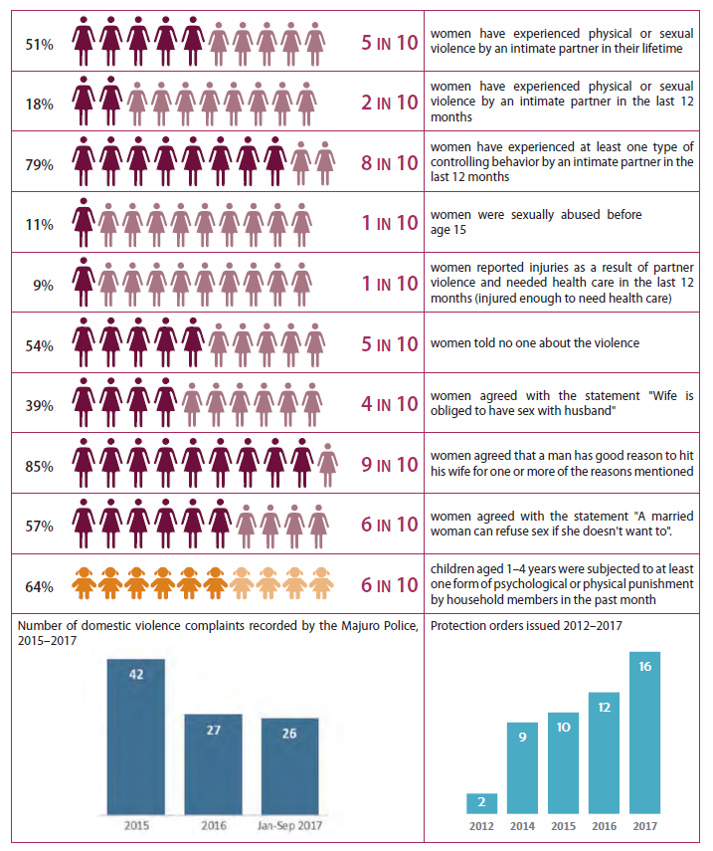
The following Figure illustrates statistics on Gender Based Violence in RMI
WUTMI (Women United Together Marshall Islands), a non-governmental organization formed to advance women’s rights, has long advocated for victims of domestic violence and has conducted a number of programs to change public attitudes.
WUTMI Weto in Mour: Violence Against Women and Girls Support Service (WIM), which is co-funded by the government and donor partners, ensures that survivors are accommodated in safety, have basic necessities and are provided with transport fares to enable them to attend their appointments with Micronesian Legal Services and with WIM for psychosocial support.
The Domestic Violence Prevention and Protection Act (DVPPA) provides for a temporary protection order if the judge is satisfied that a complainant, or a child in the care of a complainant, is in danger from an act of domestic violence. A judge is available 24/7 to consider protection order applications, with no filing fees charged.
For the purposes of this Project, any Grievance raised in respect of GBV will be immediately referred to WIM. Conversely, WIM will inform the CIU of any grievances they receive relating to GBV that may be project-related.

PROJECT ACTIVITIES
In summary the Project involves the following broad description of activities (all subject to confirmation during Project implementation):
Subcomponent 1.1. Prevention and Surveillance
Prevention and communication:
- Financial support -population-based prevention efforts - communication, behavior change, containment measures, and physical (social) distancing.
- Working with other partners such as IOM, UNICEF and WHO.
- Messaging - mental health and socio-emotional support (for public and health providers), healthy conflict resolution, healthy parenting, stress and anger management in community and other awareness campaigns; information on GBV-related services during periods of physical distancing.
- Finance development, coordination, and deployment of contextually relevant containment and physical distancing strategies.
- As needed, the subcomponent can finance enhanced shielding for vulnerable populations.
Epidemiological surveillance and control:
- Finance strengthening of core epidemiological functions to respond to COVID-19 and future public health emergencies.
- Will not introduce new surveillance systems unless specifically requested by the MOHHS; instead, it will strengthen use, connectivity, and interoperability of existing systems and processes.
- Epidemiologist technical assistance will be deployed to support the MOHHS to prepare and operationalize disease investigation, case detection, and contact tracing protocols.
- Additional surveillance officers or IT specialists may be supported, as necessary.
- Financing will be provided to train the human resources across sectors in these protocols and expand the workforce to implement case detection and contact tracing.
- Finance consultant lab staff for Majuro and Ebeye laboratories, laboratory reagents and consumables, and relevant operational and logistics costs.
- May also support the costs of minor laboratory facility upgrading and emerging [appropriate] diagnostics.
- Support for strengthening communications, interoperability, disease recording and reporting capacities in the short and medium term: technical assistance, training and capacity building; information management and reporting systems upgrades (for example, introduction of the laboratory information system module of the RMI’s health information platform on Ebeye; and small ICT hardware as requested by the Government.
- May also finance community engagement in disease surveillance and early warning systems, as necessary. Any personal data collected under the project will be handled according to the details set forth in the project operations manual.
Subcomponent 1.2. Strengthening health service delivery to respond to COVID-19
Enhanced clinical care capacity:
- Finance the costs of equipping health facilities on Majuro and Ebeye to manage COVID-19 cases and sustain routine health service delivery through:
(a) clinical surge support to add provider capacity;
b) trainings, coaching, and backstopping (on-site or virtual) for existing and surge health professionals; and
(c) procurement of medical equipment, commodities, and supplies for COVID-19 case management.
- Finance the incremental transportation and logistics costs as agreed with the World Bank for pharmaceuticals, equipment, medical referrals, and so on. to minimize the COVID-19 related disruptions to health service delivery.
Infection Prevention and Control (IPC)
- IPC technical assistance;
- appropriately targeted risk communication and IPC training and monitoring for frontline workers across sectors (including international ports of entry, rapid response team, school system) and health providers;
- supplies and consumables (PPE, IPC consumables, hand sanitizer);
- minor facility refurbishment or upgrading to enhance IPC in health facilities (handwashing, ventilation) and/or PPE storage facilities to ensure adherence to agreed minimum standards; and
- minor health care waste management system upgrading (as necessary).
- PIHOA will provide technical assistance to the MOHHS to conduct a needs assessment and procure equipment and supply commodities aligned with needs, health system and service delivery capacity, and storage ability; where possible, goods will be procured through a United Nations (UN) agency, with Bank Facilitated Procurement (details below), or with endorsement of specifications through Centre for Disease Control (CDC), U.S. Food and Drug Administration, or other normative body to support quality assurance. Technical assistance will be provided to assist with monitoring, recording, and reporting of inventories.
Component 2: Implementation Management and Monitoring and Evaluation (M&E)
Project Management:
- Support the MOHHS and the NDMO in emergency response management, coordination and communication across sectors and stakeholders, including the RMI Ports Authority, Marshall Islands Marine Resource Association, Public Schools System and other stakeholders.
- Support operating costs (including fuel, transport, among others) of the MOHHS and the NDMO, and relevant clusters, as deemed necessary, for the COVID-19 emergency response activities.
- Will finance technical assistance to develop and revise policies, strategies, and guidelines for a multisectoral health response, strengthen management processes and as required provide secretariat support to the NDMO and its clusters (particularly the health cluster).
- The component will finance consultant support (administrative, fiduciary, environmental, social, and procurement as needed). It will finance the project’s financial audit as well as a third-party audit of the anti-corruption mitigation measures and procedures.
- It will also support coordination and professional development activities in the form of meetings, trainings, workshops, and the RMI participation in Pacific regional and other international forums and platforms.
M&E:
- Support M&E of the RMI’s prevention and preparedness activities, building capacity for data use, and joint-learning within the RMI and across PICs (as outlined in learning agenda earlier).
- Support training in participatory M&E across the NDC stakeholders and administrative levels.

Table 5.3 Specific procurements envisaged for the Project
Contracts -Agency
PIHOA Contract [See Note 1]
Contracts - Personnel
Nurses at Ebeye (2)
Project Administrator 2 year contract
Pre-position of nurses (18) in Fiji
Equipment Purchase
PPE/Equipment/Medications
HEPA Filters
Portable X-ray
Laboratory Rehabilitation Works
“Minor laboratory facility upgrading”.
Support
CIU support
Logistics -fuel, transportation.
Note 1: The Pacific Island Health Officers Association (PIHOA) is a non-profit organization, established in 1986. PIHOA is led by and represents the collective interests of the Ministers, Secretaries, and Directors of Health of the U.S.-Affiliated Pacific Islands (USAPI) of American Samoa, Guam, Northern Mariana Islands, FSM, RMI, and Palau. PIHOA provides a collective voice for Pacific health advocacy and regional policymaking, and supports partnership engagement and provision of technical assistance to USAPI health departments and ministries.

POTENTIAL ENVIRONMENT AND SOCIAL RISKS AND MITIGATION

Summary
No major civil works are required. The Project may fund minor renovations and upgrades to existing laboratories and health care facilities such as plumbing, interior fit-outs, and information technology (IT) hardware. There is no requirement for the use of additional land, and works will be limited to within existing building footprint.
The following activities may have environmental and social risks and impacts that require mitigation:
- Management of hospital waste that may also be infectious and / or hazardous, requiring landfilling and / or incineration;
- Waste management upgrades may include improving waste handling and storage procedures at the source of waste, waste transportation procedures and ensuring the incinerators are operational through the duration of the project;
- The purchase of medical equipment, personal protective equipment, pharmaceuticals, chemical and / or biological reagents and other supplies, that may require specific management, training, use and disposal; and
- The use of direct workers, contracted workers and potentially community workers.
The main environmental risks identified are:
- the occupational health and safety issues related to the use of supplies and the possibility that they are not safely used by laboratory technicians and medical staff;
- the occupational health and safety (OHS) issues for Project workers related to the treatment of COVID-19 patients (if an outbreak were to occur); and
- medical waste management and community health and safety issues related to the handling, transportation and disposal of hazardous and infectious healthcare waste.
While some social risks and impacts are substantial, they are considered temporary, predictable, and readily managed through Project design features and mitigation measures. No land acquisition or involuntary resettlement impacts are expected.
A key social risk is the potential for inequitable access to Project-supported facilities and services particularly for vulnerable and high-risk social groups (poor, disabled, elderly, isolated groups). To mitigate these risks MOHHS has committed to the provision of services and supplies to all people, regardless of their social status, based on the urgency of the need, in line with the latest data related to the prevalence of the cases, and the implementation of WHO guidance tools for COVID-19 risk communication and engagement.
The MOHHS has committed to assessing the risks of GBV, SEA/SH and implementing mitigation measures to protect and support the workforce and population interacting with the Project workforce.
While supporting the protection of health of communities from infection with COVID-19 is a central part of the project, without adequate controls and procedures, project activities ranging from medical facility operation through to on-ground public engagement exercises have the potential to contribute to virus transmission and other community health and safety issues. Some project activities also present increased health and safety risks for project workers, particularly those working in medical and laboratory facilities.

Evaluation of Eligible Activities
Table 7.1 describes in general terms the potential environment and social risks of the types of eligible activities that will be supported by the Project.
Table 7.1 Potential environment and social impacts of the types of activities that will be supported by the Project
Eligible Activities | Associated Environmental and Social Risks | Mitigation Measures, Auditing and Monitoring
Minor renovations to existing health care facilities.  Plumbing, electrical, interior fit outs, information technology (IT) hardware installations, storage facilities, washrooms.  All works will be confined to existing facilities. No new facilities or extension to facilities are proposed; works will be within existing building footprint.  No new land is required. | There are low to moderate risks due to the small scale and temporary nature of works:  OSH risks relating to contractor workforce (electrocutions, slips/trips/falls, working at heights, noise, dust, asbestos dust, exposure to COVID-19 or other infectious diseases)  Community health and safety risks relating to renovations within a working health care facility (noise, dust, slips/trips/falls, loss of running water or power, asbestos dust) and privacy of patients and visitors from the workforce.  Minor amounts of renovation waste generated that could be dumped rather than transported to landfill, creating littering and pollution risks.  ESS4 states that “where technically and financially feasible, the Borrower will also apply the concept of universal access to the design and construction of such new buildings and structures.”  (Risks relating to workforce rights and grievances are discussed below). | Contractor procurement and contract management follows LMP and the requirements of the ESMF.  Contractor required to prepare and implement OHS plan to protect workers and bystanders (health care workers, patients, visitors).  Contractor to follow Covid-19, waste management and other MOHHS protocols while working in health care facilities.  Contractors to remove all waste for recycling or disposal using hospital waste collection systems or their own, to Majuro or Ebeye landfill.  Asbestos screening prior to any works starting. Asbestos protocols to be prepared and implemented if necessary.  In respect of Universal Access, in the case of limited works third-party life and fire safety (L&FS) should be aligned with local legal requirements. This will be the case with the proposed laboratory upgrades.  Works with moderate or substantial risks will require a project-specific ESMP.  CIU will conduct verification audits.
Procurement, delivery, storage of non-hazardous goods.  Pharmaceuticals, PPE and medical equipment.  The US Department of Defense may be used for logistics. | No risk for non-hazardous goods transported by NGOs and private sector.  Low risk to community health and safety from the use of military personnel, since they are unlikely to interact with the public or be deployed for security purposes and they already have a long-standing relationship with and presence in RMI. | Procurement agreements to include relevant environmental and social risk assessment and management measures consistent with this ESMF and the ESF.  Maintain existing RMI importation protocols to avoid risk of contamination on entry.  Annex III Protocol regarding use of Military Forces to be followed and all risk mitigation measures put in place prior to deployment of the US Department of Defense.  CIU to conduct audits.
Procurement, delivery, storage of hazardous goods.  Biohazards, toxic, flammable etc. | Low to moderate risk of spills or physical harm to workers from inappropriate labeling, handling, containment or storage. | Specific ESHS risks to be screened during the procurement phase and specific labelling, transportation, handing and storage requirements included in procurement and transportation agreements.  Maintain existing RMI importation protocols to avoid risk of contamination on entry and gap fill where required.  CIU to conduct audits.
PPE and equipment use.  Could be distributed to any health care facility in RMI and used by any health care worker, including direct workers, contracted workers and MOHHS staff. | Low to substantial risk of infection of health care workers and public from inappropriate handling of equipment and use of PPE in the treatment and care of COVID-19 patients. | MOHHS Infection Prevention and Control Protocol on COVID-19 be followed.  Training for workers – provided by MOHHS or PIHOA.  Project grievance mechanism and Project labor grievance mechanism to be used (which both use MOHHS grievance/complaints processes).  Equipment to be screened for risks and additional health and safety mitigation measures implemented prior to use, including training.  CIU to conduct audits.
PPE, equipment and other medical waste recycling, disposal and incineration.  Waste may be generated in any health care facility in RMI.  Non-hazardous waste is transported to Majuro and Ebeye landfills for disposal.  Hazardous / infectious waste is transported to incinerator on Majuro or Ebeye for incineration.  Improvements to waste avoidance, handling, storage, transportation, landfilling procedures or incinerator operations. | Low to substantial risks of infection and other harm of health care workers and waste care workers from inappropriate management of infectious, sharps and hazardous waste.  Low to moderate risk of contributing large volumes of waste to existing unsanitary landfills on Ebeye and Majuro, taking up valuable space.  Low to moderate risks of contributing additional discharges to air of contaminants from incinerators and contaminated ash.  Low to moderate risk of outer island waste being burnt or ‘dumped’ in outer islands causing local air, land and water pollution. | MOHHS Infection Prevention and Control Protocol on COVID-19.  MOHHS HCWM COVID19 Quarantine Site and COVID Isolation Ward - Waste Management Policy draft.  Training for workers – provided by MOHHS under separate funding.  Project grievance mechanism and Project labor grievance mechanism to be used (which both use MOHHS grievance/complaints processes).  All other special waste types identified during the project will be screened and, if necessary, additional procedures developed prior to work starting.  CIU to conduct audits of health-related waste management operations in both Majuro and Ebeye..
Technical advisory to support epidemiological surveillance and control, infection prevention and control, and emergency response.  Strengthening existing MOHHS initiatives for epidemiological surveillance and control and infection prevention and control.  Support for strengthening information technology for information management, recording and reporting.  Develop and revise policies, strategies, and guidelines for a multi-sectoral health response, strengthen management processes and as required provide secretariat support to the NDMO and its clusters (particularly the health cluster).  Training and other capacity building activities. | Overall benefit to health care workers and community from improved epidemiological surveillance and control in health care facilities and in the community, improved infection prevention and control, improved information management and improved emergency response procedures in future.  Low risk of technical advisory services not adequately addressing the specific needs of women or vulnerable people, such as those with underlying health conditions, elderly, remote communities, youth.  Low risk of private data being shared without consent.  (Risks relating to technical advisory workforce are discussed below). | All technical advisory Terms of Reference will be screened for environmental and social risks and specific clauses will be included for the consultant or contractor to avoid or mitigate risks.  MOHHS Infection Prevention and Control Protocol on COVID-19 will be used and enhanced with WHO guidance and other forms of Good International Industry Practice.  Personal data management protocols will be prepared prior to any works starting.  CIU will undertake due diligence audits of TOR and technical advisory activities and outputs.
Recruitment, training and management of direct and contracted workers.  For example:  Project Administrator  Support staff  Nurses  Laboratory staff  Technical assistance consultants  IT specialists  Building contractors  PIHOA (third party contracted workers – may provide technical advisory, support staff, surveillance, IT specialists, health care workers, trainers) | Low to substantial risk of infection of health care workers and public from inappropriate handling of equipment and use of PPE in the treatment and care of COVID-19 patients.  Low to substantial risk of other occupational health and safety incidents from working in health care facilities and travel between islands.  Low to substantial risk of migrant workers introducing COVID-19 into RMI.  No risk of child or forced labor.  Low to moderate risk of complaints and grievances relating to worker rights and conditions. | LMP provisions will apply to persons directly recruited to the project and to contracted workers contracted via third parties such as PIHOA and building contractors.  All PIHOA contracts have a grievance and legal arbitration mechanism in place per US federal and Hawaii state requirements.  Personnel entering RMI under PIHOA will be subject to quarantine requirements as stipulated by the Secretary of Health.  All direct and contracted workers working in health care facilities will be subject to MOHHS Infection Prevention and Control Protocol on COVID-19.  CIU to conduct audits.
Government workers working in connection with the project.  e.g. DIDA, CIU, MOHHS staff (not funded by the project, but contributing to the project activities and outputs) | Low to substantial risk of infection of health care workers and public from inappropriate handling of equipment and use of PPE in the treatment and care of COVID-19 patients.  Low to substantial risk of other occupational health and safety incidents from working in health care facilities and travel between islands.  No risk of forced labor.  Low risk of children aged between the ages of 15 and 18 working in hazardous work places (such as health care facilities treating COVID-19 patients). | All government workers working in connection with the project will be subject to MOHHS Infection Prevention and Control Protocol on COVID-19.  LMP to be followed to ensure no children between the ages of 15-18 working in hazardous work places.  CIU to conduct audits.
Community engagement and communications  Support for messaging, communications and engagement activities relating to the RMI COVID-19 response carried out by MOHHS, IOM, UNICEF, WHO, PIHOA and other agencies working with RMI government.  Activities may include media and face-to-face communications. Broad awareness campaigns, targeted messaging to specific groups.  Messaging related to communication, behavior change, containment measures, and physical (social) distancing, mental health and socio-emotional support (for public and health providers), healthy conflict resolution, healthy parenting, stress and anger management in community and other awareness campaigns; information on GBV-related services during periods of physical distancing. | Overall social benefits expected from supporting communications and engagement activities.  Low risk that vulnerable people are poorly targeted and miss out on relevant messaging. This could lead to missing out on critical support during the pandemic, such as health care, social services and support, GBV and SEA/SH support services. Poor messaging and outreach can impact on the rates of infection in the community.  ESMF consultation has identified a gap in the coverage of the RCCP. There is no private sector involvement, particularly in regard to food suppliers such as supermarkets and other food outlets.  WHO Guidance explicitly states that “competent authorities should provide advice for food businesses regarding prevention of possible transmission of SARS-CoV-2 in the food chain and how to protect the workers”. Consultation to date indicates that RMI private sector food businesses consider they are not sufficiently involved in COVID-19 response planning. This presents a potentially moderate to substantial social risk given the importance of the private sector in continuing to supply food to the community. | The RMI “COVID-19 Risk Communication and Community Outreach Plan March 31, 2020”, which sets out the NDC’s risk communication and community engagement team established to coordinate all aspects of community outreach and communications for Marshall Islands, will be followed.  The project SEP will be used to fill gaps in the methods and messaging to meet ESMF and ESF requirements.

PROCEDURES FOR NEW ACTIVITIES
Given the limited nature of activities associated with the Project most activities will have been addressed above with mitigation measures relating to existing MOHHS protocols and the Environmental and Social Management Plan (ESMP) (Annex VI), LMP and SEP. Project activities will be subject to screening by CIU Safeguards Team as set out in Annex IV. In broad terms the process to address environmental and social issues for new Project-related activities covers the following considerations:
- Screening of potential Project-related E&S issues and classifying its risk levels (Annex IV). CIU safeguards specialists will regularly meet with the Project Director/Administrator to identify upcoming work packages/activities, screen risks and advise on the use of instruments;
- Project workers will follow/implement the LMP, SEP, ESMP and MOHHS protocols where relevant;
- Where screening identifies a new instrument is required, the CIU Safeguards Specialists will draft the new instrument with technical support from MOHHS;
- Consultation and disclosure of activities-specific E&S instruments by the CIU Safeguards Specialists (with review and approval by MOHHS) prior to works starting;
- Review and approval of activity-specific E&S instruments by the World Bank Task Team; and
- Implementation and monitoring of activity-specific E&S instruments.

STAKEHOLDER ENGAGEMENT

Stakeholder Engagement Plan
The Stakeholder Engagement Plan (SEP) is developed as a stand-alone document. The Grievance Mechanism set out in this ESMF is adopted in the SEP.
The main objective of the stand-alone Stakeholder Engagement Plan (SEP) [included here for reference as Annex V] is to define a program for stakeholder engagement, including public information disclosure and consultation, throughout the entire project cycle. It also outlines a communication strategy with the project stakeholders, and offers mechanisms for them to raise concerns, provide feedback, or make complaints about project.

In general, stakeholders are categorized as affected or interested:

Affected Parties include local communities, community members and other parties who may be subject to direct impacts from the Project. Specifically, the following individuals and groups fall within this category:
- COVID19 infected people (currently none identified in RMI)
- Communities (i.e. religions, race, gender) of COVID19 infected people
- Family members of COVID19 infected people
- People at COVID19 risks (travelers, inhabitants of areas where cases have been identified, etc.)
- Communities close to laboratories, hospitals
- Workers at construction sites of laboratories
- Waste disposal workers
- MOHHS staff
- Nurses and other medical specialists/personnel engaged on the Project
- Other public officials who may be directly working on the project

Interested Parties. The projects’ stakeholders also include parties other than the directly affected communities, including:
- Donors, CSOs who may be actively working in public health and/or service provision
- Traditional media (newspaper, radio)
- Participants of social media
- Other public sector administrations concerned about economic or development impacts of coronavirus outbreak
- Politicians
- National and international health organizations
- National and international non-governmental organizations (NGOs);
- Businesses with international links;
- Private sector operators in RMI, particularly food sector operators; and
- The public at large.

Vulnerable or disadvantaged groups may include and are not limited to the following:
- The elderly
- Individuals with pre-existing medical conditions such as pulmonary or heart disease, diabetes, people with comprised immune systems, cancer patients, among others
- Mentally or physically disabled
- Illiterate people
- Female head of households
- Victims or potential victims of Gender Based Violence (GBV), Sexual Exploitation, Abuse and Harassment (SEA/SH)
- Vulnerable groups working in informal economy
- People living in remote geographic areas with limited health services or access to information

Consultations during Project Preparation
Initial consultations were held with relevant MOHHS staff in March 2020 to inform them of the Project as well as to seek their feedback. Consultations were conducted remotely by phone and email. Immediately before and after the Project effective date consultations were held with NDMO staff and MOHHS staff, to discuss Project elements and determine existing initiatives which could be adopted within the Project engagement. In addition, consultations were held with private sector operators in RMI.

Parties consulted during preparation of the ESMF indicated that one overarching consideration should be that the Project should avoid adding to existing work burdens wherever possible as all stakeholders are currently very overloaded on COVID-19 response activities. Accordingly, the approach set in the SEP is intended to integrate with existing RMI COVID-19 initiatives.

COVID-19 Communications
RMI has a coordinated communication strategy for COVIDd-19, the COVID-19 Risk Communication and Community Outreach Plan’, prepared under the direction of the Marshall Islands National Disasters Committee. The Risk Communication and Community Engagement (RCCE) team established under the Plan comprises a range of government agency, state-owned enterprises, international agency and NGO representatives, which provides a good coverage of all public sector stakeholders interests such as government departments, IOM, WHO, Marshall Islands Red Cross Society, community organizations..
This plan has been developed in alignment the national COVID-19 response plan, for each of the various stages of the response.

The MOHHS and NDMO have been regularly communicating to the public via their websites and Facebook pages sinc:
https://ndmo.gov.mh/
https://www.facebook.com/RMINDMO/
https://www.facebook.com/rmimoh
Information shared includes: travel advisories, COVID-19 situational reports (live recordings and written updates) and every Tuesday and Thursday MOHHS gives live broadcasts to the radio station V7AB and MOHHS Facebook page with the Health Minister. MOHHS staff provide responses to comments posted on Facebook from the public.
A hotline has been set up (refer to the GM below).

Consultations During Project Implementation
Consultations and information disclosure will be an ongoing process of Project implementation. These consultations will be made with project affected/interested stakeholders using existing RMI COVID-19 initiatives – any public consultations will be channeled via the COVID-19 Risk Communication and Community Outreach Plan [Annex VIII], which sets out procedures for coordinated public communications regarding COVID-19 initiatives in RMI.

Parties consulted during preparation of the ESMF indicated that one overarching consideration should be that the Project should avoid adding to existing work burdens wherever possible as all stakeholders are currently very overloaded on COVID-19 response activities. Accordingly the approach set in the SEP is intended to integrate with existing RMI COVID-19 initiatives.

GRIEVANCE MECHANISM

Introduction
In contrast to other World Bank-funded projects in RMI which have clearly-delineated location and scale, funding for the RMI COVID-19 Emergency Response Project is directed to MOHHS for procurement of a range of goods and services. To any outside observer, it won’t be obvious whether any particular RMI COVID-19 initiative is a Project-funded activity vs some other donor-funded activity. Therefore, the GM has been designed to reflect the realities that a complaint could come from any direction and is likely to be received by front line health workers or anyone else involved with RMI’s COVID-19 response.
From a Project perspective the key issue is how grievances or complaints can be attributed to the Project or whether they should be dealt with under some other general MOHHS complaints process.
The procedure set out below utilizes existing RMI COVID-19 public engagement procedures and the first line of collecting potential Project-related grievances/complaints. After receipt at a central MOHHS node, grievances/complaints will be assessed by CIU to determine if they relate to the Project, and if so, how they will be dealt with.

Procedure
MOHHS has established a widely advertised COVID-19 feedback mechanism, which includes a (i) 24hr hotline, (ii) email address and (iii) facebook page as illustrated below.
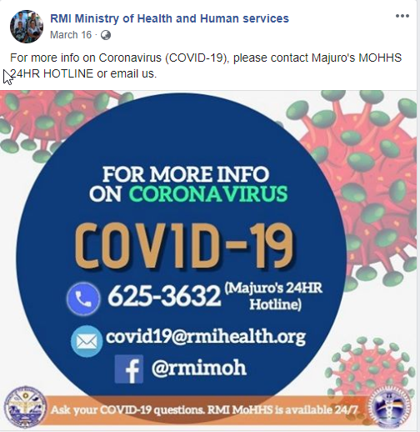
The Hotline is managed by the MOHHS Surveillance Team. If no one is available, the call goes to a group line which includes doctors for answering (including secretary). All calls are logged. Patient information is sent to clinical teams; if the call is NDC-related it is forwarded to NDC.
Follow-up and response is the responsibility of the MOHHS surveillance Team.
For the purposes of Project feedback, the CIU Safeguards Team will screen hotline feedback on a weekly basis to assess whether it relates to the Project. If so, the following template will to be used for recording Project-related grievance complaints. Each incident is to be recorded and the forms filed appropriately by the CIU Safeguards Advisor.
Following this CIU personnel will follow up with grievances received; if a grievance cannot be resolved within 10 days it will be referred to the Project director for resolution within a further 10 days, and then if still not resolved it will be referred to the Steering committee. Ultimately if a grievance cannot be resolved by the Steering Committee, the aggrieved party will have recourse to the RMI legal system.
Hotline information and information received by Project personnel in any other way, which raises concerns about GBV, SEA and Violence Against Children (VAC), will be immediately referred to the WUTMI Weto in Mour: Violence Against Women and Girls Support Service (WIM). Conversely, any information provided by WUTMI WIM to the Project Administrator, Director or CIU regarding a GBV, SEA/SH or VAC grievance, will be recorded by the Project as a grievance and support will be provided, as necessary to WUTMI WIM to support the survivor(s).

GRIEVANCE REPORT FORM

 | Grievance Information: Summarize Details
 | Name of Complainant (or anonymous), and gender |  | Employee ID (If  Employee) |  | Telephone  Email
Date of Complaint |  | Date of 2 week deadline for resolution or escalation: |  | Actual date of close out:
 | Date, time, and location of Event leading to Grievance:
 | Detailed account of Grievance (Include names of persons involved) if known:
 | Are there any policies, procedures, guidelines that may have been violated:
 | Proposed solution or sought remedy:
 | Outcome of Grievance:
Date and Signature of Entry into Record:

Date and Signature of Close-out:

INSTITUTIONAL ARRANGEMENTS, RESPONSIBILITIES AND CAPACITY BUILDING

Institutional Arrangements
The Implementing Agency is MOHHS. A PIU will not be established.
MOHHS will nominate a Project Manager/Project Administrator to ensure that project implementation is expedited through involvement of government officials at the decision-making level given the emergency needs. PIHOA will contract the project administration consultant, as well as additional technical personnel to support MOHHS departments and units in project implementation.
The Project Manager/Administrator will be supported by the Central Implementation Unit (CIU) in MOF, as required, to carry out safeguards and fiduciary functions associated with project implementation. Although the CIU is not currently a formally established entity, MOF maintains essential expertise in WB financial management, safeguards, and procurement procedures within the CIU to provide implementation support for donor financed project.
The National Disaster Committee (NDC), chaired by the Chief Secretary (National Disaster Controller, or NDC-CS) will serve as the project steering committee. NDC will provide the oversight and guidance for project implementation.

E&S Risk Management Responsibilities
In regard to E&S risk management the following responsibilities arise:
- MOHHS operational responsibility for infection control and waste management processes.
- MOHHS to ensure adequate and qualified staff are in place, including those in charge of infection control and biosafety
- CONTRACTOR responsible for waste collection, transport and incineration.
- MANAGERS of each health care facility to take overall responsibility for infection control and waste management, with involvement of relevant departments to manage, coordinate and regularly review the issues and performance;
- MOHHS to maintain existing information management system to track and record the waste streams; and
- MOHHS with CIU support as necessary, to provide appropriate capacity building and training for medical workers, waste management workers and cleaners. Third-party waste management service providers to be provided with relevant awareness as well.

Awareness Raising and Capacity Building
MOHHS and PIHOA staff responsible for the COVID-19 Emergency Response do not have any prior experience of implementing World Bank Environmental and Social Framework. Key MOHHS and PIHOA personnel will need to know requirements to comply with the ESMF and LMP when they work on specific Project-funded activities or aspects.
The CIU safeguards team will conduct awareness raising via video conferencing and in person with relevant staff to explain the ESMF and other instruments, the roles and responsibilities, the expectations for the implementation of the RMI Infection Prevention and Control Guides, Training will include specific procedures for receiving and managing complaints and grievances in accordance with the Grievance Mechanism.
This training will be provided within 30 days of the clearance of the ESMF and prior to any deployment of goods funded by the Project and will be repeated as required.
Training on COVID-19 infection control, use of PPE, etc. will be delivered to the health sector by trained professionals. The CIU safeguards team will monitor the implementation of this training and its relevance to the compliance with the ESMF.

AUDITING
The CIU safeguards team are responsible for ensuring MOHHS comply with the ESCP and all environmental and social risk management instruments. This will be done by supporting MOHHS to implement the instruments, undertaking screening under the ESMF, providing awareness raising and capacity building as discussed above, and conducting random and planned audits of various activities.
Random audits will be conducted on procurement, within health care facilities and waste management to determine the compliance with the ESMF, MOHHS Infection Prevention and Control Protocol on COVID-19, MOHHS HCWM COVID19 Quarantine Site and COVID Isolation Ward - Waste Management Policy draft and other instruments.
Weekly checks of the grievance mechanism records will be carried out. Audits may be carried out on any active or closed grievances to make assurances that the ESCP, Project GMs and ESF have been complied with.
Regular audits of any minor building works will be carried out to ensure the Contractor is following all ESHS practices.
Audits will be recorded and reported. Any improvements or non-compliances will be reported to the Project Director, Administrator and relevant MOHHS staff for action. Audits will identify any improvements required to instruments and will identify any requirements for ongoing monitoring, supervision or additional training / awareness raising.

ANNEXES
Annex I: Abbreviations and Acronyms
Annex II: References
Annex III: Protocol on Use of Military Forces to Assist in COVID-19 Operations
Annex IV: Screening of Potential Environment and Social Issues
Annex V: Stakeholder Engagement Plan
Annex VI: Environmental and Social Management Plan
Annex VII: Infection Prevention and Control Protocol
Annex VIII RMI COVID-19 Risk Communication and Community Outreach Plan March 31, 2020
Annex IX HCWM COVID19 Quarantine Site and COVID Isolation Ward - Waste Management Policy draft

Annex I: Abbreviations and Acronyms
CDC | Centre for Disease Control (US)
CIU | Centralized Implementation Unit of DIDA
DIDA | Division of International Development Assistance
DVPPA | Domestic Violence Prevention and Protection Act
E&S | Environmental and social
EHS Guidelines | World Bank Group Environmental, Health and Safety Guidelines
EPA | Environmental Protection Authority
ESCP | Environmental and Social Commitment Plan
ESF | World Bank’s Environmental and Social Framework
ESHS | Environmental, Social, Health and Safety
ESMF | Environmental and Social Management Framework
ESMP | Environmental and Social Management Plan
ESS | World Bank Environmental and Social Standards
GBV | Gender Based Violence
GM | Grievance Mechanism
GoRMI | Government of the Republic of the Marshall Islands
ILO | International Labor Organization
IPC | Infection Prevention and Control
IPC&WMP | Infection Prevention and Control and Waste Management
IT | information technology
LMP | Labor Management Procedure
M&E | Monitoring and Evaluation
MIMRA | Marshall Islands Marine Resources Authority
MOHHS | RMI Ministry of Health and Human Services
NDC | National Disaster Committee
NEPA | National Environmental Protection Act 1984
NGO | Non-governmental organization(s)
NTA | National Telecommunications Authority
OHS | Occupational Health and Safety
OI | Outer Islands
PHEOP | RMI Public Health Emergency Operations Plan
PIHOA | Pacific Islands Health Officers Association
PPE | Personal protective equipment
PSC | Public Service Commission
RMI | Republic of the Marshall Islands
SEA | Sexual Exploitation and Abuse
SEP | Stakeholder Engagement Plan
SH | Sexual Harassment
SPC | The Pacific Community
TB | Tuberculosis
UNOPS | United Nations Operation for Project Services
US | United States of America
VAC | Violence Against Children
WB | World Bank
WHO | World Health Organisation
WIM | WUTMI Weto in Mour: Violence Against Women and Girls Support Service
WUTMI | Women United Together Marshall Islands

Annex II: References
Available at: Dropbox link to view cited ESMF documents
MOHHS Hospital Waste Management Status Report 13 April 2020
MOHHS Majuro Radiology Service Operations
MOHHS Protocol according to location for COVID-19

Annexed to this ESMF
MOHHS Infection Prevention and Control Guide to Protocol on COVID-19 update 2 [see Annex VII]
MOHHS RMI COVID-19 Risk Communication and Community Outreach Plan [See Annex VIII]
MOHHS HCWM COVID19 Quarantine Site and COVID Isolation Ward - Waste Management Policy draft [ Annex IX]

Annex III Protocol regarding Use of Military Forces to Assist in RMI COVID-19 Response Project
Introduction
The US Department of Defense may be used for the transportation logistics for goods and equipment to and within the Marshall Islands in preparation for, or in response to, a COVID-19 outbreak. There is no intention to use the Department of Defense for security purposes or humanitarian aid. The US DoD has a base in the Marshall Islands (Kwajalein) and a long-standing relationship with the Marshall Islands government.
The World Bank ESF, and ESS4 specifically, identifies the use of security personnel as a potential risk to community safety. ESS4 risk assessment is primarily related to personnel providing security services rather than the role of logistical support. In any case, the ESF and the World Bank Good Practice Note for Assessing and Managing the Impacts of the Use of Security Personnel, and the World Bank Technical Note: Use of Military Forces to Assist in COVID-19 Operations have been used to develop this protocol, along with the legal agreement and environmental and social commitment plan for the Project.
RMI COVID-19 Response Project Legal Agreement.
Section IV of the Financial agreement for the World Bank RMI COVID-19 Response Project (the Project) sets out as follows in respect of undertakings in regard to assistance from military or security forces.
Section IV. Other Undertakings
1. In the event that the Recipient intends to engage a military or security force to assist with the implementation of the Project, the following conditions shall be met prior to any such engagement:
a) the Recipient has:
i. furnished to the Association a written request setting forth details of the proposed engagement and roles and responsibilities of the military or security force and any other relevant parties, and has provided any information to the Association that the Association may request with respect to such proposed engagement, all to the satisfaction of the Association; and
ii. the Association has agreed to such request and notified the Recipient thereof;
b) the Recipient has ensured that appropriate legal arrangements and risk mitigation measures for said engagement have been put in place for the purposes of the Project, in a form, substance and manner satisfactory to the Association; and
c) the Recipient has ensured the preparation and disclosure of the ESCP and all environmental and social instruments, and/or an update to any such instruments, as may be required for said engagement in accordance with the provisions of Section I.D of this Schedule 2, the Association has approved all said instruments, and the Recipient has ensured the implementation of any actions which are required to be taken under said instruments.
2. The Recipient shall ensure that no Financing proceeds shall be used for any activities or expenditures related to law enforcement, security, or military purposes, and unless the Association agreed otherwise in writing, no Financing proceeds shall be used for any expenditures incurred by military or security forces.
Accordingly, this protocol sets out the explicit steps to be followed if RMI intends to engage a military or security force to assist with the implementation of the Project. These measures will all need to be undertaken in a manner consistent with the Environmental and Social Commitment Plan (ESCP):
PROJECT PROTOCOL TO ADDRESS RISKS
If the RMI Government intends to engage a military or security force to assist with the implementation of the Project:
- MOHHS (or CIU) shall prepare a written request for the World Bank setting out details of the proposed engagement and roles and responsibilities of the military or security force and any other relevant parties
- MOHHS (or CIU) shall provide any further information that the World Bank may request with respect to such proposed engagement to the satisfaction of the Association
- MOHHS (or CIU) to prepare appropriate legal arrangements for said engagement.
- CIU to undertake a security risk assessment, referring to ESS4 and World Bank guidance on the use of military personnel, and develop risk mitigation measures for said engagement. Note: Risk relates to likely activities associated with moving goods around – there will be no contact with the public.
- MOHHS (or CIU) to send details of legal arrangements and risk mitigation measures to the World Bank for approval.
- CIU to confirm the preparation update and disclosure of the ESCP and all environmental and social instruments, and/or an update to any such instruments, as may be required for said engagement; that the Association has approved all said instruments, and that MOHHS has ensured the implementation of any actions which are required to be taken under said instruments.
- MOHHS shall confirm in writing to the World Bank that no Financing proceeds shall be used for any activities or expenditures related to law enforcement, security, or military purposes, and unless the World Bank has agreed otherwise in writing, no Financing proceeds shall be used for any expenditures incurred by military or security forces.
- Military deployment will occur only when all relevant approvals have been received and risk management measures are in place.

Annex IV: Screening of Potential Environment and Social Issues
Annex IV Screening Form for Potential Environmental and Social Issues
This form is to be used by the Centralized Implementation Unit (CIU) to screen for the potential environmental and social risks and impacts of a proposed activity. It will help the CIU in identifying the relevant Environmental and Social Standards (ESS), establishing an appropriate E&S risk rating for these activities and specifying the type of environmental and social assessment required, including specific instruments/plans. Use of this form will allow the CIU to form an initial view of the potential risks and impacts of an activity. It is not a substitute for project-specific E&S assessments or specific mitigation plans.
A note on Considerations and Tools for E&S Screening and Risk Rating is included in this Annex to assist the process.
Activity Name
Activity Location
Activity Proponent
Estimated Investment
Start/Completion Date

Questions | Answer |  | ESS relevance | Due diligence / Actions
Questions | Yes | no | ESS relevance | Due diligence / Actions
Is the activity in the Prohibited Activities List in Table A2 |  |  | If Yes do not proceed as activity is not part of this Project | If Yes do not proceed as activity is not part of this Project
Does the activity involve civil works including upgrading or rehabilitation of healthcare facilities? |  |  | ESS1 | Use the mitigation measures in the ESMF/ESMP, SEP  Site specific ESMP required where risks are not adequately covered in ESMF/ESMP.
Does the activity involve land acquisition and/or restrictions on land use? See Table A2 |  |  | If Yes do not proceed as activity is not part of this Project | If Yes do not proceed as activity is not part of this Project
Does the activity involve acquisition of assets for quarantine, isolation or medical treatment purposes? |  |  | If Yes do not proceed as activity is not part of this Project | If Yes do not proceed as activity is not part of this Project
Is the activity associated with any external waste management facilities such as a sanitary landfill, incinerator, or wastewater treatment plant for healthcare waste disposal? |  |  | ESS3 | Site specific ESMP required.
Does the activity have an adequate system in place (capacity, processes and management) to address waste? |  |  | ESS3 | ESMF/ESMP, SEP  MOHHS Infection Prevention and Control Protocol on COVID-19  MOHHS HCWM COVID19 Quarantine Site and COVID Isolation Ward - Waste Management Policy draft
Does the activity involve recruitment of workers including direct, contracted, primary supply, and/or community workers? |  |  | ESS2 | LMP, SEP  Update instruments for any new risks not already covered.
Does the activity have appropriate OHS procedures in place, and an adequate supply of PPE (where necessary)? |  |  | ESS2 | ESMF/ESMP, SEP  MOHHS Infection Prevention and Control Protocol on COVID-19  MOHHS HCWM COVID19 Quarantine Site and COVID Isolation Ward - Waste Management Policy draft  MOHHS Majuro Radiology Service Operations  Prepare separate OHS Plan for any new OHS risks.
Does the activity have a GM in place, to which all workers have access, designed to respond quickly and effectively? |  |  | ESS2 | LMP  Update the LMP for any new or additional GM..
Does the activity involve use of security or military personnel during construction and/or operation of healthcare facilities and related activities? |  |  | ESS4 | ESMF Annex III
Is the activity located within or in the vicinity of any ecologically sensitive areas? |  |  | ESS6 | ESMF/ESMP, SEP  If the activity will create harm in a way that meets the definition in Table A2, do not proceed as activity is not part of this Project.
Are there any indigenous groups (meeting specified ESS7 criteria) present in the activity area and are they likely to be affected by the proposed activity negatively or positively? |  |  | Not relevant to RMI | Not relevant to RMI
Is the activity located within or in the vicinity of any known cultural heritage sites? |  |  | ESS8 | ESMF/ESMP, SEP  If the activity will create harm in a way that meets the definition in Table A2, do not proceed as activity is not part of this Project.
Does the project area present considerable Gender-Based Violence (GBV) and Sexual Exploitation and Abuse (SEA) risk? |  |  | ESS1 | ESMF/ESMP, SEP  Update instruments for any new risks not already covered.
Is there any territorial dispute between two or more countries in the activity and its ancillary aspects and related activities? |  |  | Not relevant to RMI | Not relevant to RMI
Will the activity and related activities involve the use or potential pollution of, or be located in international waterways? |  |  | Not relevant to RMI | Not relevant to RMI

Conclusions:
- Proposed Environmental and Social Risk Ratings (High, Substantial, Moderate or Low). Provide Justifications.

- Proposed E&S Management Plans/ Instruments / Updates.

Table A2: Prohibited Activities

- New structures on existing facility property
- Activities that have potential to cause any significant loss or degradation of critical natural habitats whether directly or indirectly.
- Activities that could adversely affect forest and forest health.
- Activities that could affect sites with archaeological, paleontological, historical, religious, or unique natural values.
- Activities that will result in the involuntary taking of land, relocation of households, loss of assets or access to assets that leads to loss of income sources or other means of livelihoods, and interference with households’ use of land and livelihoods.
- Use of goods and equipment on lands abandoned due to social tension / conflict, or the ownership of the land is disputed or cannot be ascertained.
- Use of goods and equipment to demolish or remove assets, unless the ownership of the assets can be ascertained, and the owners are consulted.
- Uses of goods and equipment involving forced labour, child labour, or other harmful or exploitative forms of labour.
- Uses of goods and equipment for activities that would affect indigenous peoples, unless due consultation and broad support has been documented and confirmed prior to the commencement of the activities.
- Uses of goods and equipment for military or paramilitary purposes;

INFECTION CONTROL: CONSIDERATIONS AND TOOLS TO ASSIST IN E&S SCREENING AND RISK RATING:
In the context of global COVID-19 outbreak, many countries have adopted a containment strategy that includes extensive testing, quarantine, isolation and treatment either in a medical facility or at home.
A COVID-19 response project may include the following activities:
- construction of and/or operational support to medical laboratories, quarantine and isolation centers at multiple locations and in different forms, and infection treatment centers in existing healthcare facilities
- procurement and delivery of medical supplies, equipment and materials, such as reagents, chemicals, and Personal Protective Equipment (PPEs)
- transportation of potentially infected specimens from healthcare facilities to testing laboratories
- construction, expansion or enhancing healthcare waste and wastewater facilities
- training of medical workers and volunteers
- community engagement and communication

- Screening E&S Risks of Medical laboratories
Many COVID-19 projects include capacity building and operational support to existing medical laboratories. It is important that such laboratories have in place procedures relevant to appropriate biosafety practices. WHO advises that non-propagative diagnostic work can be conducted in a Biosafety Level 2 (BSL-2) laboratory, while propagative work should be conducted at a BSL-3 laboratory. Patient specimens should be transported as Category B infectious substance (UN3373), while viral cultures or isolates should be transported as Category A “Infectious substance, affecting humans” (UN2814).The process for assessing the biosafety level of a medical laboratory (including management of the laboratory operations and the transportation of specimens) should consider both biosafety and general safety risks. OHS of workers in the laboratory and potential community exposure to the virus should be considered.
The following documents provide further guidance on screening of the E&S risks associated with a medical laboratory. They also provide information for assessing and managing the risks.
- WHO; Prioritized Laboratory Testing Strategy According to 4Cs Transmission Scenarios
- WHO Covid-19 Technical Guidance: Laboratory testing for 2019-nCoV in humans:
- WHO Laboratory Biosafety Manual, 3rd edition
- USCDC, EPA, DOT, et al; Managing Solid Waste Contaminated with a Category A Infectious Substance (August 2019)

- Screening E&S Risks of Quarantine and Isolation Centers
According to WHO:
- Quarantine is the restriction of activities of or the separation of persons who are not ill but who may have been exposed to an infectious agent or disease, with the objective of monitoring their symptoms and ensuring the early detection of cases
- Isolation is the separation of ill or infected persons from others to prevent the spread of infection or contamination.

Many COVID-19 projects include construction, renovation and equipping of quarantine and isolation centers at Point of Entry (POE), in urban and in remote areas. There may also be circumstances where tents are used for quarantine or isolation. Public or private facilities such as a stadium or hotel may also be acquired for this purpose.

In screening for E&S risks associated with quarantine and isolation, the following may be considered:
- contextual risks such as conflicts and presence or influx of refugees
- construction and decommissioning related risks
- land or asset acquisition
- use of security personnel or military forces
- availability of minimum requirements of food, fuel, water, hygiene
- whether infection prevention and control, and monitoring of quarantined persons can be carried out effectively
- whether adequate systems are in place for waste and wastewater management
The following documents provide further guidance regarding quarantine of persons.
- WHO; Considerations for quarantine of individuals in the context of containment for coronavirus disease (COVID-19)
- WHO; Key considerations for repatriation and quarantine of travelers in relation to the outbreak of novel coronavirus 2019-nCoV
- WHO; Preparedness, prevention and control of coronavirus disease (COVID-19) for refugees and migrants in non-camp settings

- SCREENING E&S RISKS OF TREATMENT CENTERS
WHO has published a manual that provides recommendations, technical guidance, standards and minimum requirements for setting up and operating severe acute respiratory infection (SARI) treatment centers in low- and middle-income countries and limited-resource settings, including the standards needed to repurpose an existing building into a SARI treatment center, and specifically for acute respiratory infections that have the potential for rapid spread and may cause epidemics or pandemics.
- WHO Severe Acute Respiratory Infections Treatment Centre
- WHO Covid-19 Technical Guidance: Infection prevention and control / WASH
- WBG EHS Guidelines for Healthcare Facilities
4. SCREENING E&S RISKS RELATING TO LABOR AND WORKING CONDITIONS
A COVID-19 project may include different types of workers. In addition to regular medical workers and laboratory workers who would normally be classified as direct workers, the project may include contracted workers to carry out construction and community workers (such as community health volunteers) to provide clinical support, contact tracing, and data collection, etc. The size of the workforce engaged could be considerable. Risks for such a workforce will range from occupational health and safety to types of contracts and terms and conditions of employment. Further details relevant to labor and working conditions for COVID-19 projects are discussed in the LMP template for COVID-19.

Annex V: Stakeholder Engagement Plan
refer to SEP : http://rmi-mof.com/division-of-international-development-assistance/reports/

.

Annex VI: Environmental and Social Management Plan
This ESMP collates all undertakings by various parties as identified in the ESMF and LMP. The ESMP format provides a template for future Environmental and Social risk mitigation activities which might be identified in the future as Project implementation proceeds.
Key Activities | Potential E&S Issues | Proposed Mitigation | Responsibilities | Timeline | Budget
Monitor COVID-19 related legislative changes | Emergency legislative changes might change obligations of parties. | Monitor changes and adapt Project accordingly | CIU/MOHHS review changes as the arise for relevance to Project. | Through Project | NIL – CIU internal budget
Building Works “minor laboratory facility upgrading”. | No requirement for the use of additional land. Activities confined to existing operating sites; where existing waste management protocols will apply. |  | Contractor to plan for OHS prior to commencing work (including asbestos screening prior to any works starting; and asbestos protocols if necessary).  Contractor to implement the OHS plan throughout.  CIU Safeguards to undertake verification checks | Jun-Dec 2020 | Nil – Internal CIU budget
Delivery and storage of goods, including samples, pharmaceuticals, reagents and other hazardous materials; | Delivery might be undertaken by standard commercial procedures, specially chartered planes or vessels or with assistance of overseas military personnel.  Storage of materials will follow existing protocols. No hazardous materials are identified in any of the potential purchase lists.  No more than minor environmental risks | Maintain existing RMI importation protocols to avoid risk of contamination on entry.  Deployment of military subject to protocol Annex III | CIU Procurement;  MOHHS inward goods management.  CIU implement ESMF Protocol III if necessary. | Through Project | NIL – CIU internal budget
Waste management; | Solid waste generation from packaging will follow existing MOHHS solid waste management protocols. | MOHHS waste management protocol. | CIU verification | Through Project | MOHHS - internal
Human Resources | Risk that personnel entering RMI from overseas might bring COVID19,  Accommodation for incoming personnel to avoid conflict with other parties in RMI in respect of access to accommodation. | LMP provisions will apply to persons contracted through Project funding – particularly work conditions and OHS.  Personnel entering RMI subject to quarantine requirements as stipulated by the Secretary of Health; and subject to MOHHS protocols including infection control and waste management planning. | MOHHS to ensure PIHOA meets requirements for personnel management, OHS and Waste Management. | Through Project | MOHHS - internal
Subcomponent 1.1. “Communication” | No private sector involvement in the RMI “COVID-19 Communication strategies - particularly in regard to food suppliers such as supermarkets and other food outlets.  WHO Guidance:“competent authorities should provide advice for food businesses regarding prevention of possible transmission of SARS-CoV-2 in the food chain and how to protect the workers”.  This presents a potential social risk given the importance of the private sector in continuing to supply food to the community. | RMI “COVID-19 Communication strategies - RMI “COVID-19 Risk Communication and Community Outreach” planning process should be modified to accommodate private sector food suppliers. | MOHHS through its involvement in the RCCP  CIU verification. | Immediate | Nil – part of ongoing involvement in RCCP
New Activities | Any new activities undertaken under the Project have potential for adverse environmental and social impacts. | Screening under Section 8 and Annex IV of ESMF | CIU Safeguards | Through Project | Nil – CIU contribution to MOHHS
CVID-19 Hotline Follow-up | Rely on existing MOHHS Hotline as basis for Project GM inputs. | CIU weekly screen all contacts to hotline to identify relevance to Project.  CIU incorporate any Project-relevant matters into GM. | CIU Safeguards | Through Project | Nil – CIU contribution to MOHHS
IPC Training and implementation | Training relating to IPC to mitigate risk of contamination; IPC protocols to be implemented by all parties. | CIU Safeguards Team monitor training in relation to LMP  CIU Safeguards Team due diligence verification of adherence to MOHHS IPC protocols. | CIU Safeguards | Through Project | Nil – CIU contribution to MOHHS
Contractor Management | Third party contractors to maintain documentation in accordance with LMP. | CIU Safeguards Team monitor third party LMP compliance. | CIU Safeguards | Through Project | Nil – CIU contribution to MOHHS
Labor GM | Labor GM for “Direct Workers- Other” to be implemented as part of contract inception,  Labor GM to be included in contracts for “Contracted Workers”. | CIU verify Labor GM included in contracts for “Direct Workers- Other”  CIU Safeguards Team monitor GM implementation. | CIU Safeguards | Through Project | Nil – CIU contribution to MOHHS
Workers’ rights to refuse unsafe work environments. | Project workers need ability to report unsafe or unhealthy work situations and to remove themselves from such situations until remedied and without fear of reprisal. | CIU develop workplace safety procedures as part of OHS program covering all Project workers. | CIU Safeguards | June -July 2020 | Nil – CIU contribution
ESMF Awareness Raising | Explain ESMF | CIU take lead in ESMF awareness raising. | CIU Safeguards | May-June 2020 | Nil – CIU contribution

Annex VII: Infection Prevention and Control Protocol on COVID-19, Update 2


Infection Prevention and Control Protocol on COVID-19



Version 1 - March 13, 2020
Updated - March 16, 2020
Updated - March 17, 2020

Prepared by : Jacob Dela Cruz, IPC
Concurred by : Dr. Rodney Catilo
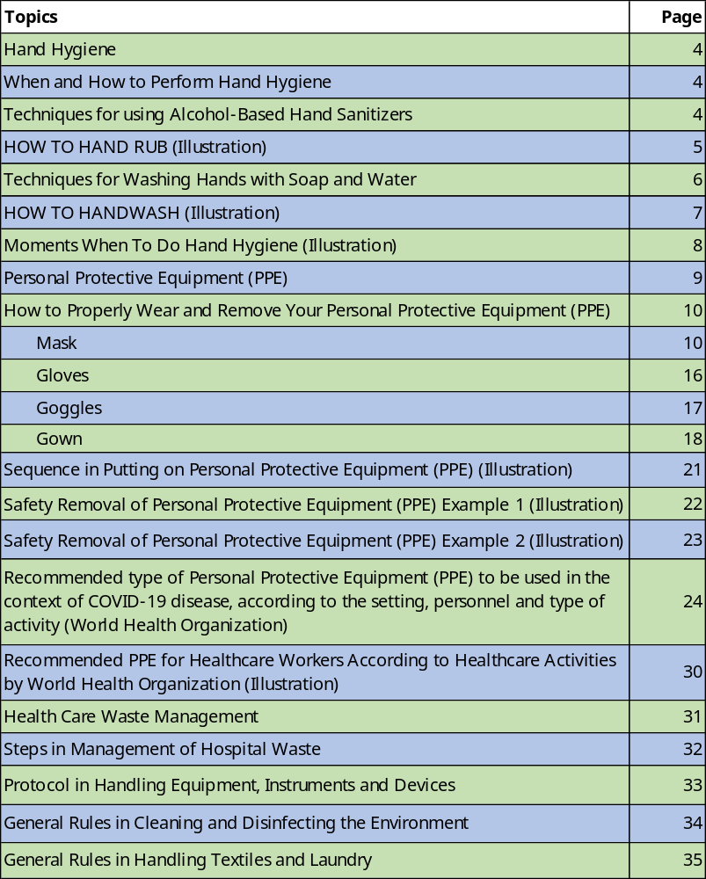
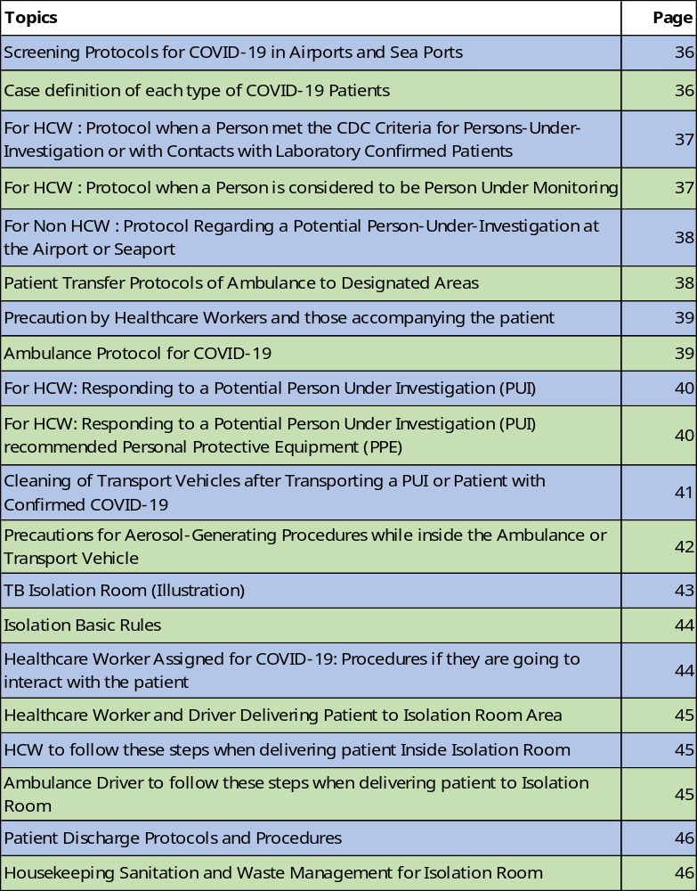

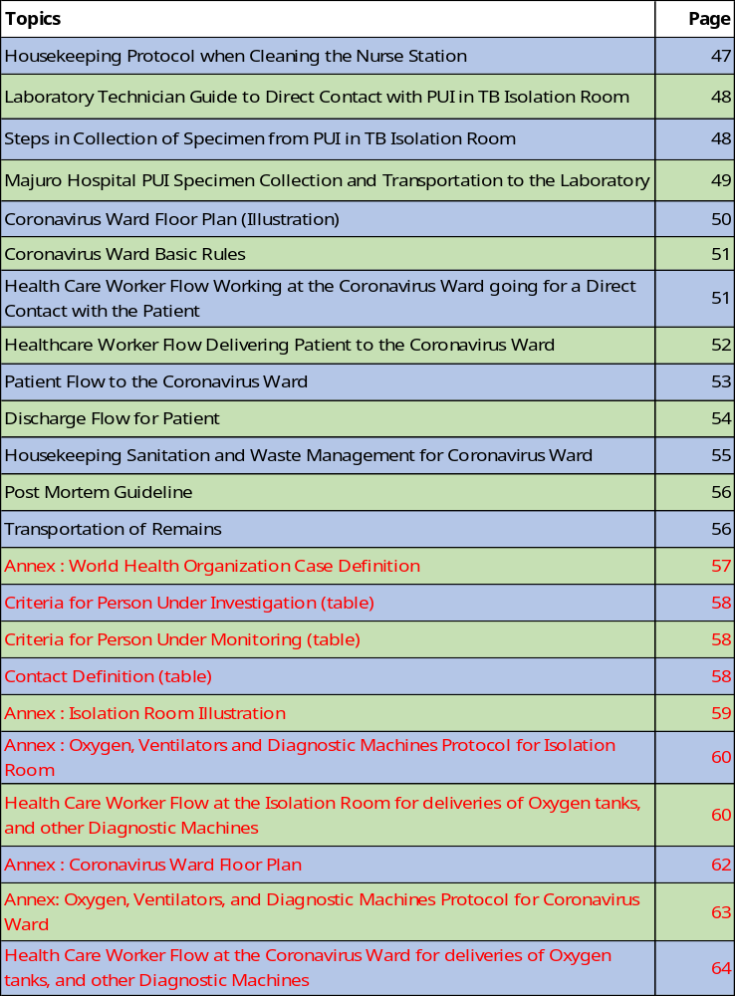
Hand Hygiene
Hand Hygiene is cleaning your hands by doing hand washing with the use of soap and water or the use of an antiseptic hand wash or hand rub with alcohol-based hand sanitizer including foam or gel, or surgical hand antisepsis.

When and How to Perform Hand Hygiene
- Hand washing

  - When hands are visibly soiled.
  - After caring for a person with known or suspected infectious diarrhea.
  - After known or suspected exposure to spores (e.g. B. anthracis, C difficile outbreaks).

- Use an Alcohol-Based Hand Sanitizer

  - Immediately before touching a patient.
  - Before performing an aseptic task (e.g., placing an indwelling device) or handling invasive medical devices.
  - Before moving from work on a soiled body site to a clean body site on the same patient.
  - After touching a patient or the patient’s immediate environment.
  - After contact with blood, body fluids or contaminated surfaces.
  - Immediately after glove removal.

- Surgical Hand Antisepsis
  - Before performing a procedure that requires aseptic technique.

Techniques for using Alcohol-Based Hand Sanitizers
When using alcohol-based hand sanitizer:
- Put product on hands and rub hands together
- Cover all surfaces until hands feel dry
- This should take around 20 seconds

HOW TO HAND RUB
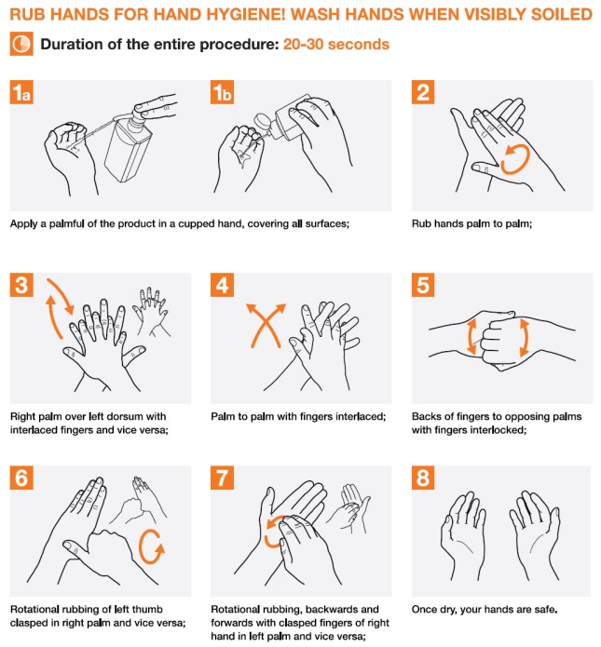

Techniques for Washing Hands with Soap and Water
The CDC Guideline for Hand Hygiene recommends:
- When cleaning your hands with soap and water, wet your hands first with water, apply the amount of product recommended by the manufacturer to your hands, and rub your hands together vigorously for at least 15 seconds, covering all surfaces of the hands and fingers.
- Rinse your hands with water and use disposable towels to dry. Use towel to turn off the faucet.
- Avoid using hot water, to prevent drying of skin.
- Other entities have recommended that cleaning your hands with soap and water should take around 20 seconds.
- Either time is acceptable. The focus should be on cleaning your hands at the right times.

HOW TO HANDWASH

WASH HANDS WHEN VISIBLY SOILED! OTHERWISE, USE HANDRUB
Duration of the entire procedure: 40-60 seconds

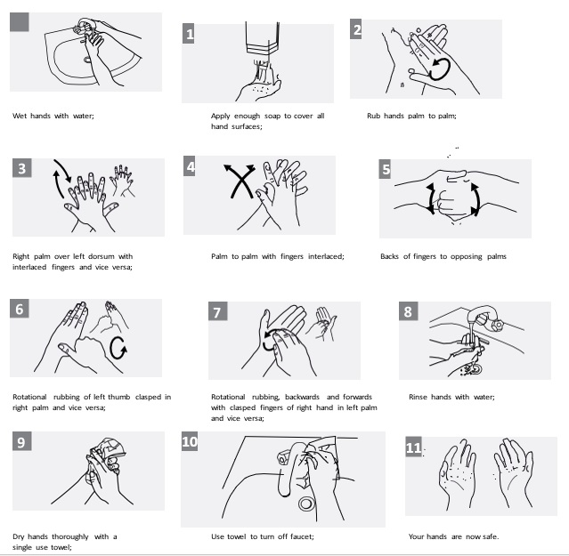

Moments When to Do Hand Hygiene
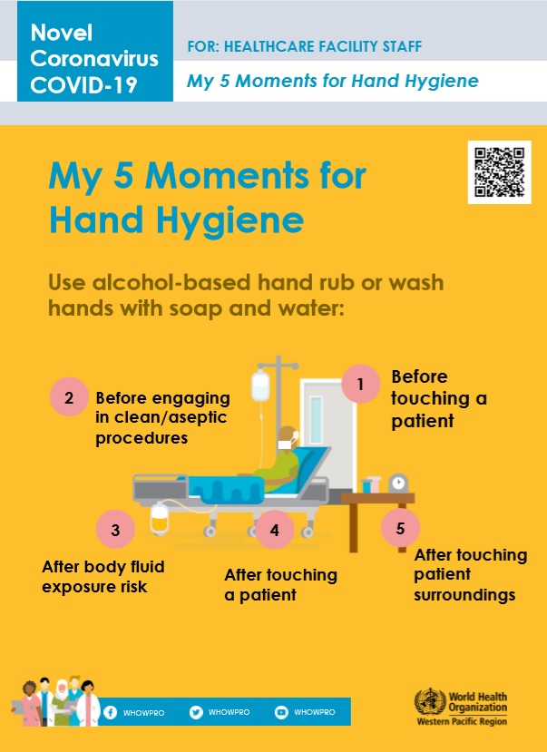
Personal Protective Equipment (PPE)
PPE is protective clothing, or other garments or equipment (helmets, goggles) designed to protect the wearer's body from injury or infection. The purpose of personal protective equipment is to reduce employee exposure to hazards. PPE consists of mask, gloves, gown, and goggles.

- Mask
Mask serves to protect the user from breathing in contaminants in the air, thus preserving the health of one's respiratory tract. For COVID-19 RMI will utilize 2 types of mask: N95 Respirator and Surgical Mask (Face Mask)
- N95 Respirator - protective device designed to achieve a very close facial fit and very efficient filtration of airborne particles. N95 respirators are not designed for children or people with facial hair. Because a proper fit cannot be achieved on children and people with facial hair, the N95 respirator may not provide full protection.

- Surgical Mask (Face Mask) - is a loose-fitting, disposable device that creates a physical barrier between the mouth and nose of the wearer and potential contaminants in the immediate environment. Surgical masks are made in different thicknesses and with different ability to protect you from contact with liquids. If worn properly, a surgical mask is meant to help block large-particle droplets, splashes, sprays, or splatter that may contain germs (viruses and bacteria), keeping it from reaching your mouth and nose. Surgical masks may also help reduce exposure of your saliva and respiratory secretions to others.
The similarities among surgical masks and surgical N95s are:
- They are tested for fluid resistance, filtration efficiency (particulate filtration efficiency and bacterial filtration efficiency), flammability and biocompatibility.
- They should not be shared or reused.

- Gloves
The primary purpose of surgical gloves is to act as a protective barrier to prevent possible transmission of diseases between healthcare professionals and patients from infection and contamination.

- Goggles
Goggles, or safety glasses, are forms of protective eyewear that usually enclose or protect the area surrounding the eye in order to prevent particulates, water, bodily fluids or secretions from striking the eyes.
- Gown
Gowns are used to protect the wearer from the spread of infection or illness if the wearer comes in contact with potentially infectious liquid (bodily fluids, secretions etc.) and solid material. They may also be used to help prevent the gown wearer from transferring microorganisms that could harm vulnerable patients, such as those with weakened immune systems.

How to Properly Wear and Remove Your Personal Protective Equipment (PPE)

- Mask

- Clean your hands. Before touching a clean medical mask, wash your hands thoroughly with both soap and water or disinfect them with hand sanitizer. (Refer to Hand Hygiene Procedures)

- Check the medical mask for defects. Once you’ve taken a new (unused) medical mask from the box, check it to ensure it doesn’t contain any defects, holes or tears in the material. If the mask has defects, holes or tears, throw it away and select another new (unused) mask from the box.

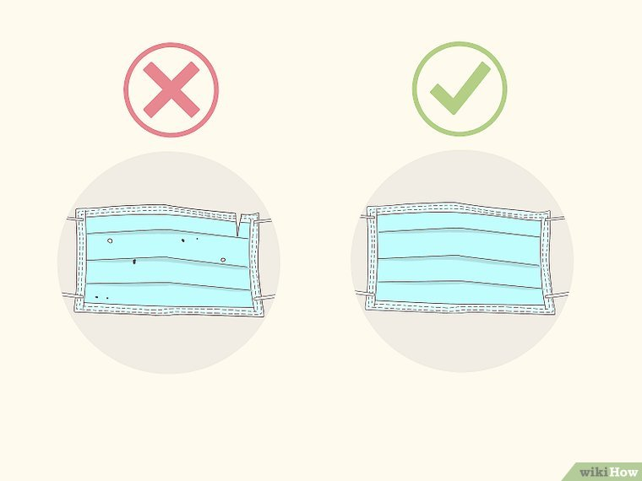

- Orient the top of the mask properly. In order for the mask to fit as close to your skin as possible, the top portion of the mask will have a bendable, but stiff, edge that can be moulded around your nose. Ensure this bendable side is facing upwards before applying the mask to your face.

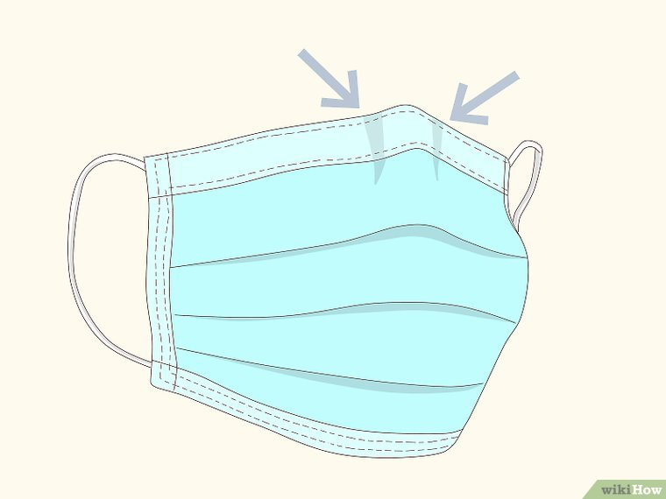

- Ensure the proper side of the mask faces outwards. The inside of most medical masks are white in color, while the outside has a color of some sort. Before applying the mask to your face, make sure the white side of the mask is facing towards your face.

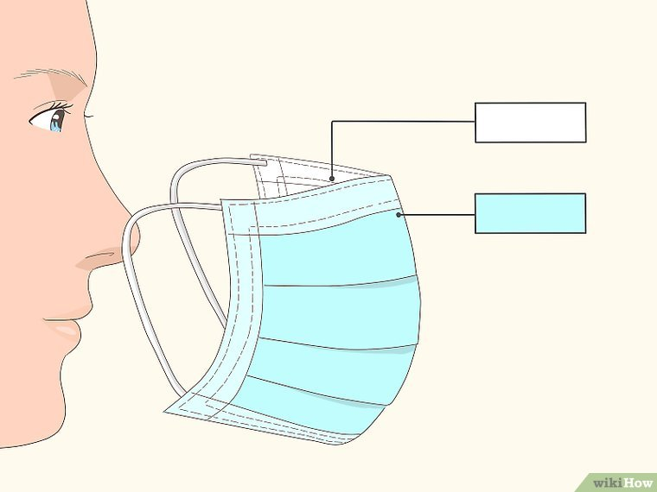

- Placing the mask on your face. There are many types of medical masks available, each with different methods of attaching the mask to your head.

- Ear Loops — Some masks have 2 ear loops on either side of the mask. These loops are normally made of an elastic material so they can be stretched. Pick up this type of mask by the loops, put 1 loop around one ear and then put the other loop around your other ear.
- Ties or Straps — Some masks come with pieces of fabric that are tied around the back of your head. Most masks with ties come with an upper and lower ties or straps. Pick up the mask by the upper ties, place the ties around the back of your head and attach them together with a bow.
- Bands — Some masks come with 2 elastic bands that are placed over and around the back of your head (as opposed to around your ears). Hold the mask in front of your face, pull the top band over the top of your head and place it around the crown of your head. Then pull the bottom band over the top of your head and place it at the base of your skull.

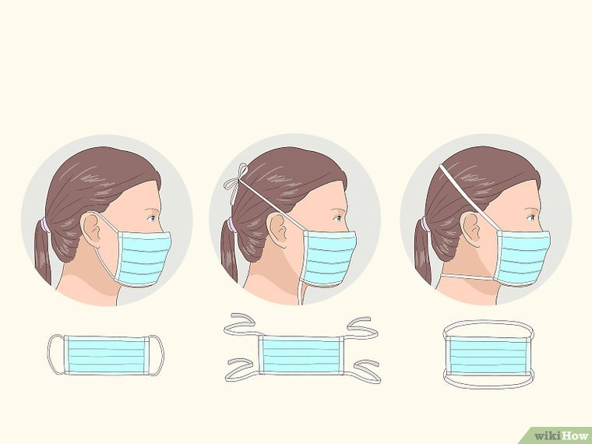

- Adjust the nose piece. Now that the medical mask is in place on your head and face, use your index finger and thumb to pinch the bendable portion of the top edge of the mask around the bridge of your nose.

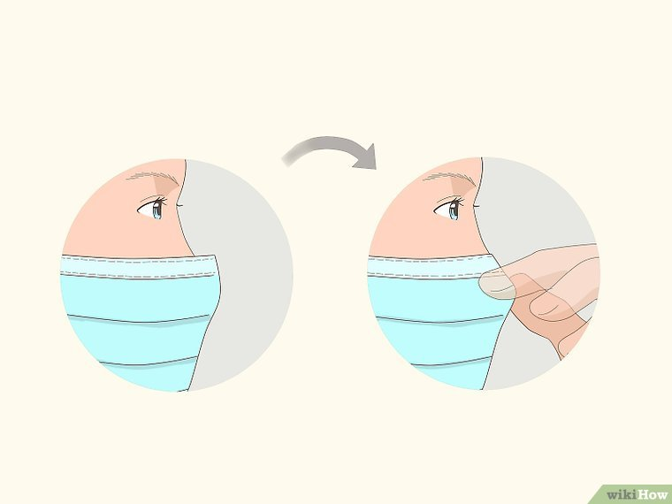

- Tie the lower band of the mask if needed. If you’re using a mask with bands that tie on the top and bottom, you can now tie the bottom band around the base of your skull. Because adjusting the bendable nose piece can impact the fit of the mask, it is best to wait until after the nose piece is in place before tying the bottom straps.
  - If you’ve already tied the bottom straps, you may need to re-tie them tighter if needed.

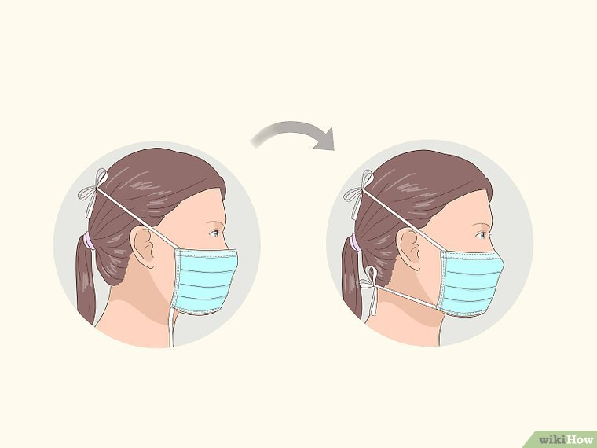

- Fit the mask to your face and under your chin. Once the mask is completely secured, adjust it to ensure it covers your face and mouth, and so the bottom edge is under your chin.
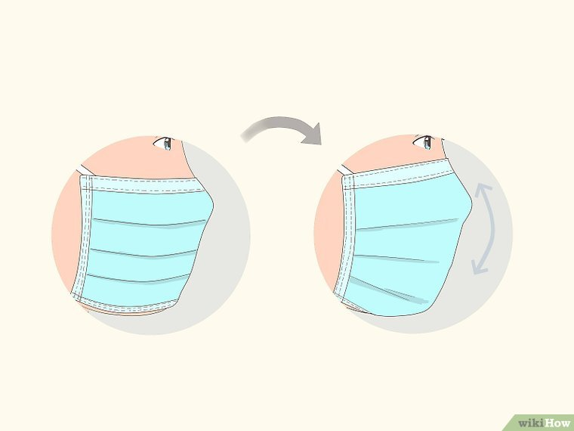

How to Remove A Surgical Mask Correctly
- Clean your hands with soap and water, or hand sanitizer, before touching the mask. (Refer to Hand Hygiene Procedures)
- Remove the mask carefully. In general, remove the mask by only touching the edges, straps, loops, ties or bands. Do not touch the front portion of the mask which may be contaminated.

- Ear Loops — Use your hands to hold the ear loops and remove them from around each ear.
- Ties/Straps — Use your hands to untie the bottom straps first, then untie the top straps. Remove the mask while holding onto the top ties.
- Bands — Use your hands to bring the bottom elastic band up and over your head, then use your hands to do the same with the top elastic band. Remove the mask from your face while holding the top elastic band.
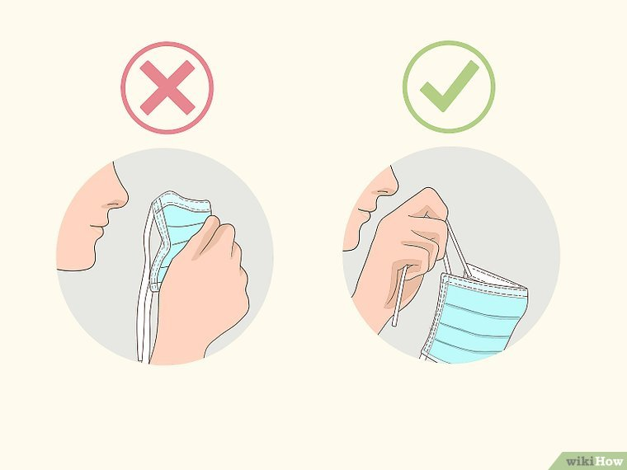

- Dispose of your mask safely. Medical masks are designed to only be used once. Therefore, when you take the mask off, place it in the trash immediately.
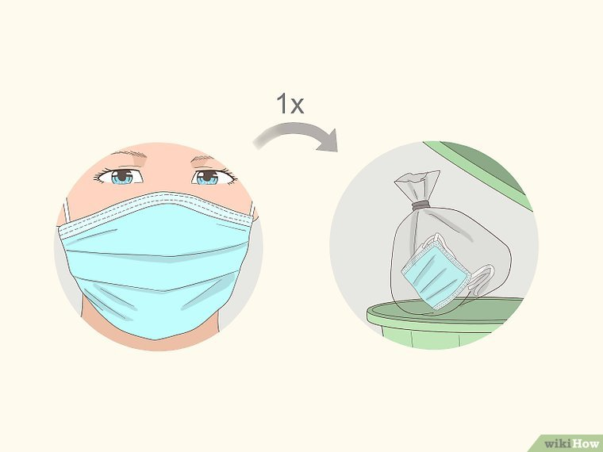

- Wash your hands again. Once you’ve disposed of the mask safely, wash your hands once more to ensure they’re clean and didn’t get contaminated by touching the dirty mask. (Refer to Hand Hygiene Procedures)

- Gloves
Open-glove technique
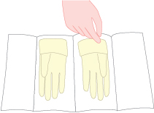
1. Pick up the cuff of the right glove with your left hand. Slide your right hand into the glove until you have a snug fit over the thumb joints and knuckles. Your bare left hand should only touch the folded cuff – the rest of the glove remains sterile.
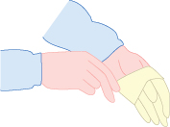
2. Slide your fingertips into the folded cuff of the left glove.
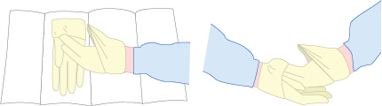
3. Use gloved left hand pick up folded cuff of right glove and pull glove up to gowned wrist.
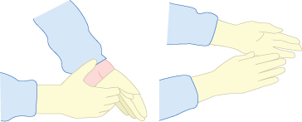
4. Place the fingers of the gloved right hand under the cuff of the partially gloved left hand. Unfold the cuff down over your gown sleeves. Make sure your gloved finger tips do not touch your bare forearms or wrists.

How to Safely Remove Gloves

- Pinch and hold the outside of the glove near the wrist area.
- Peel downwards, away from the wrist, turning the glove inside out.
- Pull the glove away until it is removed from the hand and hold the inside-out glove with the gloved hand.
- With your un-gloved hand, slide your finger/s under the wrist of the remaining glove, taking care not to touch the outside of the glove.
- Again, peel downwards, away from the wrist, turning the glove inside out.
- Continue to pull the glove down and over the inside-out glove being held in your gloved hand. This will ensure that both gloves are inside out, one glove enveloped inside the other, with no contaminant on the bare hands.
- Once both gloves are removed. Discard immediately.
- Wash your hands (Refer to Hand Hygiene Procedures)

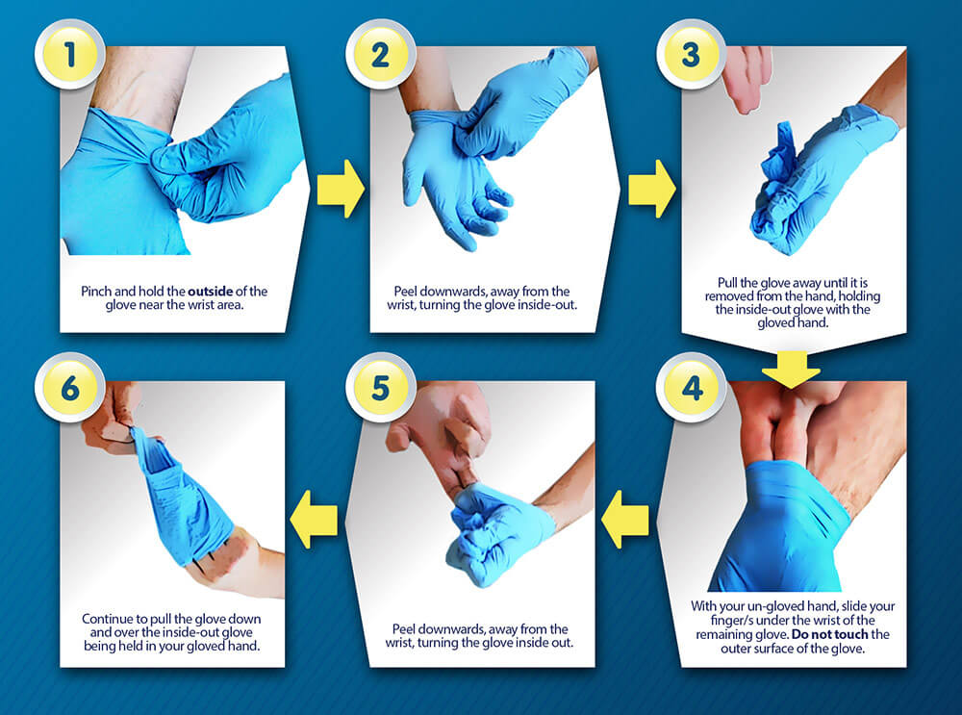

- Goggles

- Disinfect your hands before taking your goggles.
- If goggles are re-usable disinfect them before using.
- Goggles should fit tightly and comfortably on the wearers face.
- Once you are done using the goggles, disinfect hands before removing your goggles. Dispose immediately or disinfect afterwards.
- Wash your hands after removing your PPE.
- Gown

Surgical Gowning Steps

Picking up the gown
1. With one hand, pick up the entire folded gown from the wrapper by grasping the gown through all layers, being careful to touch only the inside top layer which is exposed.
2. Once your hands are securely pinching the gown in these slots, step back from the shelf and allow the gown to drop.
3. Make sure the gown does not touch any surrounding unsterile objects.
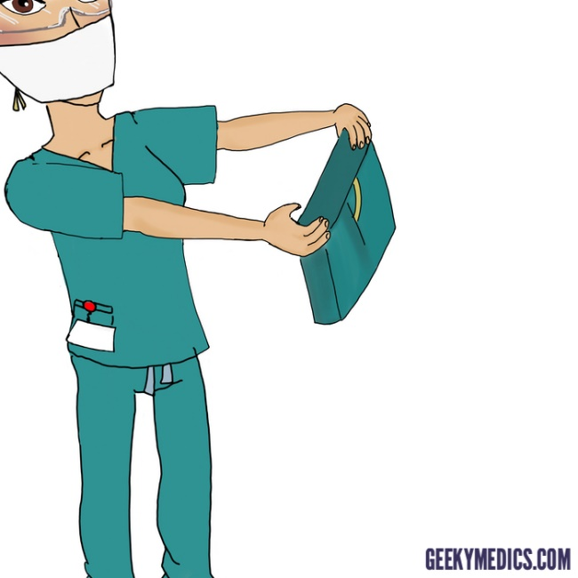

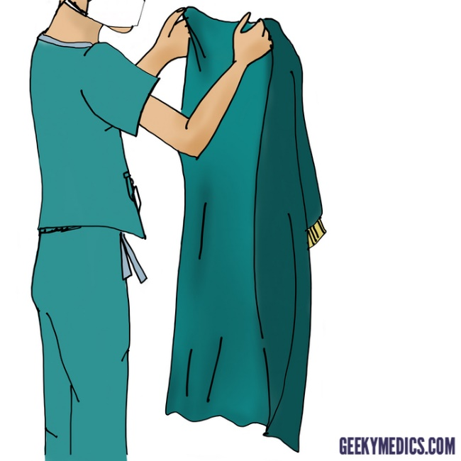

Inserting your arms into the sleeves of the gown
4. Grasp the inside shoulder seams and open the gown with the armholes facing you.
5. Carefully insert your arms part way into the gown one at a time, keeping hands at shoulder level away from the body.
6. Slide the arms further into the gown sleeves and when the fingertips are level with the proximal edge of the cuff, grasp the inside seam at the cuff hem using thumb and index finger. Be careful that no part of the hand protrudes from the sleeve cuff.
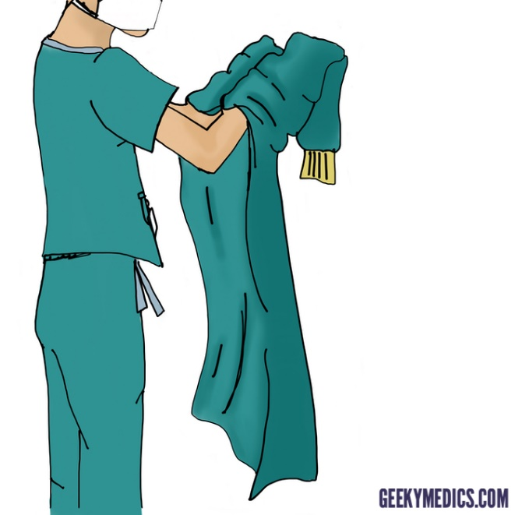

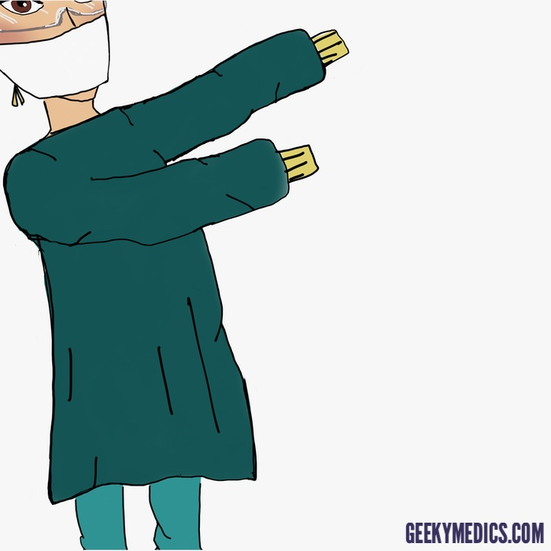

Fastening the gown
7. Fasten the gown behind you, positioning it over the shoulders by grasping the inside surface of the gown at the shoulder seam.
8. Secure the gown at the neck and upper back. Gowns differ in how they are secured, but most with have either ties, buttons or Velcro tabs.

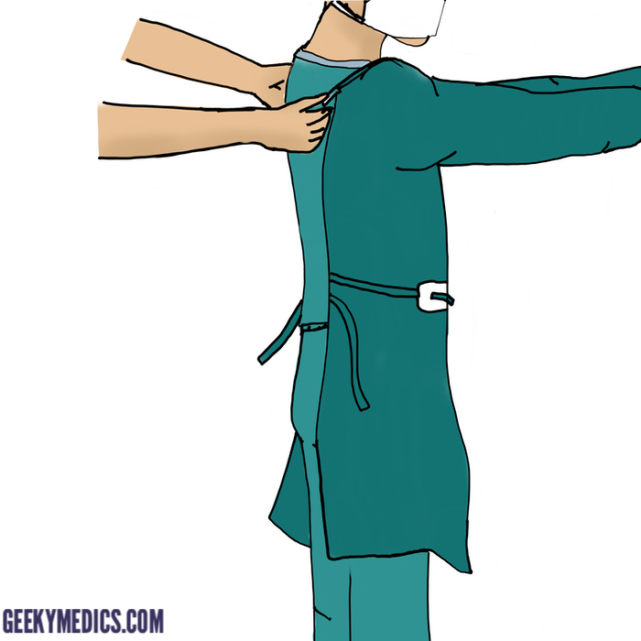

Sequence in Putting on PPE

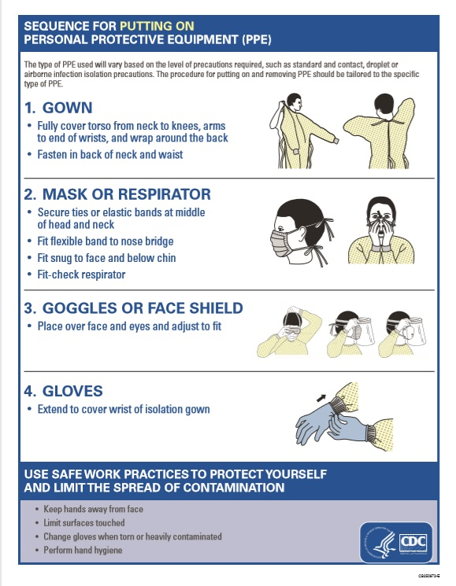

Safety Removal of Personal Protective Equipment (PPE) Example 1

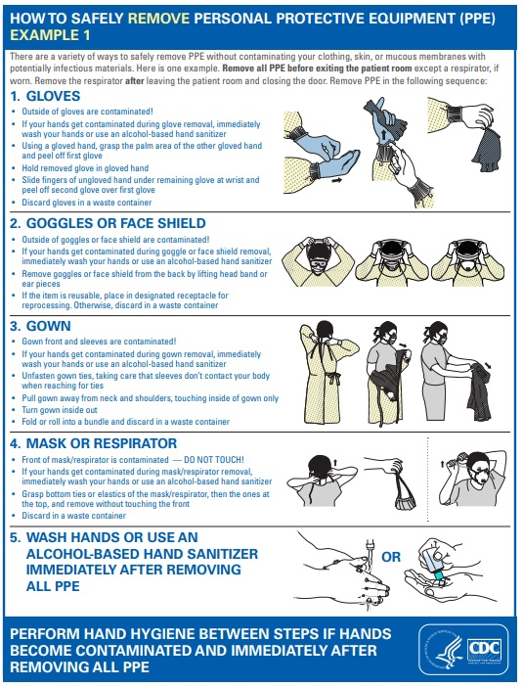

Safety Removal of Personal Protective Equipment (PPE) Example 2

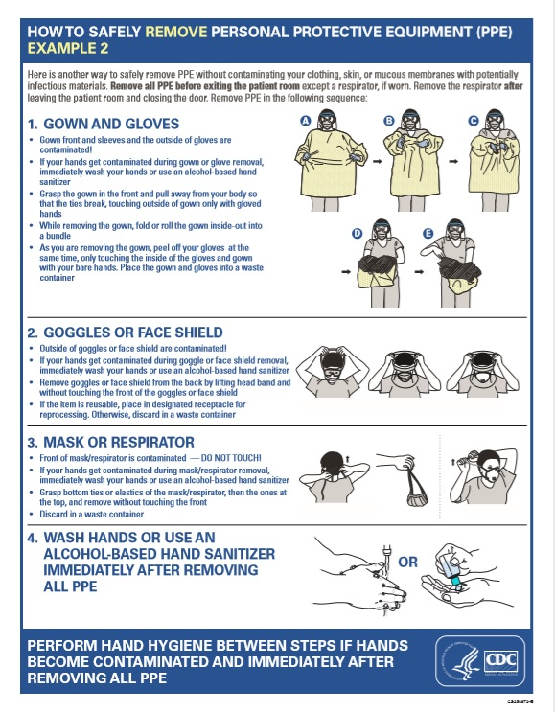

Recommended type of Personal Protective Equipment (PPE) to be used in the context of COVID-19 disease, according to the setting, personnel and type of activity (World Health Organization)

Setting | Target Personnel or Patients | Activity | Type of PPE or Procedure
Healthcare Facilities
Inpatient Facilities
Patient Room | Healthcare Workers | Providing direct care to COVID-19 patients | - Medical Mask  - Gown  - Gloves  - Eye Protection (Goggles or Face shield)
Patient Room |  | Aerosol-generating procedures performed on COVID-19 patients | - Respirator N95 or FFP2 standard, or equivalent  - Gown  - Gloves  - Eye Protection  - Apron
Patient Room | Cleaners | Entering the room of COVID-19 patients | - Medical Mask  - Gown  - Heavy Duty Gloves  - Eye Protection (if risk of splash from organic material or chemicals)  - Boots or closed work shoes
Patient Room | Visitors | Entering the room of COVID-19 patient | - Medical Mask  - Gown  - Gloves
Other areas of patient transit (e.g. wards, corridors) | All staff, including healthcare workers | Any activity that does not involve contact with COVID-19 patients. | No PPE required
Triage | Healthcare Workers | Preliminary screening not involving direct contact | - Maintain spatial distance of at least 1m  - No PPE required
Triage | Patients with respiratory symptoms | Any | - Maintain spatial distance of at least 1m  - Provide medical mask if tolerated by patient
Triage | Patients without respiratory symptoms. | Any | No PPE required
Laboratory | Lab Technician | Manipulation of respiratory samples. | - Medical Mask  - Gown  - Gloves  - Eye protection (if risk of splash)
Administrative Areas | All staff, including healthcare workers | Administrative task that do not involve contact with COVID-19 patients | No PPE required
Outpatient Facilities
Consultation Room | Healthcare Workers | Physical examination of patient with respiratory symptoms. | - Medical Mask  - Gown  - Gloves  - Eye protection
Consultation Room | Healthcare Workers | Physical examination of patient without respiratory symptoms. | PPE according to standard precautions and risk assessment.
Consultation Room | Patients with respiratory symptoms | Any | Provide medical mask if tolerated.
Consultation Room | Patients without respiratory symptoms | Any | No PPE required.
Consultation Room | Cleaners | After and between consultations with patients with respiratory symptoms. | - Medical Mask  - Gown  - Heavy Duty Gloves  - Eye Protection (if risk of splash from organic material or chemicals)  - Boots or closed work shoes
Waiting Room | Patients with respiratory symptoms. | Any | - Provide medical mask if tolerated by patient.  - Immediately move the patient to an isolation room or separate area away from others; if this is not feasible, ensure spatial distance of at least 1 m from other patients.
Waiting Room | Patients without respiratory symptoms | Any | No PPE required
Administrative Area | All staff, including healthcare workers | Administrative tasks | No PPE required
Triage | Healthcare workers | Preliminary screening not involving direct contact | - Maintain spatial distance of at least 1m  - No PPE required
 | ADDITIONAL:  Healthcare workers | Preliminary screening involving direct contact such as doing vital signs | - Medical Mask  - Gloves
 | Patients with respiratory symptoms | Any | - Maintain spatial distance of at least 1m  - Provide medical mask if tolerated by patient
 | Patients without respiratory symptoms | Any | No PPE required
Community
Home | Patients with respiratory symptoms | Any | - Maintain spatial distance of at least 1m  - Provide medical mask if tolerated, except when sleeping.
 | Caregiver | Entering the patient’s room, but not providing direct care or assistance. | - Medical Mask
 | Caregiver | Providing direct care or when handling stool, urine, or waste from COVID-19 patient being cared for at home. | - Medical Mask  - Gloves  - Apron (if risk of splash)
 | Healthcare workers | Providing direct care or assistance to a COVID-19 patient at home. | - Medical Mask  - Gown  - Gloves  - Eye protection
Public areas (e.g. schools, shopping malls, train stations) | Individuals without respiratory symptoms | Any | No PPE required
Points of Entry
Administrative Areas | All staff | Any | No PPE required
Screening area | Staff | First screening (temperature measurement) not involving direct contact. | - Maintain spatial distance of at least 1m  - No PPE required
Screening area | Staff | Second screening (i.e., interviewing passengers with fever for clinical symptoms suggestive of COVID-19 disease and travel history). | - Medical Mask  - Gloves
Screening area | ADDITIONAL for Staff:  Since we don’t have a non-contact temperature measurement device, screening staff | Screening | - Medical Mask  - Gloves
Screening area | Cleaners | Cleaning the area where passengers with fever are being screened. | - Medical Mask  - Gown  - Heavy Duty Gloves  - Eye Protection (if risk of splash from organic material or chemicals)  - Boots or closed work shoes
Temporary Isolation Area | Staff | Entering the isolation area, but not providing direct assistance. | - Maintain spatial distance of at least 1m  - Medical mask  - Gloves
Temporary Isolation Area | Staff, healthcare workers | Assisting passenger being transported to a healthcare facility | - Medical Mask  - Gown  - Gloves  - Eye protection
Temporary Isolation Area | Cleaners | Cleaning isolation area | - Medical Mask  - Gown  - Heavy Duty Gloves  - Eye Protection (if risk of splash from organic material or chemicals)  - Boots or closed work shoes
Ambulance or transfer vehicle | Healthcare workers | Transporting suspected COVID-19 patients to the referral healthcare facility | - Medical Mask  - Gown  - Gloves  - Eye protection  (Rationale : You are in an enclosed space with a patient with not much room for spatial distance)
Ambulance or transfer vehicle | Driver | Involved only in driving the patient with suspected COVID-19 disease and the driver’s compartment is separated from the COVID-19 patient. | - Maintain spatial distance of at least 1m  - No PPE required
Ambulance or transfer vehicle | Driver | Assisting with loading or unloading patient with suspected COVID-19 disease. | - Medical Mask  - Gown  - Gloves  - Eye protection
Ambulance or transfer vehicle | Driver | No direct contact with patient with suspected COVID-19, but no separation between driver’s and patient’s compartments. | - Medical Mask
 | Patient with suspected COVID-19 disease. | Transport to the referral healthcare facility | - Medical Mask if tolerated
 | Cleaners | Cleaning after and between transport of patients with suspected COVID-19 disease to the referral healthcare facility. | - Medical Mask  - Gown  - Heavy Duty Gloves  - Eye Protection (if risk of splash from organic material or chemicals)  - Boots or closed work shoes
Special Considerations for Rapid Response Teams Assisting with Public Health Investigation
Community
Anywhere | Rapid response team investigators. | Interview suspected or confirmed COVID-19 patients or their contacts. | No PPE if done remotely (e.g., by telephone or video conference).  Remote interview is the preferred method.
Anywhere | Rapid response team investigators. | In-person interview of suspected or confirmed COVID-19 patients without direct contact. | - Medical Mask  - Maintain spatial distance of at least 1 m.  The interview should be conducted outside the house or outdoors, and confirmed or suspected COVID-19 patients should wear a medical mask if tolerated.
Anywhere | Rapid response team investigators. | In-person interview with asymptomatic contacts of COVID-19 patients. | - Maintain spatial distance of at least 1 m.  - No PPE required  The interview should be performed outside the house or outdoors. If it is necessary to enter the household environment, use a thermal imaging camera to confirm that the individual does not have a fever, maintain spatial distance of at least 1 m and do not touch anything in the household environment.  ADDITIONAL:  Do a self-risk assessment. You may opt to wear a mask during interview if you don’t feel confident that the patient is asymptomatic.
Recommended PPE for Healthcare Workers According to Healthcare Activities by World Health Organization
Illustration for TRIAGE/POINTS OF ENTRY SCREENING PERSONNEL has been modified according to Republic of the Marshall Islands’ COVID-19 Protocol. Wearing of gloves has been added.

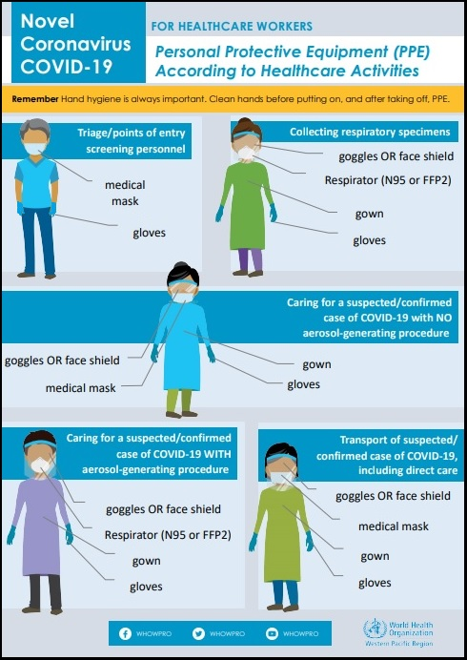

Health Care Waste Management

The term health-care waste includes all the waste generated within health-care facilities, research centers and laboratories related to medical procedures. In addition, it includes the same types of waste originating from minor and scattered sources, including waste produced in the course of health care undertaken in the home (e.g. home dialysis, self-administration of insulin, recuperative care). It is classified as Hazardous Health Care Waste and Non-Hazardous or General Health-Care Waste

Hazardous health-care waste
- Sharps Waste
Used or unused sharps (e.g. hypodermic, intravenous or other needles; auto-disable syringes; syringes with attached needles; infusion sets; scalpels; pipettes; knives; blades; broken glass)

- Infectious Waste
Waste suspected to contain pathogens and that poses a risk of disease transmission (e.g. waste contaminated with blood and other body fluids; laboratory cultures and microbiological stocks; waste including excreta and other materials that have been in contact with patients infected with highly infectious diseases in isolation wards)

- Pathological Waste
Human tissues, organs or fluids; body parts; fetuses; unused blood products

- Pharmaceutical Waste, Cytotoxic Waste
Pharmaceuticals that are expired or no longer needed; items contaminated by or containing pharmaceuticals Cytotoxic waste containing substances with genotoxic properties (e.g. waste containing cytostatic drugs – often used in cancer therapy; genotoxic chemicals)

- Chemical Waste
Waste containing chemical substances (e.g. laboratory reagents; film developer; disinfectants that are expired or no longer needed; solvents; waste with high content of heavy metals, e.g. batteries; broken thermometers and blood-pressure gauges)
- Radioactive Waste
Waste containing radioactive substances (e.g. unused liquids from radiotherapy or laboratory research; contaminated glassware, packages or absorbent paper; urine and excreta from patients treated or tested with unsealed radionuclides; sealed sources)

Non-hazardous or general health-care waste
Waste that does not pose any biological, chemical, radioactive or physical hazard

All objects that come in contact with patients should be considered as potentially contaminated. If an object is disposable, it should be discarded as waste. If it is reusable, transfer of infectious agents must be prevented by cleaning, disinfection, or sterilization.

Hospital waste is a potential reservoir of pathologic micro-organisms and requires appropriate, safe and reliable handling. Appropriate receptacles must be provided and hospital employees must practice segregation of infectious from non-infectious materials, collection, handling, storage, and disposal of waste.

Steps in Management of Hospital Waste
- Segregation
  - Separate different types of waste
    - Infective Waste – Utilize the red HAZARDOUS bag
    - Sharps Waste – Utilize the SHARPS containers
    - Pathological Waste – Utilize the red HAZARDOUS bag
    - General Waste – Utilize common garbage bags: black bag, blue bag, white bag
    - Pharmaceutical Waste – All expired drugs will be returned to the pharmacy for disposal

- Collection
  - This is the responsibility of the housekeeping staff.
  - Transport waste in a dedicated trolley. Ensure that the carts or trolleys used for the transport of segregated waste collection are not used for any other purpose. It should be cleaned regularly.

- Storage
  - Store waste in a specific area with restricted access.

- Disposal
  - Housekeeping staff shall then dispose collected waste at the disposal area.
Protocol in Handling Equipment, Instruments and Devices
- Wear PPE (e.g., gloves, gown), according to the level of anticipated contamination, when handling patient-care equipment and instruments/devices that is visibly soiled or may have been in contact with blood or body fluids
- Remove organic material from critical and semi-critical instrument/devices, using recommended cleaning agents before high level disinfection and sterilization to enable effective disinfection and sterilization processes.
- In hospitals, perform most cleaning, disinfection, and sterilization of patient-care devices in a central processing department in order to more easily control quality.
- Meticulously clean patient-care items with water and detergent, or with water and enzymatic cleaners before high-level disinfection or sterilization procedures.
  - Remove visible organic residue (e.g., residue of blood and tissue) and inorganic salts with cleaning. Use cleaning agents that are capable of removing visible organic and inorganic residues.
  - Clean medical devices as soon as possible, practical after use (e.g., at the point of use) because soiled materials become dried onto the instruments. Dried or baked materials on the instrument make the removal process more difficult and the disinfection or sterilization process less effective or ineffective.
- Perform either manual cleaning (i.e., using friction) or mechanical cleaning (e.g., with ultrasonic cleaners, washer-disinfector, washer-sterilizers).
- If using an automatic washer/disinfector, ensure that the unit is used in accordance with the manufacturer’s recommendations.
- Ensure that the detergents or enzymatic cleaners selected are compatible with the metals and other materials used in medical instruments. Ensure that the rinse step is adequate for removing cleaning residues to levels that will not interfere with subsequent disinfection/sterilization processes.
- Inspect equipment surfaces for breaks in integrity that would impair either cleaning or disinfection/sterilization. Discard or repair equipment that no longer functions as intended or cannot be properly cleaned, and disinfected or sterilized.

General Rules in Cleaning and Disinfecting the Environment
- Clean housekeeping surfaces (e.g., floors, tabletops) on a regular basis, when spills occur, and when these surfaces are visibly soiled.
- Disinfect (or clean) environmental surfaces on a regular basis (e.g., daily, three times per week) and when surfaces are visibly soiled.
- Follow manufacturers’ instructions for proper use of disinfecting (or detergent) products — such as recommended use-dilution, material compatibility, storage, shelf-life, and safe use and disposal.
- Clean walls, blinds, and window curtains in patient-care areas when these surfaces are visibly contaminated or soiled.
- Prepare disinfecting (or detergent) solutions as needed and replace these with fresh solution frequently (e.g., replace floor mopping solution every three patient rooms, change no less often than at 60-minute intervals), according to the facility’s policy.
- Decontaminate mop heads and cleaning cloths regularly to prevent contamination (e.g., launder and dry at least daily).
- Do not use high-level disinfectants/liquid chemical agents for disinfection of non-critical surfaces.
- Wet-dust horizontal surfaces regularly (e.g., daily, three times per week) using clean cloths moistened with a hospital disinfectant (or detergent). Prepare the disinfectant (or detergent) as recommended by the manufacturer.
- Do not use disinfectants to clean infant bassinets and incubators while these items are occupied. If disinfectants (e.g., phenolics) are used for the terminal cleaning of infant bassinets and incubators, thoroughly rinse the surfaces of these items with water and dry them before these items are reused.
- Promptly clean and decontaminate spills of blood and other potentially infectious materials. Discard blood-contaminated items in compliance with federal regulations.
- For site decontamination of spills of blood or other potentially infectious materials (OPIM), implement the following procedures. Use protective gloves and other PPE (e.g., when sharps are involved use forceps to pick up sharps and discard these items in a puncture-resistant container) appropriate for this task. Disinfect areas contaminated with blood spills using an EPA-registered tuberculocidal agent, a registered germicide on the EPA Lists D and E (i.e., products with specific label claims for HIV or HBV or freshly diluted hypochlorite solution).
- If sodium hypochlorite solutions are selected use a 1:100 dilution (e.g., 1:100 dilution of a 5.25-6.15% sodium hypochlorite provides 525-615 ppm available chlorine) to decontaminate nonporous surfaces after a small spill (e.g., <10 mL) of either blood or OPIM. If a spill involves large amounts (e.g., >10 mL) of blood or OPIM, or involves a culture spill in the laboratory, use a 1:10 dilution for the first application of hypochlorite solution before cleaning in order to reduce the risk of infection during the cleaning process in the event of a sharp injury. Follow this decontamination process with a terminal disinfection, using a 1:100 dilution of sodium hypochlorite.
- If the spill contains large amounts of blood or body fluids, clean the visible matter with disposable absorbent material, and discard the contaminated materials in appropriate, labeled containment.
General Rules in Handling Textiles and Laundry

- Handle used textiles and fabrics with minimum agitation to avoid contamination of air, surfaces and persons
- If laundry chutes are used, ensure that they are properly designed, maintained, and used in a manner to minimize dispersion of aerosols from contaminated laundry.
- All laundry bags should be closed while transporting soiled linens for proper disposal or disinfection.

Screening Protocols for COVID-19 in Airports and Sea Ports

All workers conducting an evaluation must follow standard and droplet precaution procedures. Wearing of PPE is a must. Mask and Gloves ONLY.

- Maintain spatial distance of at least 1 m on each individual.
- Determine whether passengers and crew will pass initial assessment.
- Categorize the passenger:

  - Patient-Under-Investigation or with Contacts with Laboratory Confirmed Patients
  - Patient-Under-Monitoring
  - Clear

- They should use alcohol-based hand sanitizer in-between the examination of suspected cases.
- They should wash their hands and face with soap and water after they finish their duty.
- They should wash their hands and face with soap and water after and before leaving the terminal area when taking a break.
- They should dispose of the gloves and mask every time they leave their post at the screening area.
- They should wash their hands/ face body with soap and water and dispose of clothes if contaminated by the bodily fluids, blood of the suspected case.
- All contaminated material must be disposed appropriately.
- Regular disinfection of commonly used items such as tables and chairs that could come in contact with every patient should be done everyday before opening of ports and after closing of ports. (1-part bleach : 99-part water)

Case Definition of the following: Refer to Annex regarding World Health Organization Case Definition

  - Patient-Under-Investigation
  - Patient-Under-Monitoring
  - Contacts

For Health Care Worker (HCW) : Protocol when a Person met the CDC Criteria for Persons-Under-Investigation
- Give medical mask.
- Isolate the patient.
- At ports (airport and seaports) Inform Immigration Officer for protocols in accelerating the passenger's immigration clearance.
- Take patient to port’s designated isolation areas. If isolation room not available keep a distance of at least 1 m / 3 feet between patients.
- Advice on good respiratory hygiene.
- Cover nose and mouth during coughing or sneezing with tissue or on flexed elbow and dispose of used tissues in dustbins.
- Frequent hand hygiene (soap and water or alcohol-based hand-rub).
- Perform contact tracing.
- Inform the following personnel:
  - Dr. Robert Maddison
  - Dr. Bong Villaroya
  - Dr. Caryl Labe
  - Dr. Aina Garstang
  - Dr. Tom Jack
  - Dr. Rodney Catilo
  - ICN Jacob Dela Cruz
  - Surveillance Team

- Inform areas where we will be delivering the patient:

  - CMI-Arrak Campus
  - Coronavirus Ward
  - TB Isolation Ward

- Deliver the patient using the ambulance.

For Health Care Worker (HCW): Protocol when a Person is considered to be Person Under Monitoring (PUM)
- All HCW will adhere to screening protocols. Wear your mask and gloves.
- All Person Under Monitoring (PUM) are to be quarantined at the CMI-Arrak.
- Spatial distance of at least 1m on every patient will still be in effect.

For Non Health Care Worker: Protocol Regarding a Potential Person-Under-Investigation (PUI) at the Airport or Seaport
- Isolate immediately.
- Tell them to wash their face and hands with soap and water.
- Practice coughing etiquette. Cough or sneeze on disposable towel, a flexed elbow or underneath ones’ shirt. Sanitize after each occasion.
- Place mask on patient if they present any cough, runny nose, or sneezing.
- Get the full history of the incident.
- Inform the following personnel:

  - Dr. Robert Maddison
  - Dr. Bong Villaroya
  - Dr. Caryl Labe
  - Dr. Aina Garstang
  - Dr. Tom Jack
  - Dr. Rodney Catilo
  - ICN Jacob Dela Cruz
  - Surveillance Team

- Take their ID card number/passport number/work permit number, Work place (for expatriates), name, age, gender, current residential address, contact number, email address, date of the incident and the date at which the 14-day incubation period is over.
- Wait for the HCW personnel to receive the patient.
- Once suspected case is taken by the HCW, perform environmental disinfection to contaminated areas (chairs, table, etc.) always use PPE. Disinfect contaminated surface with diluted bleach solution (1-part bleach: 99-part water). Follow manufacturer’s recommendation for disinfection and sanitation.

Patient Transfer Protocols of Ambulance to Designated Areas
- Make sure that the patient keeps on the face mask at all times, unless to vomit or drink fluids.
- Perform hand hygiene after contact with respiratory secretions.
- Health care worker (HCW) should perform hand hygiene before and after all patient contact, contact with potentially infectious material, and before putting on and upon removal of personal protective equipment, including gloves. If hands are visibly soiled, use soap and water, not alcohol-based hand rubs. Use paper towels temporarily to remove items on hands then proceed doing hand rubbing using hand sanitizer or 70% alcohol. Perform hand washing once available.
- Personal protective equipment should be worn by all people who assist the patient during transfer to the ambulance/sea ambulance. If at risk of exposure to potentially infectious materials in any patient (contact with blood or body fluids) wear the following PPE. Gown, Mask, Gloves and Goggles.
- Notify the receiving area.
- Clean and disinfect patient-contact surfaces after patient has been removed from the vehicle by using detergent and bleach (1-part bleach to 99 parts water).
- Limit the number of HCWs inside the ambulance.
- Family members and other contacts of patients with possible COVID-19 should not ride in the transport vehicle, if possible. If riding in the transport vehicle, they should wear a facemask.
- Avoid unnecessary movement inside the ambulance unless medically necessary.
- If equipment needs to be shared among patients, clean and disinfect between patient use. (Disinfect with alcohol 70% or bleach wipes)
- Maintain a record of all persons travelling in the vehicle/vessel including drivers and assistants.

Precaution by Healthcare Workers and those accompanying the patient
- HCW must wear mask and gloves always. If there will be respiratory secretions involved wearing of gown and goggles is required.
- Companions will only wear mask. Unless there is a good judgement for the companion to wear other PPE then they may do so. (e.g. breastfeeding, patient caregivers etc.)
- Maintain a 3 feet distance where possible.
- Refrain from touching eyes, nose or mouth with potentially contaminated hands.
- Always disinfect hands after each physical contact with the patient.

Ambulance Protocol for COVID-19

- Before using the ambulance ensure that it has already been disinfected.
- Before using the ambulance ensure that all materials needed are well stocked.
- Mask must be worn by the patient at all times.
- All health workers must keep their distance inside the ambulance of at least 3 feet if possible.
- All HCW must follow standard and droplet precautionary measures.
- Windows must be open if possible.
- Limit movement inside the ambulance.
- No other passengers shall be allowed inside the ambulance other than the patient but in some instances that a companion is needed ONLY ONE companion shall be allowed and will also follow standard and droplet precautionary measures.
- Disinfect contaminated areas after each use.

For HCW: Responding to a Potential Person Under Investigation (PUI)

- HCW Responders should put on appropriate PPE before entering the scene. HCW Responders should consider the signs, symptoms, and risk factors of COVID-19.
- If information about potential for COVID-19 has not been provided by the caller, HCW Responders should exercise appropriate precautions when responding to any patient with signs or symptoms of a respiratory infection. Initial assessment should begin from a distance of at least 6 feet from the patient, if possible. Patient contact should be minimized to the extent possible until a facemask is on the patient. If COVID-19 is suspected, all PPE as should be used. If COVID-19 is not suspected, HCW Responders should follow standard procedures and use appropriate PPE for evaluating a patient with a potential respiratory infection.
- A facemask should be worn by the patient for source control. If a nasal cannula is in place, a facemask should be worn over the nasal cannula. Alternatively, an oxygen mask can be used if clinically indicated. If the patient requires intubation, see below for additional precautions for aerosol-generating procedures.
- During transport, limit the number of providers in the patient compartment to essential personnel to minimize possible exposures.

For HCW: Responding to a Potential Person Under Investigation (PUI) recommended Personal Protective Equipment (PPE)
- HCW Responders who will directly care for a patient with possible COVID-19 infection or who will be in the compartment with the patient should wear recommended PPE:
  - N-95 or higher-level respirator or facemask (if a respirator is not available),
    - N95 respirators or respirators that offer a higher level of protection should be used instead of a facemask when performing or present for an aerosol-generating procedure
  - Eye protection (i.e., goggles or disposable face shield that fully covers the front and sides of the face). Personal eyeglasses and contact lenses are NOT considered adequate eye protection.
  - A single pair of disposable patient examination gloves. Change gloves if they become torn or heavily contaminated, and isolation gown.,
    - If there are shortages of gowns, they should be prioritized for aerosol-generating procedures, care activities where splashes and sprays are anticipated, and high-contact patient care activities that provide opportunities for transfer of pathogens to the hands and clothing of EMS clinicians (e.g., moving patient onto a stretcher).
- Drivers, if they provide direct patient care (e.g., moving patients onto stretchers), should wear all recommended PPE. After completing patient care and before entering an isolated driver’s compartment, the driver should remove and dispose of PPE and perform hand hygiene to avoid soiling the compartment.
  - If the transport vehicle does not have an isolated driver’s compartment, the driver should remove the face shield or goggles, gown and gloves and perform hand hygiene. A respirator or facemask should continue to be used during transport.
- All personnel should avoid touching their face while working.
- On arrival, after the patient is released to the facility, HCW Responders should remove and discard PPE and perform hand hygiene. Used PPE should be discarded in accordance with routine procedures.

Cleaning of Transport Vehicles after Transporting a PUI or Patient with Confirmed COVID-19
The following are general guidelines for cleaning or maintaining EMS transport vehicles and equipment after transporting a PUI:
- After transporting the patient, leave the rear doors of the transport vehicle open to allow for sufficient air changes to remove potentially infectious particles.
  - The time to complete transfer of the patient to the receiving facility and complete all documentation should provide sufficient air changes.
- When cleaning the vehicle, EMS clinicians should wear a disposable gown and gloves. A face shield or facemask and goggles should also be worn if splashes or sprays during cleaning are anticipated.
- Ensure that environmental cleaning and disinfection procedures are followed consistently and correctly, to include the provision of adequate ventilation when chemicals are in use. Doors should remain open when cleaning the vehicle.
- Routine cleaning and disinfection procedures (e.g., using cleaners and water to pre-clean surfaces prior to applying an EPA-registered, hospital-grade disinfectant to frequently touched surfaces or objects for appropriate contact times as indicated on the product’s label) are appropriate for severe acute respiratory syndrome coronavirus 2 (SARS-CoV-2) in healthcare settings, including those patient-care areas in which aerosol-generating procedures are performed.
- Products with EPA-approved emerging viral pathogens claims are recommended for use against SARS-CoV-2. Refer to list on the EPA website for EPA-registered disinfectants that have qualified under EPA’s emerging viral pathogens program for use against SARS-CoV-2.
- Clean and disinfect the vehicle in accordance with standard operating procedures. All surfaces that may have come in contact with the patient or materials contaminated during patient care (e.g., stretcher, rails, control panels, floors, walls, work surfaces) should be thoroughly cleaned and disinfected using an EPA-registered hospital grade disinfectant in accordance with the product label.
- Clean and disinfect reusable patient-care equipment before use on another patient.

- Follow standard operating procedures for the containment and disposal of used PPE and medical waste.
- Follow standard operating procedures for containing and laundering used linen. Avoid shaking the linen.

Precautions for Aerosol-Generating Procedures while inside the Ambulance or Transport Vehicle
- Wear an N-95 or higher-level respirator, instead of a facemask, should be worn in addition to the other PPE described above.
- EMS clinicians should exercise caution if an aerosol-generating procedure (e.g., bag valve mask (BVM) ventilation, oropharyngeal suctioning, endotracheal intubation, nebulizer treatment, continuous positive airway pressure (CPAP), bi-phasic positive airway pressure (biPAP), or resuscitation involving emergency intubation or cardiopulmonary resuscitation (CPR)) is necessary.
- If possible, the rear doors of the transport vehicle should be opened and the HVAC system should be activated during aerosol-generating procedures. This should be done away from pedestrian traffic.

TB Isolation Room
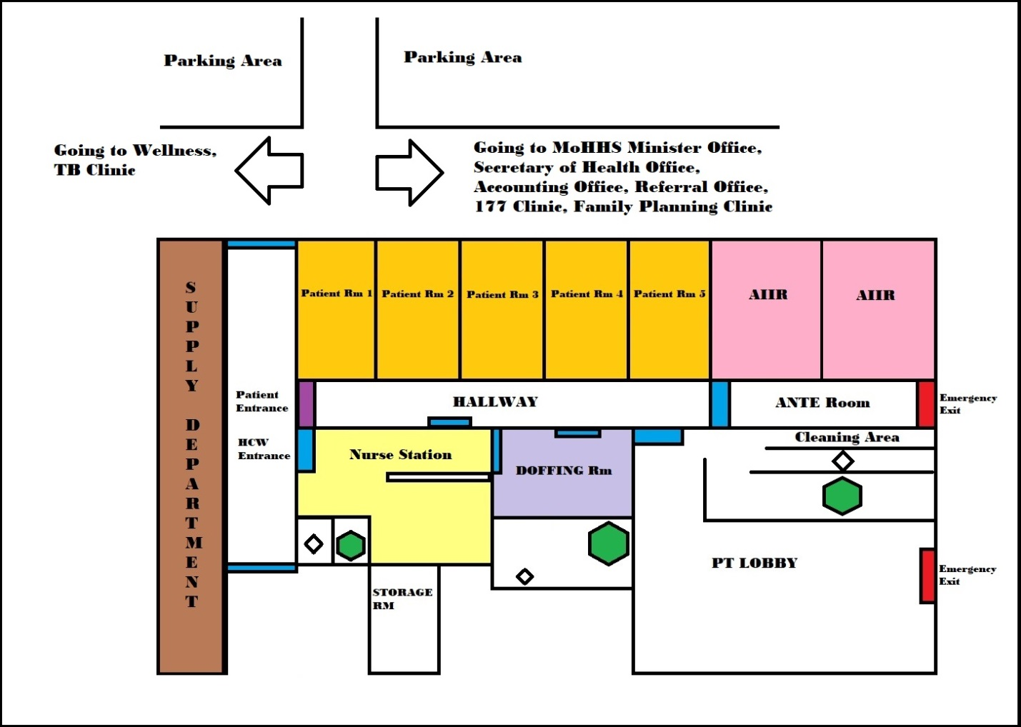
Legend
Door / Entrance
Patient Entrance Door
Nurse Station
Patient Room
AIIR (Airborne Infection Isolation Room
DOFFING Room
Exit Doors
Sink and Toilet
Shower Room

Isolation Basic Rules
- All patients will only enter through the designated patient entrance door.
- All HCW will only enter the HCW designated entrance door.
- Patient entrance door must always be kept locked.
- HCW Entrance door should be locked if you are going to wear your PPE and going to any patient room.
- HCW assigned at the Isolation Room are the sole responsible personnel in securing the PATIENT entrance door.
  - If PATIENT rooms are not occupied, the HCW worker may open the door from the HALLWAY side.
  - IF PATIENT rooms 1-5 are occupied and you are not wearing your PPE, unlock the door from the outside.
  - IF PATIENT rooms 1-5 are occupied and you are wearing your PPE, remove your PPE first at the DOFFING room and unlock the door from the outside.
- AIIR room must be occupied first before using other patient rooms.
- DONNING of PPE will only be done at the NURSE STATION.
- If AIIR (Airborne Infection Isolation Room) are the only rooms occupied, DOFFING will be done at the ANTE Room.
- If Patient Rooms are occupied DOFFING Room will be utilized for removal of all PPE.
- Nurse Station should always be cleaned.
- HCW delivering food at breakfast, lunch or dinner time will wear complete PPE do routine vital signs and collect all trash and secure it inside a biohazard bag. Store it at the ANTE Room waiting for collection.
- Room preparation and disinfection before and after occupancy of a COVID-19 patients will be done by the assigned HCW. Wear appropriate PPE: Gown, Mask, Goggles, Gloves.
NOTE: Food delivery without patient contact and patient communication behind a CLOSED door does not need wearing of complete PPE.
MASK and Gloves are enough.

Healthcare Worker Assigned for COVID-19: Procedures if they are going to interact with the patient
- Clean and disinfect your hands.
- Assess the situation where will you do your DOFFING. Either at the ANTE Room or at the DOFFING Room. If it will be at the DOFFING Room make sure that it is UNLOCKED before you put on your PPE.
- If AIIR are the only rooms occupied, DOFFING will be done ate the ANTE room.
- If AIIR and PATIENT Rm 1-5 are occupied, removal of PPE will be done at the DOFFING Room.
- Make sure your hands are clean and sanitized. Collect and put on your PPE at the NURSE STATION according to sequence: Gown, Mask, Goggles, Gloves
- Do your patient care. Once you are done with your patient care follow these steps:

- If AIIR are the only rooms occupied, DOFFING will be done ate the ANTE room. Remove PPE according to sequence. Gloves, Gown, Goggles, Mask. Disinfect materials which are not meant to be disposed. Discard disposable materials inside the HAZARDOUS bag. Proceed to DOFFING room for sanitation.
- If AIIR and PATIENT Rm 1-5 are occupied, removal of PPE will be done at the DOFFING Room. Remove PPE according to sequence. Gloves, Gown, Goggles, Mask. Disinfect materials which are not meant to be disposed. Discard disposable materials inside the HAZARDOUS bag.
- Once all PPE are removed. Perform hand hygiene. Wash your face. Pat them dry and exit to NURSE STATION.
- Once at the NURSE STATION, disinfect your hands.

Healthcare Worker and Driver Delivering Patient to Isolation Room Area
- All Patient will come from outside of the Isolation Room from the parking area side.
- If a patient was assessed to be PUI and they are in need of the Isolation Room, they are going to be delivered using the ambulance being accompanied by a HCW and the ambulance driver.
- Inform ahead the HCW assigned at the Isolation Room that a Patient Under Investigation is going to occupy the room. (This will give some time for the HCW to prepare the room.)

HCW to follow these steps when delivering patient Inside Isolation Room
- Accompany the patient to the PATIENT ENTRANCE door. Wait for the door to be opened by the HCW assigned at the Isolation Room.
- Once the door is unlocked, enter the HALLWAY and deliver the patient to their assigned room.
- Once patient is delivered to their assigned room, proceed to DOFFING room.
- Remove your PPE according to sequence: Gloves, Gown, Goggles, Mask
- Once all PPE is removed. Disinfect your hands and arms. Wash your face. Pat them dry and exit to NURSE STATION.
- Once at the NURSE STATION, disinfect your hands.
- Endorse and Exit.

Ambulance Driver to follow these steps when delivering patient to Isolation Room
- Park the ambulance at the designated parking area.
- Wait for the patient to enter the Isolation Room HALLWAY and be delivered on their assigned room.
- Once patient is already on their assigned room, enter the HALLWAY and proceed to DOFFING room.
- Remove your PPE.
- Perform hand hygiene including washing your face and arms. Pat them dry and exit to NURSE STATION.
- Once at the NURSE STATION, disinfect your hands and exit.

Patient Discharge Protocols and Procedures
- Make sure that patient has fresh clothes from relatives before discharge.
- Disinfect patient items and place all items inside a plastic bag for transport.
- Proceed to DOFFING Rm.
- Remove all items worn by patient and place them on a separate plastic bag.
- Let the patient take a shower or at least wash their face, hands and legs.
- Tell the patient to put on fresh clothes.
- Sanitize hands before exiting door leading to the Nurse Station.
- At the Nurse Station check that all items are prepared before leaving the hospital.
- Exit and sanitize hands on the dispenser provided.

Housekeeping Sanitation and Waste Management for Isolation Room
- Before a housekeeping employee decides to clean the Isolation Room, make sure that you have all necessary materials for cleaning, disinfection, and collection of waste.
  - Mop
  - Water bucket
  - Disinfectants such e.g. bleach
  - Waste bins or waste trolleys
  - Replacement bags for hazardous materials (red bags)

- Trash bins, trolleys for waste collection, and mops and bucket will only enter the PATIENT ENTRANCE door. Leave it outside designated PATIENT ENTRANCE Door.
- Enter the designated HCW Entrance and proceed to NURSE STATION.
- Once inside the NURSE STATION, disinfect hands and wear PPE. Gown, Mask, Goggles, Gloves.
- Ask HCW to unlock door. Then proceed to taking your trash bins, waste trolleys, mop and bucket inside the HALLWAY.
- Remove all patient waste. Place it on the BIOHAZARD bag, close lid and store it inside the waste trolleys or trash bins. Trash bins or waste trolleys must not be wheel around the ISOLATION ROOM. It should only stay at the entrance of the HALLWAY.
- After patient waste, start to disinfect patient environment. Start with AIIR occupied rooms followed by other PATIENT ROOM 5-1.
  - Table, Chairs, Door should be prioritized since these are the items which are commonly used by the patient.
  - All items used to disinfect patient environment should be placed and secured in the BIOHAZARD bag.
- Once collecting of waste and disinfecting patient environment is done, dump your bucket water at the CLEANING AREA and take all items to the PATIENT ENTRANCE. Then proceed to DOFFING room.
- If DOFFING room is locked ask the HCW to unlock it.
- At DOFFING room, collect waste inside and store it in the housekeeping trash bin or waste trolley currently located at the PATIENT ENTRANCE.
- Once done collecting waste at the DOFFING room, ask the HCW to unlock the PATIENT ENTRANCE door. Wheel out the waste trolley, mops and bucket. Go back to the HALLWAY and ask the HCW to lock the PATIENT ENTRANCE door then proceed to DOFFING ROOM.
- At DOFFING room replace the used hazardous bags being removed. Remove PPE according to sequence. Gloves, Gown, Goggles, Mask. (Refer to the guide on how to remove PPE)
- Disinfect hands before exiting DOFFING ROOM and proceeding to NURSE STATION. Make sure that before you exit, DOFFING ROOM should be locked.
- Collect waste and disinfect the NURSE STATION, exit and collect the trash bins, waste trolleys and deliver them to our disposal area. Mops and bucket should be sun-dried.
- Disinfect hands after.

Note: Housekeeping environmental disinfection and sanitation should be done every first entry of the day by the housekeeping department.

Housekeeping Protocol when Cleaning the Nurse Station
- Cleaning the nurse station and its environment should be done on a regular basis.
- Do not use the mop which was used to disinfect COVID-19 patient rooms unless they have already been sun-dried.
- Always have the mop and bucket be sun-dried.
- Wear appropriate PPE.

Laboratory Technician Guide to Direct Contact with PUI in TB Isolation Room
- All laboratory technician will enter the HCW Entrance door.
- All items for collection of specimens must be inside a fluid resistant bag.
- Collected specimen should have the following:
  - Specimen bag
  - Transport box
  - Hawaii-PUI completed form also be included.
- All laboratory technician who’s going for direct contact with PUI must wear complete PPE. Gown, Mask, Goggles, Gloves. (Refer to guide on how to don PPE)

Steps in Collection of Specimen from PUI in TB Isolation Room
- Carry your transport box with items for collection of specimens inside the box to front of PATIENT ENTRANCE door.
- Ask the HCW to open the PATIENT ENTRANCE door.
- Once PATIENT ENTRANCE door is open, leave your box in the HALLWAY.
- Ask the HCW in-charge of Isolation Room to lock the door and proceed to NURSE STATION using the HCW ENTRANCE door.
- Once inside the NURSE STATION, disinfect your hands. (Refer to Hand Hygiene Procedures)
- Don your PPE. (Refer to How to Properly Wear and Remove Your Personal Protective Equipment)
- Proceed to HALLWAY.
- Get your items for collection of specimens but do not take the transport box with you.
- Collection of Specimen
  - Attending medical staff will collect (1) nasopharyngeal swab and one (1) oropharyngeal swab from the PUI, using VTM collection kits provided by the laboratory.
  - Each swab will be tested separately so each swab will be in a separate biohazardous specimen transport bag and zip lock.
  - Label the specimen container with PATIENT’S NAME, HOSPITAL NUMBER, and DATE OF COLLECTION.
  - Complete the Hawaii-PUI Form and place the form in the outer pouch of the specimen bag. (Form completion must be done prior to exposure to infectious environment)
  - Proceed to the ANTE Room and disinfect the external portion of the specimen bag.
- Delivering your specimen bag to the transport box
  - Make sure that the external portion of the specimen bag has been disinfected.
  - Remove gloves only and put on fresh ones.
  - Place the specimen bag inside the transport box.
  - Ask the HCW in-charge of the Isolation Room to open the PATIENT ENTRANCE door.
  - Place the transport box outside the HALLWAY and ask the HCW to guard it while you are DOFFING.
- Proceed to DOFFING room. Remove PPE according to sequence. Gloves, Gown, Goggles, Mask. Perform hand hygiene. Wash your face and arms. Pat them dry and proceed to NURSE STATION.
- At NURSE STATION, perform hand hygiene once again. Exit and take the transport box.
Majuro Hospital PUI Specimen Collection and Transportation to the Laboratory
Guidelines from Laboratory Services

Approved specimen referral to Hawaii State Laboratory from the USAPI:
- Specimen Requirements

- Two (2) Upper Respiratory Specimens
  - Nasopharyngeal Swab (NPS)
  - Oropharyngeal Swab (OPS)

- Collection Kit: Ensure that you have VTM (recommended) for specimen collection.

- Additional Specimens (e.g. urine, stool) may be required and should be collected and stored till needed by CDC.

- Refer to CDC website for handling of the collected specimens and storage requirements. Full guidance is located at: https://www.cdc.gov/coronavirus/2019

- Documents to submit with specimen(s).

  - Hawaii-PUI-nCoV-19 Form
  - HSL Clinical Specimen Submission Form (81.3) – completed by the laboratory

- Collection of Specimens
  - Attending medical staff will collect one (1) nasopharyngeal swab and one (1) oropharyngeal swab from the PUI, using VTM collection kits provided by the laboratory.
  - Each swab will be tested separately so each swab will be in a separate biohazardous specimen transport bag and zip lock.
  - Label the specimen container with PATIENT’S NAME, HOSPITAL NUMBER, and DATE OF COLLECTION.
  - Complete the Hawaii-PUI Form and place the form in the outer pouch of the specimen bag.
  - If available soak a paper towel and wipe the exterior of specimen transport bag with 1% Bleach Solution.
  - Place the specimen package in the specimen transport box for the laboratory staff to pick up and call the laboratory to have the specimens picked up and taken to the laboratory – DO NOT DELIVER the specimens to the laboratory.
  - Designated laboratory will soak a paper towel with 10% bleach solution and wipe the exterior of the specimen box before removing it from the Isolation Area.
  - The Specimen box will only be opened in the Biosafety Cabinet Room for handling and before storage in the designated refrigerator.
Coronavirus Ward Floor Plan
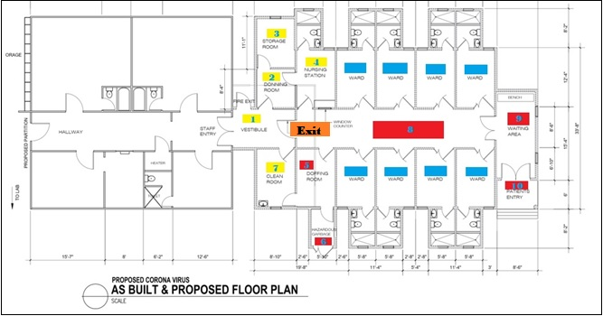
Legend:
- Vestibule : Lobby
- Donning Room : A place where we put on our Personal Protective Equipment
- Storage Room : A place where we store our items such as PPE, etc.
- Nursing Station : An area for HCW not working directly with patients.
- Doffing Room : A place where we remove our PPE
- Hazardous Garbage : A place where we discard our infected materials such as PPE, etc.
- Clean Room
- Walkway
- Patient Waiting Area
- Patient Entry
Patient Ward
Clean Area
Infected Area
Exit Door

Coronavirus Ward Basic Rules

- ALL STAFF assigned to take care a patient must enter the “vestibule” area.
- Donning of PPE is a MUST. NO STAFF shall enter the patient ward without donning proper PPE.
- BEFORE taking your PPE materials, MAKE SURE that you are already sanitized or have cleaned your hands.
- BEFORE donning please be aware that once you are already wearing your PPE, your personal items such as your pens, markers and small items that can fit on your pocket will remain on your pocket and can never be taken out to be used inside the ward until such time that you have removed your PPE. Bigger items such as your bags will be left at the donning area inside your locker.
- Donning of PPE will ONLY be done in the donning room and NOT at the Nursing Station.
- BEFORE you leave the Nursing Station, make sure to check all your items.
- Remember that the doors going out of the nursing station will only be opened on the other side and if you plan on going back to the nursing station you will need to remove your PPE and re-do the whole process. NO EXEMPTIONS.
- Once done providing your services to the patient, you are required to remove your PPE ONLY at the DOFFING area.
- Dispose your trash IMMEDIATELY at the HAZZARDOUS GARBAGE bin provided.
- Sanitize your hands before you exit the DOFFING room.
- Once you entered the CLEAN ROOM make sure to have washed your hands and face before exiting.
- ALL patient charts will stay at the Nursing Station.
- Items such as big containers, coolers, mats, etc. will not be allowed inside. Phones, laptops, chargers may be allowed.

Health Care Worker Flow Working at the Coronavirus Ward going for a Direct Contact with the Patient

- Proceed to DONNING ROOM (2). Wash your hands or sanitize with antibacterial hand sanitizers or alcohol with 60-70% proof.
- Before taking items inside the STORAGE ROOM (3) make sure that your hands are already clean.
- Put on your PPE at the DONNING ROOM (2) before proceeding to the NURSING STATION (4).
- Do not directly go to the patient ward unless deemed necessary.
- Proceed with direct patient care. Check WAITING AREA (9) for any patient waiting for bed space.
- Once you are done with patient care proceed to DOFFING ROOM (5). Follow Removal of PPE protocol and discard items at HAZARDOUS GARBAGE (6). Wash your hands, face and arms. Pat them dry and proceed to CLEAN ROOM (7).
- CLEAN ROOM (7) this would serve as your last checkpoint before going out to other areas. Make sure to clean your hands. Wash your face. All PPE are already removed.
- Exit.
Note:
A Healthcare Worker is not allowed to exit through the PATIENT ENTRY (10) door.
Endorsement will be done at the NURSING STATION (4).
It would be a serious violation to contaminate the CLEAN ROOM (7).

In an event that a Healthcare Worker forgot to remove their PPE after having direct contact with a patient and has already proceeded to the CLEAN ROOM (7) this would be the appropriate actions to take:
- Remove contaminated PPE as soon as possible.
- Place PPE on a hazardous bag immediately.
- Wash your hands and face.
- Put on a new PPE.
- Bring with you extra HAZARDOUS BAG.
- Start disinfecting possible areas which was contaminated.
- Follow removal of PPE sequence.
- Discard PPE on a hazardous bag.
- Wash your hands and face.
- Exit decontaminated area.

Healthcare Worker Flow Delivering Patient to the Coronavirus Ward
All patient that needs admission will ONLY enter the Coronavirus Ward using the PATIENT ENTRY (10) door.

- Determine that a patient is for admission to the Coronavirus Ward.
- Apply all necessary precautions.
- Make sure that patient is wearing their mask.
- If patient is ambulatory, allow patient to enter the PATIENT ENTRY (10) door and wait at the WAITING AREA (9). Coronavirus-based healthcare worker will meet the patient shortly at the WAITING AREA (9).

In an event that the patient will be delivered using the stretcher or gurney, the healthcare worker delivering the patient to the Coronavirus Ward is going to enter the Coronavirus Ward with compliance to application of full PPE.

Once the patient is delivered on their assigned bed space, the healthcare worker in-charge of the stretcher or gurney will return them to the ambulance and proceed with ambulance disinfection and PPE removal. Ambulance drivers will remove and discard PPE accordingly. Perform hand hygiene afterwards.

All items used to disinfect the ambulance and PPE used shall be discarded immediately on a tightly secured hazardous bag.

Disinfect ambulance and remove PPE in an open space. Away from commonly used environment.

Drop hazardous bags at housekeeping department for proper sanitation.

- Go back inside the Coronavirus Ward through the VESTIBULE (1) going through the NURSING STATION (4) for endorsement.

- Exit accordingly.

Patient Flow to the Coronavirus Ward

- A healthcare worker shall first determine whether there is a need for a patient to be admitted inside the Coronavirus Ward. If there is no such need then they will proceed to CMI-Arrak campus for isolation and quarantine.
- Make sure that the patient is already wearing a mask prior to arrival at the health care center.
- All patient that needs admission to the coronavirus ward shall only enter the PATIENT ENTRY (10) door.
- If patient is ambulatory they may proceed to enter at the PATIENT ENTRY (10) door and wait at the WAITING AREA (9).
- Assigned Healthcare worker will meet the patient at the patient WAITING AREA (9) and take the patient to the assigned room.

In an event that the patient will be delivered using the stretcher or gurney, the healthcare worker delivering the patient to the Coronavirus Ward is going to enter the Coronavirus Ward with compliance to application of full PPE.

Once the patient is delivered on their assigned bed space, the healthcare worker in-charge of the stretcher or gurney will return them to the ambulance and proceed with ambulance disinfection and PPE removal. Ambulance drivers will remove and discard PPE accordingly. Perform hand hygiene afterwards.

All items used to disinfect the ambulance and PPE used shall be discarded immediately on a tightly secured hazardous bag.

Disinfect ambulance and remove PPE in an open space. Away from commonly used environment.

Drop hazardous bags at housekeeping department for proper sanitation.

- The patient will be taken care of by the Republic of the Marshall Islands Medical Team until such time that they are going to be discharged.

Discharge Flow for Patient

Once a patient is medically-cleared to go home, they are not going to exit through the PATIENT ENTRY (10) door.

Follow the procedure in order:
- Ask the relatives to bring extra clothes of the patient before going home.
  - These clothes should be fresh from outside to be given to the nurse at the VESTIBULE (1).
  - Get clothes from relatives. Place it inside a plastic bag. Take the bag with you inside the Coronavirus Ward.
- Disinfect personal items of the patient such as their phone, laptops, etc.
- Place all disinfected items inside another plastic bag.
- Proceed to DOFFING ROOM (5).
- Ask the patient to clean hands and face.
- All patient’s own clothes must be removed and placed inside another plastic bag.
  - Advice patient to immediately wash their clothes using a bleach if possible.
  - If you cannot use bleach, you may also use laundry sanitizers such as Lysol for laundry.
- Discard hospital own items at the HAZARDOUS GARBAGE (6).
- Ask the patient to clean hands and face once again before putting on fresh clothes.
- Put on fresh clothes.
- Pick up your items and proceed to CLEAN ROOM (7).
- Clean your hands and face once again.
- EXIT.

Housekeeping Sanitation and Waste Management for Coronavirus Ward
- All housekeeping personnel will enter the vestibule area. Mop and buckets will be left outside the EXIT door.
- All housekeeping will proceed to DONNING ROOM (2). Wash your hands or sanitize with antibacterial hand sanitizers or alcohol with 60-70% proof.
- Take you PPE. Gown, Mask, Goggles, Mask
- Before taking items inside the STORAGE ROOM (3) make sure that your hands are already clean.
- Put on your PPE at the DONNING ROOM (2) (refer to sequence on putting on PPE) before proceeding to the NURSING STATION (4).
- Do not directly go to the patient ward unless deemed necessary.
- Exit the NURSING STATION (4) and open the EXIT door to take your mop, bucket and broom.
- Proceed to the ward wearing your complete PPE to do environmental sanitation and disinfection.
- Once you are done with sanitation and disinfection of patient’s rooms, leave the broom at the corner of the DOFFING ROOM (5) and the EXIT door and proceed to DOFFING ROOM (5). Dispose waste on the HAZARDOUS GARBAGE (6) area. Clean your mop and bucket. Store them at the HAZARDOUS GARBAGE (6) area to be picked up later on from the outside of the Coronavirus Ward to be disinfected and sun-dried. Remove your PPE and discard items at HAZARDOUS GARBAGE (6). Disinfect hands, arms, and face. Pat them dry with a disposable paper towels and discard paper towels at the HAZARDOUS GARBAGE (6).
- Exit DOFFING ROOM (5) and enter the CLEAN ROOM (7).
- CLEAN ROOM (7) this would serve as your last checkpoint before going out to other areas. Make sure to clean your hands. Wash your face. All PPE are already removed.
- Exit the CLEAN ROOM (7)

Note: Housekeeping environmental disinfection and sanitation should be done every first entry of the day by the housekeeping department.

Post Mortem Guidelines
- Wear nonsterile, nitrile gloves when handling potentially infectious materials
- If there is a risk of cuts, puncture wounds, or other injuries that break the skin, wear heavy-duty gloves over the nitrile gloves.
- Wear a clean, long sleeved fluid resistant or impermeable gown to protect skin and clothing
- Use plastic face shield or a face mask and goggles to protect the face, eye, nose and mouth from splashes of potentially infectious bodily fluids.
Disinfect patient environment after body has been taken out of the room. (Refer to Housekeeping Sanitation and Waste Management for Isolation Room and Coronavirus Ward)

Transportation of human remains
Follow standard routine procedures when transporting the body after the specimens have been collected and the body has been bagged. Disinfect the outside of the bag with an EPA-registered hospital disinfectant applied according to the manufacturer’s recommendations. Wear disposable nitrile gloves when handling the body bag.

Annex:
World Health Organization Case Definition

WHO periodically updates the Global Surveillance for human infection with coronavirus disease (COVID-19) document which includes case definitions. For easy reference, case definitions are included below.

Suspect case
    - A patient with acute respiratory illness (fever and at least one sign/symptom of respiratory disease (e.g., cough, shortness of breath), AND with no other etiology that fully explains the clinical presentation AND a history of travel to or residence in a country/area or territory reporting local transmission of COVID-19 disease during the 14 days prior to symptom onset.
    - A patient with any acute respiratory illness AND having been in contact with a confirmed or probable COVID19 case in the last 14 days prior to onset of symptoms.
    - A patient with severe acute respiratory infection (fever and at least one sign/symptom of respiratory disease (e.g., cough, shortness breath) AND requiring hospitalization AND with no other etiology that fully explains the clinical presentation.

Probable case
A suspect case for whom testing for COVID-19 is inconclusive.
- Inconclusive being the result of the test reported by the laboratory

Confirmed case
A person with laboratory confirmation of COVID-19 infection, irrespective of clinical signs and symptoms.

Close contact is defined as—
- being within approximately 6 feet (2 meters) of a COVID-19 case for a prolonged period of time; close contact can occur while caring for, living with, visiting, or sharing a healthcare waiting area or room with a COVID-19 case, – or
- having direct contact with infectious secretions of a COVID-19 case (e.g., being coughed on).

Annex:
Republic of the Marshall Islands’ COVID-19 Case Definition

Criteria for Person Under Investigation
Most patients with confirmed COVID-19 have developed fever and/or symptoms of acute respiratory illness (e.g., cough, difficulty breathing).
Exhibit signs of having COVID-19  - Fever  - Cough  - Shortness of Breath | AND | - History of travel to Infected Areas  - Had Contacts with Laboratory Confirmed Patients  - Presence of Local Transmission of COVID-19 | Isolation Room

Criteria for Person Under Monitoring
Does not exhibit signs of having COVID-19 | BUT | - History of travel to Infected Areas  - Had Contacts with Laboratory Confirmed Patients  - Presence of Local Transmission of COVID-19 | Quarantine Room

Contacts
- Being within approximately 6 feet (2 meters) of a COVID-19 case for a prolonged period of time; close contact can occur while caring for, living with, visiting, or sharing a healthcare waiting area or room with a COVID-19 case  - having direct contact with infectious secretions of a COVID-19 case (e.g., being coughed on). | Does not exhibit signs of having COVID-19 | Quarantine  Area
 | Exhibit signs of having COVID-19  - Fever  - Cough  - Shortness of Breath | Isolation Room

Annex:
Isolation Room Illustration
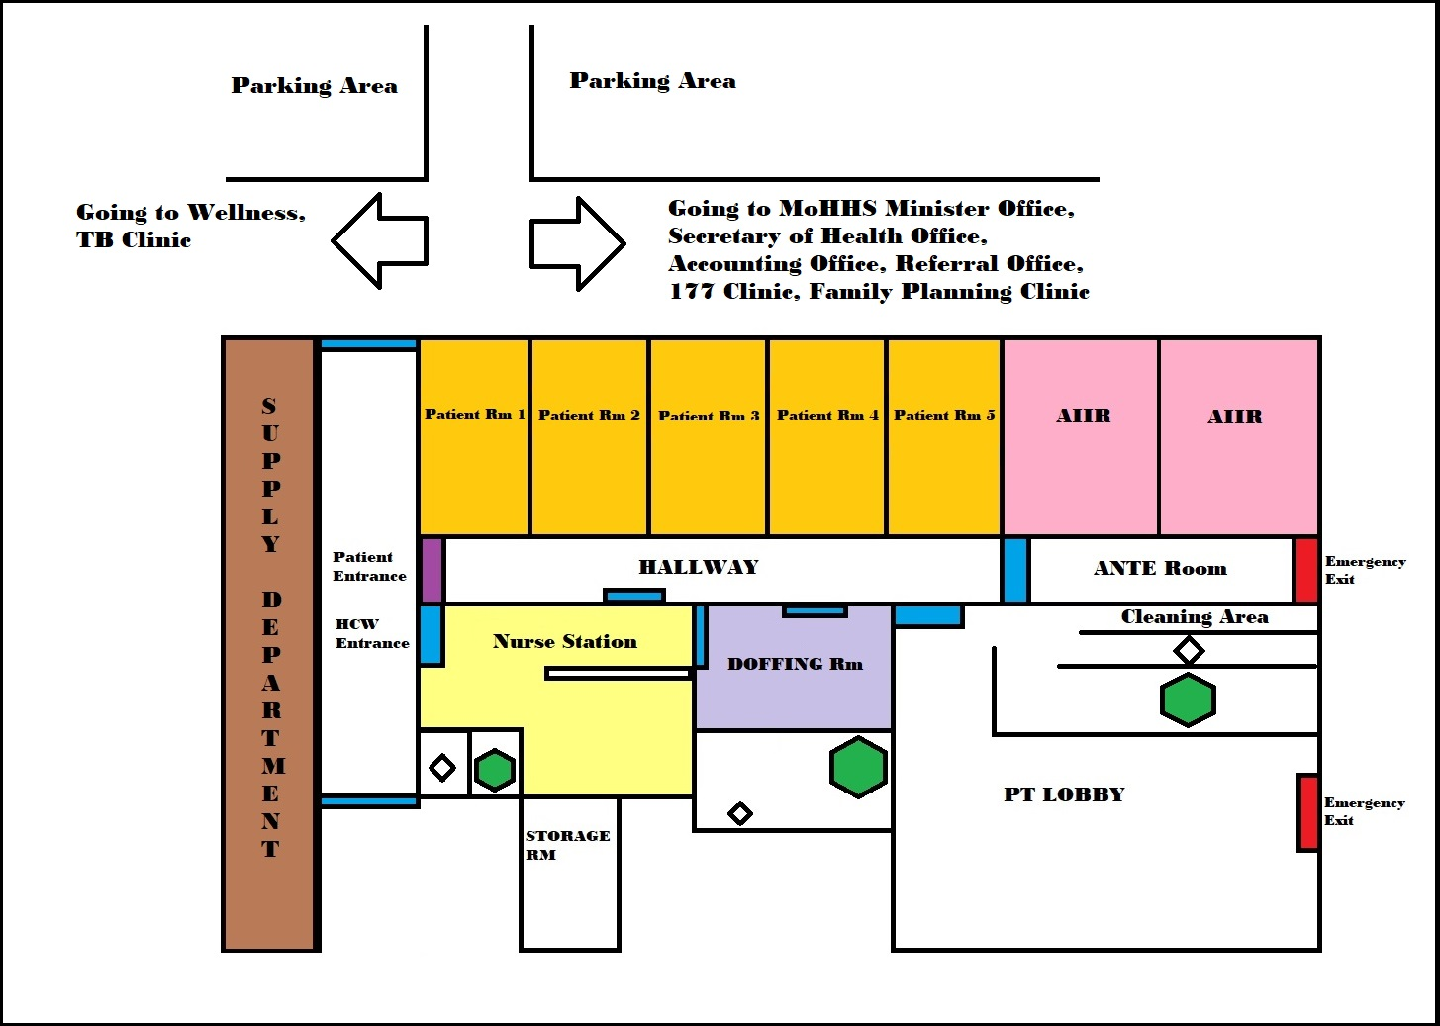
Legend
Door / Entrance
Patient Entrance Door
Nurse Station
Patient Room
AIIR (Airborne Infection Isolation Room
DOFFING Room
Exit Doors
Sink and Toilet
Shower Room

Annex:
Oxygen, Ventilators, and Diagnostic Machines Protocol for Isolation Room

General Rules for the Isolation Room when delivering oxygen, ventilators and diagnostic machines:
- All HCW entering the patient room in Isolation Room must adhere to Standard, Contact, and Droplet Protocol. Wear your PPE. Gown, Mask, Goggles, Gloves. Follow procedures on hand hygiene and proper donning of PPE. (Refer to topics regarding Hand Hygiene and Personal Protective Equipment)
- All items such as the ventilators are to be left at the Isolation Room.
- If items that are to be taken out such as the oxygen tanks, x-ray films, etc., are needed to be exteriorly disinfected before being taken out of the Isolation Room. Disinfect it with Lysol wipes, bleach wipes, disinfectant sprays or wipe it with alcohol solution. Air-dry them before taking them out of the disinfection area.
- Minimize patient contact.
- All HCW will only enter the HCW designated entrance door.
- HCW assigned at the Isolation Room are the sole responsible personnel in securing the PATIENT entrance door.
- AIIR room must be occupied first before using other patient rooms.
- DONNING of PPE will only be done at the NURSE STATION.
- If AIIR (Airborne Infection Isolation Room) are the only rooms occupied, DOFFING will be done at the ANTE Room.
- If Patient Rooms are occupied DOFFING Room will be utilized for removal of all PPE.
- Nurse Station should always be cleaned.

Health Care Worker Flow at the Isolation Room for deliveries of Oxygen tanks, and other Diagnostic Machines
- Oxygen tanks, ventilators, and diagnostic machines will only enter the PATIENT ENTRANCE door.
- Place your items outside PATIENT ENTRANCE door.
- Proceed to NURSE STATION. Disinfect your hands and wear your PPE. (Refer to topics regarding Hand Hygiene and Personal Protective Equipment).
- Proceed to HALLWAY.
- Ask the assigned HCW at the Isolation room the unlock the PATIENT ENTRANCE door.
- Once the door is opened, take your items to the HALLWAY.
- Once all your items are inside the HALLWAY, ask the HCW to lock the PATIENT ENTRANCE door.
- Do your procedure.
- If you are done with your procedure and will be taking out your item, follow these steps:

  - If AIIR are the only ones being utilized,

    - The disinfection will be done at the ANTE Room. Disinfect your gloves or remove them and put on new pair of gloves. Disinfect the external portion of your machine with bleach wipes or alcohol solution. Dispose material accordingly.
    - Remove your PPE (Refer to topics on How to Properly Wear and Remove your PPE)
    - Put on new gloves and wheel out your items to the HALLWAY.
    - Ask the HCW to open the PATIENT ENTRANCE door.
    - Exit.
    - Take your items and store your items to their proper stations. Remove PPE and dispose them properly. Do hand hygiene after removing your PPE.

  - If PATIENT room 1-5 are currently occupied, follow these steps:

    - The disinfection will be done at the HALLWAY Room. Disinfect your gloves or remove them and wear a new pair of gloves. Disinfect the external portion of your machine with bleach wipes or alcohol solution.
    - Remove your gloves.
    - Put on new gloves and ask the HCW to open the PATIENT ENTRANCE door. Wheel out your items but limit yourself from going out. Your items should be the only ones outside the HALLWAY.
    - Go back to HALLWAY and proceed to DOFFING ROOM.
    - At DOFFING ROOM, remove your PPE. (Refer to topics on How to Properly Wear and Remove your PPE)
    - Wash your hands, arms and face. Pat them dry and proceed to NURSE STATION.
    - Disinfect your hands. Put on new gloves.
    - Exit NURSE STATION.
    - Take your items and store your items to their proper stations. Remove your gloves and dispose them properly. Do hand hygiene after removing your gloves.

Annex :
Coronavirus Ward Floor Plan
Legend:

- Vestibule : Lobby
- Donning Room : A place where we put on our Personal Protective Equipment
- Storage Room : A place where we store our items such as PPE, etc.
- Nursing Station : An area for HCW not working directly with patients.
- Doffing Room : A place where we remove our PPE
- Hazardous Garbage : A place where we discard our infected materials such as PPE, etc.
- Clean Room
- Walkway
- Patient Waiting Area
- Patient Entry
Patient Ward
Clean Area
Infected Area
Exit Door

Annex:
Oxygen, Ventilators, and Diagnostic Machines Protocol for Coronavirus Ward

General Rules for the Coronavirus Ward when delivering oxygen, ventilators and diagnostic machines:
- ALL STAFF must enter the “vestibule” area.
- Donning of PPE is a MUST. NO STAFF shall enter the patient ward without donning proper PPE.
- BEFORE taking your PPE materials, MAKE SURE that you are already sanitized or have cleaned your hands.
- BEFORE donning please be aware that once you are already wearing your PPE, your personal items such as your pens, markers and small items that can fit on your pocket will remain on your pocket and can never be taken out to be used inside the ward until such time that you have removed your PPE. Bigger items such as your bags will be left at the donning area ask for assistance from the HCW assigned at the Coronavirus Ward.
- Donning of PPE will ONLY be done in the donning room and NOT at the Nursing Station.
- BEFORE you leave the Nursing Station, make sure to check all your items.
- Remember that the doors going out of the nursing station will only be opened on the other side and if you plan on going back to the nursing station you will need to remove your PPE and re-do the whole process. NO EXEMPTIONS.
- Once done providing your services to the patient, you are required to remove your PPE ONLY at the DOFFING area.
- Dispose your trash IMMEDIATELY at the HAZZARDOUS GARBAGE bin provided.
- Sanitize your hands before you exit the DOFFING room.
- Once you entered the CLEAN ROOM make sure to have washed your hands and face before exiting.
- ALL patient charts will stay at the Nursing Station.
- Items such as big containers, coolers, mats, etc. will not be allowed inside. Phones, laptops, chargers may be allowed.

Health Care Worker Flow at the Coronavirus Ward for deliveries of Oxygen tanks, and other Diagnostic Machines

- Oxygen tanks, ventilators, and diagnostic machines will only enter the EXIT door.
- Place and leave your items outside EXIT door.
- Proceed to DONNING ROOM (2). Wash your hands or sanitize with antibacterial hand sanitizers or alcohol with 60-70% proof.
- Before taking items inside the STORAGE ROOM (3) make sure that your hands are already clean.
- Put on your PPE at the DONNING ROOM (2) before proceeding to the NURSING STATION (4).
- Do not directly go to the patient ward unless deemed necessary.
- Exit the NURSING STATION (4) and ask the HCW to open the EXIT door.
- Once the EXIT door is open, take your items and proceed to do your duties and responsibilities.
- Once you are done with your duties and responsibilities, disinfect your gloves or put on new pair of gloves.
- Start disinfecting the external portion of your item.
- Once you are done. Remove your gloves and put on a new pair of gloves.
- Ask the HCW to open the EXIT door.
- Wheel out your items but limit yourself from going out. Your items should be on ones being taken out just outside the EXIT door.
- Proceed to DOFFING ROOM (5). Remove your PPE according to sequence: Gloves, Gown, Goggles, Mask. Discard PPE at the HAZARDOUS GARBAGE (6) area.
- Do hand hygiene. Wash your hands, arms, and face. Pat them dry. Exit the DOFFING ROOM (5) towards the CLEAN ROOM (7).
- CLEAN ROOM (7) would serve as a checkpoint. Make sure to do hand hygiene before you exit this area.
- Exit the CLEAN ROOM (7) and take your items currently located just outside the EXIT door.

Note:
A Healthcare Worker is not allowed to exit through the PATIENT ENTRY (10) door.
It would be a serious violation to contaminate the CLEAN ROOM (7).

In an event that a Healthcare Worker forgot to remove their PPE after having direct contact with a patient and has already proceeded to the CLEAN ROOM (7) this would be the appropriate actions to take:
- Remove contaminated PPE as soon as possible.
- Place PPE on a hazardous bag immediately.
- Wash your hands and face.
- Put on a new PPE.
- Bring with you extra HAZARDOUS BAG.
- Start disinfecting possible areas which was contaminated.
- Follow removal of PPE sequence.
- Discard PPE on a hazardous bag.
- Wash your hands and face.
- Exit decontaminated area.

Annex VIII: RMI COVID-19 Risk Communication and Community Outreach Plan
This Annex summarizes the setup and responsibilities of the RMI COVID-19 Risk Communication and Community Outreach Plan (the RCC Plan).

OBJECTIVES
The RCC Plan was developed:
- To support improved coordination and achieve a consistent approach to risk communication and community engagement in relation to coronavirus (COVID-19) in Marshall Islands.
- To help guide the Marshall Islands response to COVID-19, with a partnership comprising government departments, IOM, WHO, Marshall Islands Red Cross Society, and community organizations.
- In alignment the national COVID-19 response plan, for each of the various stages of the response.
Condition Level | Action | Color Code
5 (No Risk identified) | ‘Preparedness’ | GREEN
4 (Low Risk) | 'Threat Detected’ No potential or confirmed cases of COVID-19 in RMI, but real threat identified | YELLOW
3 (Medium Risk) | Person Under investigation (PUI) Suspect Cases Identified - Immediate Quarantine | AMBER
2 (High Risk) | ‘First’ Initial cases identified & confirmed positive (first generation of case or cases) | RED
1 (High Risk) | ‘Established Transmission’ 2nd generation of cases of multi-foci of local cases (community transmission) | RED
1b (High Risk) | Widespread Transmission on Majuro or Ebeye (exceed capacity thresholds) | RED
1c (High risk) | Widespread Transmission throughout Outer Atolls/Islands | RED

COORDINATION AND OVERSIGHT
Under the direction of the Marshall Islands National Disaster Committee, a risk communication and community engagement (RCCE) team has been established to coordinate all aspects of community outreach and communications for Marshall Islands.
Health Emergency Operations Centre (HEOC) and the National Disaster Committee provide and finalize drafts of the following:
- Situation Reports –HEOC: an up to date 1 pager report on the situation as it is.
- Press Releases – NEOC or MOHHS: Update on specific incidents as they arise
- Travel Advisories- NDC & MOHHS: travel restrictions and instruction .

RCCE WORKING GROUP MEMBERS
- NDMO - IMO
- IOM
- MIRCS
- MalGOV
- MOHHS PIO
- MOHHS
- EPA
- MOCIA – V7AB
- NTA
- Youth to Youth in Health
- PSS
- Ms Majol
- WUTMI

PARTNERS
Partner | Agency Focus
Ministry of Health and Human Services | Health
Public School System | Education, schools
IOM | WASH, GBV, mental health, ports and immigration
WHO | Technical guidance, Health
UNICEF | WASH
Marshall Islands Red Cross Society | Community outreach
National Telecommunications Authority | Telecommunications
MIRCS | Education and Awareness
MalGov Rep | Majuro Atoll leadership liaison
V7AB | AM/FM capability
NDMO | Information Dissemination

CLEARANCE PROCESS
All materials and messages developed must be reviewed and endorsed by the review panel – DS Mailynn Konelious Lang or Francyne Wase-Jacklick, Director Timmy Langrine, and IMO Yetta Aliven prior to any dissemination. The Risk Communication Focal Point will be tasked to ensure that the clearance process is adhered to.

RMI COVID-19 OPERATION’S SPOKESPERSON
The Marshall Islands Spokesperson(s) for COVID-19 are:
- Kino Kabua, Chief Secretary
- Jack Niedenthal, Secretary of Health and Human Services
- Mailynn K. Langinlur, Deputy Secretary of Health & Human Services
- Francyne Wase-Jacklick, Deputy Secretary of Health & Human Services
- Leilani Lani-Peren, MoHHS PIO
- Antari Elbon, V7ab
- Timmy Langrine, NDMO Director
- Yetta Aliven, NDMO Information Management Officer
All spokespersons should to be provided talking points, with content cleared by the Secretary of Health and Human Services before any prior media or public engagements to ensure accuracy of information.

CONTINGENCY PLANNING
The RCC Plan has established a tiered communication response based on the COVID-19 Condition Level.
Indicative actions for each Level are summarized below.
Condition 5: (No Risk Identified) ‘Preparedness’
- Public Communications: Mass media (radio, social media, posters) information sharing:
- Provide regular information via Facebook
- Radio (script and talk show)
- Establish a COVID-19 hotline for self-reporting and potential telemedicine
- Traveler communications:
- Provide health customs form and information on reporting at POE
- Internal Communications:
- Disseminate regular situation update via intranet and taskforce members
- Community outreach:
- Outreach team training to MRCS, CRS, health assistants, CWC
- IEC outreach package
- Outreach to community leaders and mayors in 5 areas (total 40 participants)
- WASH infrastructure and hygiene promotion:
- Group handwashing stations
- Install handwashing dockets at hospital; POE
- Conduct assessment report on water supply for ???
- Provide orientation on WASH setup and handwashing at various locations; schools, private sector, gov’t, churches
- Improve WASH in schools, health care facilities and communities.
- Monitoring and community feedback:
- All partners to provide 3x weekly updates on rumors/emerging issues to RCCE taskforce
- HCW/Facility
- Promote strong IPC in hospital
- Visual reminders on who to ensure appropriate case management; PPE use; health facility management; triage
Condition 4: (Low Risk) ‘Treat Detected’ No potential or confirmed cases of COVID-19 in RMI, but real threat identified
- Public Communications: Provide regular (daily) updates on situation status, and also increased emphasis on social distancing, hand and respiratory hygiene. Strengthen messaging on self-reporting. Sensitize the community on likelihood for banning all mass gatherings and inter-island travel.
- Issue immediate health alert for confirmed case
- Provide regular external situation updates on a weekly basis
- Intensify public communications on social distancing; hygiene and self-reporting
- Public outreach and communication on what is considered to be public gather and sizes
- Protection messaging
- Traveler communications: Total ban on international traveler arrivals
- Community outreach: Conduct intensified community outreach to address community anxiety and concerns, assist with contact tracing efforts by public health officials, and engage with other community partners and sectors to ensure adoption of social distancing measures. Ensure that community education includes provisions for protection of vulnerable populations.
- Community outreach teams to assist with contact tracing
- Targeted outreach for at-risk groups (elderly; existing medical conditions)
- Support churches; schools; workplaces to implement risk reducing measures in their control
- Private sector tool kit
- Fisherman/migrant labor tool kit
- Curfew hours??
- Communication on the conditions and what triggers will happen when
- WASH infrastructure and hygiene promotion: Intensively increase WASH and hygiene promotion in health facilities, high risk settings (schools; workplaces; churches)
- Handwashing information provided
- Disinfectant education
- Monitoring and community feedback: Intensively monitoring and respond to rumors and misinformation, including address issues of stigma and discrimination.
- Protection mechanism
- Health monitoring hotline
Condition 3: (Medium Risk) Person Under Investigation (PUI) Suspected Cases Identified – Immediate Quarantine
- Public communications and outreach: Enforcement of social distancing measures, home quarantine, hand and respiratory hygiene, telemedicine, counselling and psychosocial support.
- Information on blanket reduction of public gathering
- Traveler communications: Total ban on international traveler arrivals
- Community outreach: Support with distribution of home quarantine kits to affected households, for at risk populations, provide targeted assistance. Ensure protection guidance and home care guidance are provided.
- Enforcement of physical distancing at all essential businesses
- WASH infrastructure and hygiene promotion: Provide household WASH support for those in-home quarantine.
- Increased outreach households and essential services on handwashing and disinfecting
- Monitoring and community feedback: Intensively monitoring and respond to rumors and misinformation, including address issues of stigma and discrimination.
- Protection mechanism
- Health monitoring hotline
- Curfew reporting
Condition 2: (High Risk) ‘First’ initial case identified and confirmed positive (first generation of case or cases)
- Public communications and outreach: Enforcement of social distancing measures, home quarantine, hand and respiratory hygiene, telemedicine, counselling and psychosocial support.
- Traveler communications: Total ban on international traveler arrivals
- Community outreach: Support with distribution of home quarantine kits to affected households, for at risk populations, provide targeted assistance. Ensure protection guidance and home care guidance are provided.
- WASH infrastructure and hygiene promotion: Provide household WASH support for those in-home quarantine.
- Monitoring and community feedback: Intensively monitoring and respond to rumors and misinformation, including address issues of stigma and discrimination.
- Protection mechanism
- Health monitoring hotline
- Curfew reporting

Condition 1: (High Risk) ‘Established transmission’ 2nd generation of cases of multi0foci or local cases (community transmission)
- Public communications and outreach: Enforcement of social distancing measures, home quarantine, hand and respiratory hygiene, telemedicine, counselling and psychosocial support.
- Traveler communications: Total ban on international traveler arrivals
- Community outreach: Support with distribution of home quarantine kits to affected households, for at risk populations, provide targeted assistance. Ensure protection guidance and home care guidance are provided.
- WASH infrastructure and hygiene promotion: Provide household WASH support for those in-home quarantine.
- Monitoring and community feedback: Intensively monitoring and respond to rumors and misinformation, including address issues of stigma and discrimination.

Condition 1b: (High Risk) ‘Widespread Transmission’ on Majuro and Ebeye (exceed capacity thresholds)
- Public communications and outreach: Enforcement of social distancing measures, home quarantine, hand and respiratory hygiene, telemedicine, counselling and psychosocial support.
- Community outreach: Support with distribution of home quarantine kits to affected households, for at risk populations, provide targeted assistance. Ensure protection guidance and home care guidance are provided.
- WASH infrastructure and hygiene promotion: Provide household WASH support for those in-home quarantine.
- Monitoring and community feedback: Intensively monitoring and respond to rumors and misinformation, including address issues of stigma and discrimination.

Annex IX: HCWM COVID19 Quarantine Site and COVID Isolation Ward - Waste Management Policy draft

Person responsible for review of this policy: Director of Public Health
Date of review:

Introduction

The Practice has a duty to ensure, as far as reasonably practical, the health and safety of employees and other people who may be affected by the storage, handling, or disposal of waste products.

Aim of the protocol

The aim of this protocol is to set out the proper procedures by which waste should be disposed of in order to comply with legislation and for best practice.

Definitions

- Waste is anything that is discarded by a business.
- Hazardous waste is defined as waste having the potential to harm persons or the environment.
- Clinical waste is waste that consists wholly or partly of human tissue, blood or other body fluids, syringes, needles, or other sharp instruments. It is waste that unless rendered safe may prove hazardous to any person coming into contact with it. It is classed as hazardous.
- Non-clinical waste includes general waste such paper or packaging. It may be non-hazardous or hazardous.
- Non-hazardous non-clinical waste includes printing paper, stationary, paper rolls from examination couches and paper hand towels.
- Hazardous non clinical waste includes fluorescent light tubes, some electrical components, solvents, used chemicals.

Procedures for handling waste

General precautions

Staff should wear appropriate clothing or PPE (personal protective equipment) when disposing of waste.

Waste should be placed in the appropriate container.

Clinical waste

When handling clinical waste, staff should wear gloves. Where there is risk of spillage onto other body areas or clothing, extra precautions should be taken as appropriate e.g. use of an apron or goggles.

Single use disposable gloves should be made available in all clinical rooms. Single use disposable aprons and multi-use goggles should be made available in the treatment rooms and in the nursing area. The goggles should be cleaned and replaced after use.

Clinical waste bins should ONLY be used for clinical waste and not, for example, for paper sheets from examination couches or hand towels, unless contaminated by body fluids.

Clinical waste bins must not be used for sharp materials e.g. needles, lancets, blades or surgical instruments.

Clinical waste bins will be bagged up in red clinical waste bags and these bags will then be place in the large fence clinical waste bin in at the rear of the building of the isolation ward and Arrak quarantine site building to be ready for collection. The large clinical waste bin will be kept locked and chained for unauthorized public access. The key will be kept with the designated waste handling personnel.

Clinical waste bins will be emptied and collected by an authorized contractor. This is currently ISI. Clinical waste will be collected regularly by the contractor for Majuro Hospital Isolation Ward and for Arrak quarantine site, clinical waste will be collected three times a week. Clinical waste containers (bags, sharps bins etc) will be provided by the Ministry of Health & Human Services. All clinicals wastes will be collected and incinerated by the contractor.

All waste transfers will be supported by a WASTE Transfer Note. Waste transfer note will be provided by the contractor. Completed waste transfer from both Majuro hospital isolation ward and from Arrak quarantine site will be filed in the finance office at Majuro hospital and retained for 3 years.

Sharps Bins

Sharps bins are provided by the MoHHS and are available in each clinical room and in the dispensary. They should not be overfilled. Spare sharps bins are available in the Majuro hospital medical supply procurement area.

Other waste

Other general waste bins will be emptied by the designated cleaning contractors and collected by the ISI contractor.

Responsibilities

All partners, staff and all those who work at Majuro Hospital and Arrak Quarantine site have responsibility for following the procedures laid out in this protocol.

Any person who notices a problem or potential problem with regard to waste management has responsibility to report it to his/her line manager. It may appropriate to complete a significant event form.

Training

Training of waste handlers will be provided on waste management regarding how to be identifying, collecting, storing and transporting of healthcare waste. Periodic updates will be provided, which staff are encouraged to attend. Other extraordinary training may be arranged if need is identified.

Contact details

Clinical Waste Contractor ISI
Housekeeping Contractor Pending

Housekeeping Lead Lilliha Algunes
Environmental Health Manager Linda Chutaro
Infection Control Lead Jacob Peter

According to the most recent (2011) population and housing census.
See the RMI Communicable Disease Response Plan COVID-19 (RMICDR Plan COVID-19)
As set out in the Project Environmental and Social Review Summary (ESRS) http://documents.worldbank.org/curated/en/622481586658792454/pdf/Appraisal-Environmental-and-Social-Review-Summary-ESRS-RMI-COVID-19-Emergency-Response-Project-P173887.pdf
See RMI Immunization standard operating procedure
2014 Baseline Study for the Pacific Hazardous Waste Management Project - Healthcare Waste
"Gender Equality Where do we stand? Republic of the Marshall Islands", Prepared by the Community Development Division, Ministry of Culture and Internal Affairs, and the Economic Policy, Planning and Statistics Office; Office of the President Government of the Republic of the Marshall Islands May 2018
Certain information from the SEP is included in this ESMF for context. In the event of any discrepancies in wording between the SEP and the ESMF, the wording of the SEP will prevail
MOHHS Facebook page: https://www.facebook.com/rmimoh/posts/for-more-info-on-coronavirus-covid-19-please-contact-majuros-mohhs-24hr-hotline-/1515214375307603/

