Republic of the Marshall Islands

Education & Skills Strengthening Project

Grievance Redress Mechanism

Updated July 2023
(Revision C)

Prepared by
RMI Ministry of Finance
Division of International Development Assistance.

Quality Information

Document | ESSP Grievance Redress Mechanism
Date | Updated Nov 2022
Prepared by | CIU Safeguards Team

Revision History
Revision | Revision Date | Details | Revision By
A | August 2020 | Working Draft | CIU
B | November 2022 | Updated GBV and SEA/SH procedures | CIU
C | July 2023 | Updated contact information | CIU

Contents

Acronyms iii
1. Introduction 1
2. Key Feature of this GRM 2
3. How this GRM Operates 3
4. Gender Based Violence, Sexual Exploitation, Abuse & Harassment 5
5. Human Trafficking 6
6. Communication the GRM to the Public 6
7. Reporting on Grievances 6
8. Information Handling and Storage 7
9. Contact Information 8
Grievance Report Form 9
Grievance Register Form 11

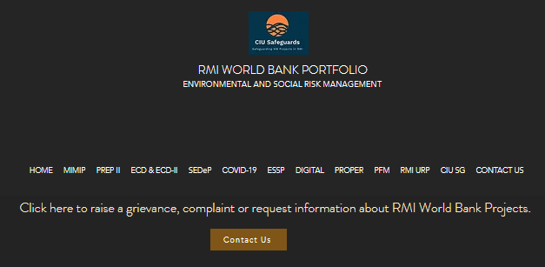

Project Contact Information
Susan Kommwa, ESSP Project Manager or
Kimber Rilometo, Safeguards Officer
In person: National Training Council (College of the Marshall Islands Old Library ) or DIDA Office (across Pacific Pure Water)
By phone: 458-4198 and 625-5968
By email: ciu.safeguards1@gmail.com or suekommwa@gmail.com
By mail: PO Box 3125 or PO Box D
Internet: https://www.ciudidasafeguards.com/

Acronyms
AP | Aggrieved Party
CIU | Central Implementation Unit
CSS | Construction Site Supervisor
DIDA | Division of International Development Assistance
DCP | Designated Contact Person
ESSP | Education and Skills Strengthening Project
GM | General Manager
GRM | Grievance Redress Mechanism
MOEST | Ministry of Education, Sports and Training
MOF | Ministry of Finance
NTC | National Training Council
PSC | Project Steering Committee
RMI | Republic of the Marshall Islands
SEA/H | sexual exploitation, abuse and harassment
VAC | Violence Against Children
WB | World Bank
WUTMI | Women United Together Marshall Islands

Introduction
Purpose of this Document
This document is relevant to anyone who has an interest in the World Bank (WB) funded Republic of the Marshall Islands (RMI) Education and Skills Strengthening Project (“ESSP” or the “Project”). This includes members of the public who would like information about ESSP, as well as people who want to raise a concern. It explains how to contact the Project and what happens when people make a complaint or lodge a grievance. It also explains the purpose of the project and the work ESSP is doing.
The process of making a complaint and ensuring that concerns are investigated and addressed according to set procedures and timelines is called a Grievance Redress Mechanism or GRM. These procedures are explained in this document including the process for dealing with “serious or sensitive” matters that may require the involvement of external agencies such as the police or counselling services.
If you are concerned, or you know someone who is concerned, about any aspect of the ESSP, please contact the Project Manager, the Safeguards Officer or anyone else working on the project (see Section 8) as soon as possible.
Purpose of this GRM
The purpose of the ESSP GRM is to ensure that:
- the basic rights and interests of everyone affected by the Project are protected
- all concerns about the Project are addressed in a fair, timely and effective manner
- the procedures and processes to resolve grievances are clearly identified and communicated to all interested parties
- the Project makes adjustments and improvements in response to people’s concerns and feedback.
The ESSP GRM covers the entire duration of the project because concerns can arise at any point. Concerns, complaints and grievances can be raised about any aspect of the ESSP, including project activities, services, environmental or social impacts, safety issues, land use or about the behavior and attitudes of people carrying out project works, including issues related to physical and sexual violence, exploitation and harassment.
Purpose of the Project
The purpose of the ESSP is to increase equitable access to quality education and training programs focused on foundational and market-relevant skills development, and to opportunities for continuing education, training, and employment in RMI and abroad.
The Implementing Agencies for the Project is the Ministry of Education, Sports and Training (MOEST) and the key focal agencies are the National Training Council (NTC) and the Public School System (PSS). Environmental and social instruments for the Project were prepared by the Central Implementation Unit (CIU) of the Division of International Development Assistance (DIDA), under the RMI Ministry of Finance (MOF).
The Project is structured around four components: the first and second components focus on improving the accessibility and quality of selected education and training programs offered in secondary schools, post-secondary institutions, and private training providers. The third component involves enhancing academic and career counselling and labor market intermediation services. The fourth component supports Project implementation and monitoring and evaluation. Within MOEST, the first component will be managed by PSS, the second and third by the NTC and the fourth jointly by NTC and PSS.

2. Key Feature of this GRM
✓ It only deals with project related matters
✓ It can be used by an individual or by a group of people who have concerns about how the project is impacting their lives or the lives of others
✓ Grievances can be raised in an open and public manner, or anonymously and in confidence
✓ The identity of the person(s) who make a complaint will be kept confidential and all documentation related to the concern will be kept in a secure location that can only be accessed by the Project Manager and the Safeguards Officer
✓ It provides different options for lodging a complaint (i.e., in person, on the phone, by internet or email) and aggrieved party (AP) can choose to talk with either a man or a woman
✓ There are different kinds of issues that can arise during project implementation which require different kinds of responses including “series or sensitive” matters.
“Serious or sensitive matters” refer to issues involving potential criminal activity, political interference, conflicts of interest, corruption, land claims, gender-based violence (GBV), sexual exploitation, abuse, or harassment (SEAH) violence against children (VAC) or human trafficking (HT). In the case of potential criminal activity, it is important that SEDeP GRM processes do not impede investigation by the appropriate authorities. In situations involving land disputes or claims, the matter will be referred to the Project Steering Committee for immediate attention. If the concern is related to GBV or SEAH, the Project will first seek to ensure that the victim is safe and has access to required support services. For these reasons, a referral will be made to the WUTMI Weto in Mour: Violence against Women and Girls Support Service (see page 8 for contact information).
- The person in charge of making sure that the ESSP GRM process operates properly, is called the “Designated Contact Person” or the “DCP”
- The ESSP Project Manager is the DCP for all grievances and will stay involved until the matter is resolved. During periods of construction, the Construction Site Supervisor (CSS) can also serve as the DCP until the matter is resolved or transferred to the Project Manager
- The person who receives the complaint or grievance is called the Recipient, and must provide a full account of the complaint to the DCP using the required form
- The DCP is the main point of contact for person(s) making a complaint and is responsible for regular reporting of all grievances to the RMI Government and to the World Bank (names are kept confidential)
- Concerned persons can seek information or make a complaint to any staff involved with the project who will immediately direct the matter to the Project Director
- The ESSP GRM is not a substitute for legal or other public or civic resolution mechanisms and does not remove people’s right to take their grievance to a formal dispute-resolution mechanism.
- The ESSP GRM provides important information about how well the project is functioning and what improvements are required based on the kinds of concerns that arise.

3. How this GRM Operates
Figure 1 shows how the ESSP GRM operates from the time a grievance is received and lodged by the Project Manager (the DCP), until the matter is resolved. Resolution could involve a number of steps and parties including the PSS General Manager (GM), the Secretary of Education, and the Project Steering Committee (PSC). Table 1 on page 4 explains the roles and responsibilities of the parties involved with this GRM, and the timeframes for completing each step.
Figure 1: ESSP Grievance Redress Process
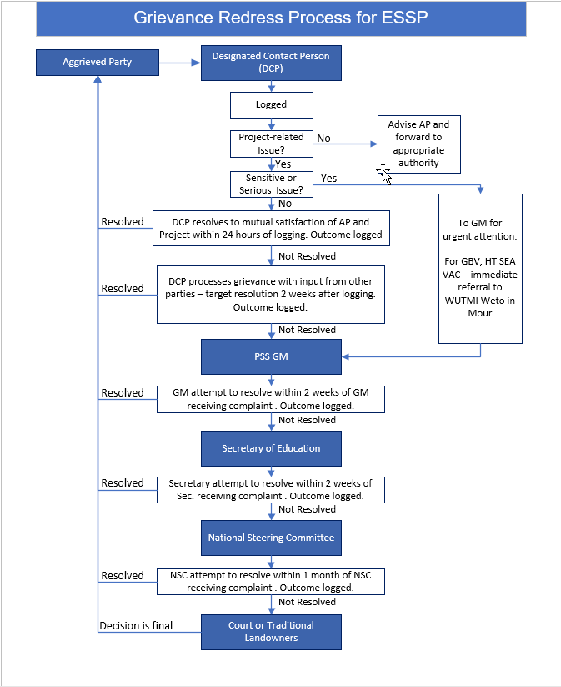

Table 1: Grievance Redress Process
Step | Process | Timeline
1. | Aggrieved Party (AP) takes their concern or complaint to the Designated Contact Person (DCP) or to anyone else involved with the Project (“recipient”).  The Recipient must forward all information received to the DCP within 12 hours of receipt.  During construction, the Construction Site Supervisor (CSS) becomes the DCP. In this case, in addition to the following steps, the DCP (CSS) shall report any concern or complaint directly to the ESSP Project Manager within 12 hours of receipt.  Within 12 hours of receipt, the DCP shall:  - Log concern or complaint [Section 7 of this GRM]  - Determine whether the concern or complaint is Project related.  - If not Project-related DCP advises AP and forwards concern or complaint to appropriate authority. A record of the complaint is recorded on the Complaint Register, and the case in closed.  - Determine whether the concern or complaint is sensitive or serious matter.  - If the matter relates to GBV, SEA/H or VAC or Human Trafficking, the DCP immediately refers the survivor to WUTMI, and escalates the matter to the PSS General Manager.  - Notify the CIU Safeguards Team and the World Bank (WB) Project Team Leader. | Any time  Recipient: within 12 hrs. of Receiving Complaint  DCP:  within 12 hrs. of receiving complaint
2. | DCP endeavors to resolve the concern or complaint within 24 hours of receipt and logging the grievance. For complaints that are satisfactorily resolved by the DCP, the nature and time of resolution is logged. | Within 12 hrs. of logging grievance
3. | If issue is unable to be resolved within 24 hours of lodging, DCP will continue to process the grievance (with input from other parties as appropriate) with the AP.  Note: the timeframe for this step may be extended with the mutual agreement of all involved parties. | Within 2 weeks of logging grievance (subject to extension by mutual agreement).
4. | Where the AP is not satisfied with the resolution from Step 3, the DCP will refer the AP to the PSS General Manager. | 2 weeks after logging grievance
5. | The PSS General Manager endeavors to address and resolve the complaint (by way of identifying a solution or negotiating a resolution with the AP) and informs the AP in writing.  For complaints that were satisfactorily resolved by the PSS General Manager the incident and resultant resolution will be logged by the DCP.  The PSS General Manager will refer to the Secretary of Education any unresolved issues for action/resolution. Any complaints relating to GBV will be dealt with pursuant to Section 6 of this GRM. | 2 weeks after GM receives complaint.
6. | The Secretary of Education endeavors to address and resolve the complaint and inform the AP.  If the matter remains unresolved within 2 weeks of the Secretary receiving the complaint, or AP is not satisfied with the outcome, the Secretary of Education will then refer to matter to the Project Steering Committee (PSC) for a resolution.  The DCP will log details of issue and resultant resolution status. | 2 weeks after Secretary receives complaint.
7. | Project Steering Committee resolves issue. | 1 month after PSC receives complaint
8. | If complaint remains unresolved or the AP is dissatisfied with the outcome proposed by the PSC, he/she is free to refer the matter to the appropriate legal or judicial authority. A decision of the Court will be final. | Anytime.

Gender Based Violence, Sexual Exploitation, Abuse & Harassment
If a complaint is related to gender-based violence (GBV), sexual exploitation, abuse, or harassment (SEAH), violence against children (VAC), it will be immediately referred to the WUTMI Weto in Mour: Violence against Women and Girls Support Service (WUTMI - WIM). This will ensure that the safety and support needs of the victim are addressed sensitively, and as quickly as possible. WUTMI - WIM will also be responsible for assisting the victim initiate legal action as required.
In the event WUTMI - WIM becomes aware of a situation involving ESSP-related GBV, SEAH or VAC, a staff member will contact the Project Manager or DIDA Safeguards Officer within 12 hours. At that point, the concern will be documented and an internal ESSP investigation with commence.
Throughout the referral and investigation process, it is critical that confidentially is fully respected and that the safety and dignity of the victim is upheld.
In situations involving GRB, SEAH or VAC, the ESSP will use a “survivor-centered approach”. This means that:
- The rights, needs, and wishes of the survivor (or victim) is the foremost priority of everyone involved with the project
The survivor-centered approach aims to create a supportive environment in which the survivor’s rights are respected and in which she is treated with dignity and respect. The approach helps to promote the survivor’s recovery and her ability to identify and express needs and wishes, as well as to reinforce her capacity to make decisions about possible interventions (UN Women)
- The survivor has a right to:
- be treated with dignity and respect instead of being exposed to victim-blaming attitudes.
- choose the course of action in dealing with the violence instead of feeling powerless
- privacy and confidentiality instead of exposure
- non-discrimination instead of discrimination based on gender, age, race/ ethnicity, ability, sexual orientation, HIV status or any other characteristic
- receive comprehensive information to help her make her own decision instead of being told what to do.

Human Trafficking
If anyone working on the Project is made aware of actual or suspected human trafficking, they must immediately contact the Project Manager or CIU Safeguards Team. In addition to contacting the RMI Police Department, the DCP will also contact WUTMI or WAM if there is a victim who requests support services.

Communication the GRM to the Public
ESSP beneficiaries and other interested parties will be made aware of project activities and grievance procedures through one or more of the following means. Further information regarding stakeholder engagement requirements can be found in the Project Stakeholder Engagement Plan (SEP) available on the Safeguard Team website (see below).
Radio: | Announcements about project activities and stakeholder engagement opportunities will be made prior to significant project works including how the interested parties can get more information and raise concerns.
Newspaper | Articles on Project activities and works prepared for the Marshall Islands Journal should include contact and grievance information.
Internet: | A summary of the Project will be posted on the MOEST Facebook page, the Project website.  All Environmental and Social (Safeguard) Project documents are housed on the CIU Safeguards Website.  https://www.ciudidasafeguards.com/essp-safeguards-instru  This site also contains allows concerned parties to register complaints and grievances anonymously.
Notice Boards: | In all areas where construction and renovation work will be conducted, a notice board will be installed outside each operational area, describing the Project, where to get further information and how to raise concerns.
Community and School Meetings | In situations where renovation and construction work will be conducted on school premises or other public buildings, school/facility administrators and students will be notified in advance and informed about the grievance process, including strategies to prevent incidents of GBV, SEA/H and VAC. Schools will be asked to nominate a male and female designated contact who are known and accessible to students should they have any concerns. These designated contacts will need to be informed of Project GRM processes and how to deal with sensitive matters.

Reporting on Grievances
The template for documenting a grievance or complaint in contained in Annex 1. It is also available on the CIU Safeguards Website: https://www.ciudidasafeguards.com/grm.
The Grievance Report Form needs to be completed by the person who receives the complaint through any means (i.e., phone, in person, by email, through a third party etc.) and given to the Designated Contact Person (Project Manager or Construction Site Supervisor) in a confidential manner, within 12 hours of receipt.
The DCP will then log the complaint on the Grievance Register which is provided in Annex II and also available on CIU Safeguards Website.
ALL grievance and complaints must be recorded and entered into the Grievance Register by the DCP, who will also document all steps taken to investigate and resolve the matter. If the concern is not project related, it is referred to the appropriate agency (as required) and closed on the register.
Project six-month reports shall contain the following grievance statistics:
- Total number of grievances and complaints received
- Total number of grievances and complaints resolved
- Total number of grievances and complaints active
- Total number of grievances and complaints unresolved
- Average number of days to resolve grievances and complaints.
In addition, an up-to-date copy of the ESSP Grievance Register will form part of Project Six Month Reports. Note: Before sharing the register, the names and any other identifying information will be redacted.

Immediate reporting to the CIU and World Bank of the following:
- Grievance or complaint relates to physical injury, harm or death
- Grievance or complaint relates to GBV, SEA/H, VAC or human trafficking.
Immediate reporting to WUTMI of the following:
- Grievance or complaint received relating to GBV and SEA/H

Information Handling and Storage
Each concern or complaint received by the DCP shall be allocated a unique File identifier – ESSP GRM – 2022 #1, ESSP GRM – 2022 #2 etc.
A hard copy of the Grievance Report Form will be filed by the DCP in a locked filing cabinet.
As noted in Section 7, the names and any other identifying information related to a Project grievance will be redacted from the Form and the Register before it is shared with the World Band and identified Government of RMI representatives.
Detailed information relating to GBV, SEA/H, HT, VAC will be treated as personal and confidential (retained only by Project management and the PSC) and shall only be made available to WUTMI with the permission of the survivor/victim. In cases of alleged criminal activity, the police will be informed. Any other information shall be treated as confidential unless all parties have approved release.

Contact Information
If you or someone you know has a concern or complaint about the ESSP, please contact the Project in any of the following ways. You can make an analysis complaint.
In person:
Majuro: DIDA (across Pacific Pure Water) Uliga Village, Majuro MH 96960 or
PIU, National Training Council (College of the Marshall Islands Old Library)
Ebeye: KADA Building, Ebeye, Kwajalein Atoll
By Phone:
Project Implementation Unit (692) 458-4198
DIDA Office, Majuro (692) 625 5968
Ebeye: (692) 458-3069
By email:
Project Manager, Designated Contact Person
Susan Kommwa suekommwa@gmail.com
DIDA Safeguards Team
Kimber Rilometo ciu.safeguards1@gmail.com
Yumi Crisostomo mikefamilystore@gmail.com
Garry Venus gazza700@gmail.com
Colleen Peacock colleen@tautai.com
By mail:
Majuro – DIDA, P.O. Box D Majuro, MH 96960
Majuro – NTC, P.O. Box 3125 Majuro, MH 96960
On the internet
Majuro – NTC www.ntcinfo.org
If the concern is related to gender-based violence, sexual exploitation, abuse or harassment, violence against children or human trafficking, please contact WUTMI if the survivor is female or Waan Aelon in Majel (WAM) if the survivor is male. WAM also provides counselling services for perpetrators.
WUTMI Weto in Mour | (692) 625-6687 | wetoinmour@wutmi.com
Waan Aelon in Majel. | (692) 625 6123 | associate@canoesmarshallislands.com

GRIEVANCE REPORT FORM
* Grievance Recipient to complete all non-shaded areas and DCP to completed shaded areas
Name & Position of Grievance Recipient:

Contact Information of Grievance Recipient:
Grievance Reference #:

Name of concerned party (or anonymous), gender and age (or approx.)

Address:
Telephone: Email:
Date and time complaint received:
How complaint was received:
Date and Time Project Manager was notified:
How Project Manager was notified:

Date of 2-week deadline for initial resolution or escalation:
Date, time, and location of event leading to concern

Does the complaint involve injury, death, violence, sexual abuse, exploitation, harassment, violence against children or potential criminal activity?
Yes or No

Is anyone at immediate danger or risk?
Yes or No
If yes, describe risk and any actions that have been taken to protect people or property

Does the complaint involve Project or implementing agency staff, consultants or contractors?
Yes or No
Detailed account of concern (include names of persons involved if known)

Proposed solution or remedy sought by aggrieved party (if known)
Name and Position of DCP receiving this Grievance Form:
Date and time Grievance Form Received:

Dates and steps taken to resolve concern by DCP or other parties
Outcome of resolution process
Identify any lessons learned and project modifications required resulting from this complaint
Date Grievance Closed on Register

Grievance Register Form

World Bank & RMI Government: Project Grievance Register

Name of Project: ________________________________ Name & position of person completing Register ____________________ Date of Last Update: _____________________________ Date Register Shared with: CIU ________ PSC:_______ WB _________
When/How Grievance received | File # | Name of Aggrieved Party or Complaint | Nature of Issue Raised | Sensitive or Serious Matter?  Yes/No | Description& Date of Response & Referral Info | Outcome of Response | If not resolved, steps taken & date | Status  (Date of closure or next step)
Date:  01/01/21  Method:  Phone | ESSP GRM – 2022 #1 | To be redacted when register is shared
Date:  Method: | ESSP GRM – 2022 #2 | To be redacted when register is shared
Date:  Method: |  | To be redacted when register is shared
Date:  Method: |  | To be redacted when register is shared

